Supplementary Information – European Journal of Nutrition
Choline supplementation for preterm infants - metabolism of four Deuterium-labeled choline compounds
Katrin A. Böckmann¹, Wolfgang Bernhard¹, Michaela Minarski¹, Anna Shunova¹, Cornelia Wiechers¹, Christian F. Poets¹, Axel R. Franz^{1, 2}
Affiliations: ¹Department of Neonatology, Eberhard Karls University, Tübingen, Germany ²Center for Pediatric Clinical Studies, Eberhard Karls University, Tübingen, Germany
Address of correspondence: Katrin Alexandra Böckmann, MD, Department of Neonatology, Faculty of Medicine, Eberhard Karls University, Calwer Straße 7, D-72076 Tuebingen, Germany; katrin.boeckmann@med.uni-tuebingen.de; Phone: +49 7071 29 84742

Patient ID | Supple-ment | Hours after Application | Native Choline | D9-Choline | Native PC | D9-PC
01 | D9-Choline chloride | 1 | 31.3 | 1.88 | 1313 | 0.00
10 |  | 1 | 19.3 | 0.60 | 1366 | 0.00
22 |  | 1 | 32.4 | 1.77 | 1548 | 0.00
25 |  | 1 | 30.5 | 2.37 | 1854 | 0.01
06 |  | 12 | 23.9 | 0.00 | 1643 | 10.35
09 |  | 12 | 21.3 | 0.00 | 1471 | 7.55
17 |  | 12 | 17.3 | 0.00 | 1985 | 8.62
26 |  | 12 | 27.8 | 0.00 | 1611 | 4.96
01 |  | 24 | 25.3 | 0.00 | 1404 | 6.38
10 |  | 24 | 22.2 | 0.00 | 1292 | 7.22
22 |  | 24 | 31.3 | 0.00 | 1654 | 8.40
25 |  | 24 | 29.9 | 0.00 | 1769 | 5.88
06 |  | 60 | 21.3 | 0.00 | 1400 | 4.67
09 |  | 60 | 18.7 | 0.00 | 1386 | 3.99
17 |  | 60 | 18.0 | 0.00 | 1929 | 2.81
26 |  | 60 | 23.9 | 0.00 | 1653 | 3.00
 |  | Median (P25/P75) | 23.9 (20.8/30.1) |  | 1579 (1396/1683)
04 | D9-GPC | 1 | 13.0 | 0.92 | 1272 | 0.00
16 |  | 1 | 15.9 | 1.03 | 1372 | 0.01
24 |  | 1 | 16.2 | 1.53 | 1421 | 0.01
31 |  | 1 | 21.1 | 1.51 | 1606 | 0.00
02 |  | 12 | 32.6 | 0.00 | 1683 | 10.82
14 |  | 12 | 15.5 | 0.00 | 1289 | 8.75
20 |  | 12 | 24.1 | 0.00 | 1879 | 8.11
27 |  | 12 | 19.8 | 0.00 | 1803 | 5.60
04 |  | 24 | 18.2 | 0.00 | 1303 | 10.28
16 |  | 24 | 9.0 | 0.00 | 1248 | 4.91
24 |  | 24 | 16.2 | 0.00 | 1403 | 8.96
31 |  | 24 | 19.4 | 0.00 | 1571 | 11.25
02 |  | 60 | 26.6 | 0.00 | 1722 | 5.94
14 |  | 60 | 13.9 | 0.00 | 1308 | 3.97
20 |  | 60 | 15.7 | 0.00 | 1901 | 4.19
27 |  | 60 | 29.6 | 0.00 | 1715 | 5.08
 |  |  | 17.2 (15.6/21.8) |  | 1496 (1307/1717)
05 | D9-Phosphorylcholine | 1 | 29.3 | 0.67 | 1460 | 0.00
15 |  | 1 | 25.0 | 0.98 | 1404 | 0.00
18 |  | 1 | 15.7 | 1.35 | 1357 | 0.00
28 |  | 1 | 21.7 | 1.39 | 1622 | 0.03
03 |  | 12 | 17.4 | 0.00 | 1893 | 15.89
11 |  | 12 | 37.1 | 0.13 | 1974 | 10.40
23 |  | 12 | 23.8 | 0.00 | 1635 | 9.11
32 |  | 12 | 18.7 | 0.00 | 1595 | 8.49
05 |  | 24 | 41.8 | 0.00 | 1651 | 7.43
15 |  | 24 | 23.7 | 0.00 | 1434 | 5.76
18 |  | 24 | 16.9 | 0.27 | 1619 | 7.41
28 |  | 24 | 16.6 | 0.00 | 1573 | 8.20
03 |  | 60 | 19.9 | 0.00 | 1767 | 6.45
11 |  | 60 | 28.3 | 0.00 | 1884 | 4.29
23 |  | 60 | 29.2 | 0.00 | 1464 | 2.21
32 |  | 60 | 15.4 | 0.00 | 1778 | 4.79
 |  |  | 22.7 (17.3/28.5) |  | 1621 (1463/1770)
08 | D9-POPC | 1 | 23.4 | 0.00 | 1467 | 0.00
13 |  | 1 | 15.5 | 0.00 | 1591 | 0.00
21 |  | 1 | 30.4 | 0.00 | 1620 | 0.00
29 |  | 1 | 21.0 | 0.00 | 1728 | 0.00
07 |  | 12 | 16.3 | 0.00 | 2066 | 11.30
12 |  | 12 | 22.9 | 0.00 | 1842 | 17.54
19 |  | 12 | 21.9 | 0.35 | 1707 | 8.30
30 |  | 12 | 28.6 | 0.00 | 1681 | 19.32
08 |  | 24 | 21.7 | 0.00 | 1468 | 3.77
13 |  | 24 | 19.1 | 0.00 | 1618 | 11.45
21 |  | 24 | 30.5 | 0.00 | 1660 | 8.81
29 |  | 24 | 23.1 | 0.00 | 1580 | 12.92
07 |  | 60 | 22.3 | 0.00 | 2042 | 3.94
12 |  | 60 | 22.5 | 0.00 | 1650 | 5.00
19 |  | 60 | 18.6 | 0.00 | 1449 | 1.49
30 |  | 60 | 17.0 | 0.00 | 1731 | 7.27
 |  |  | 22.1 (18.9/23.2) |  | 1655 (1589/1729)

Supplemental Table 1: Concentrations of native choline and phosphatidylcholine and their D9-labeled analogues of 64 measurements in 32 preterm infants. Samples were taken at 1h+24h or 12h+60h after administration of the D9-labeled supplement. Groups showed similar native choline concentrations, Wilcoxon for all groups p= 0.2, but significant difference between choline chloride and GPC group, p= 0.05. Native PC concentrations were also similar, Wilcoxon for all groups p= 0.4, also no significant difference when comparing each group. Abbreviation: D9: deuterium labeled, PC= phosphatidylcholine, D9-POPC= D9-palmitoyl-oleoyl-phosphatidylcholine,

Supplemental Figure s1; Method of AUC calculation.
AUC was calculated for each patient. When blood was taken at 1 and 24h an area under curve for 0, 1, 24 and 60h was calculated, assuming a value of 0 for the timepoint 0 and 60h.

Supplemental Figure s2; Method of AUC calculation
AUC was calculated for each patient. When blood was taken at 12 and 60h an area under curve for 0, 12 and 60h was calculated, assuming a value of 0 for the timepoint 0h.

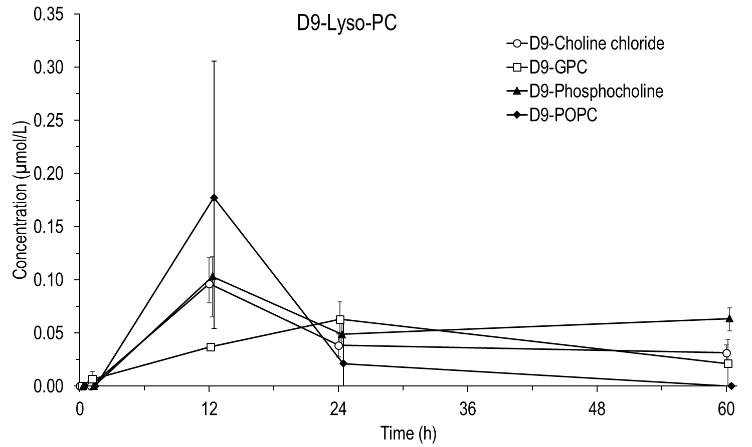
Supplemental Figure s3: D9-Lyso-PC concentrations in plasma after the administration of four deuterium labeled supplements.
Abbreviations: D9= deuterium labeled, D9-GPC= D9-alpha-glycerophosphorylcholine, PC= phosphatidylcholine, D9-POPC= D9-palmitoyl-oleoyl-phosphatidylcholine, h=hour.

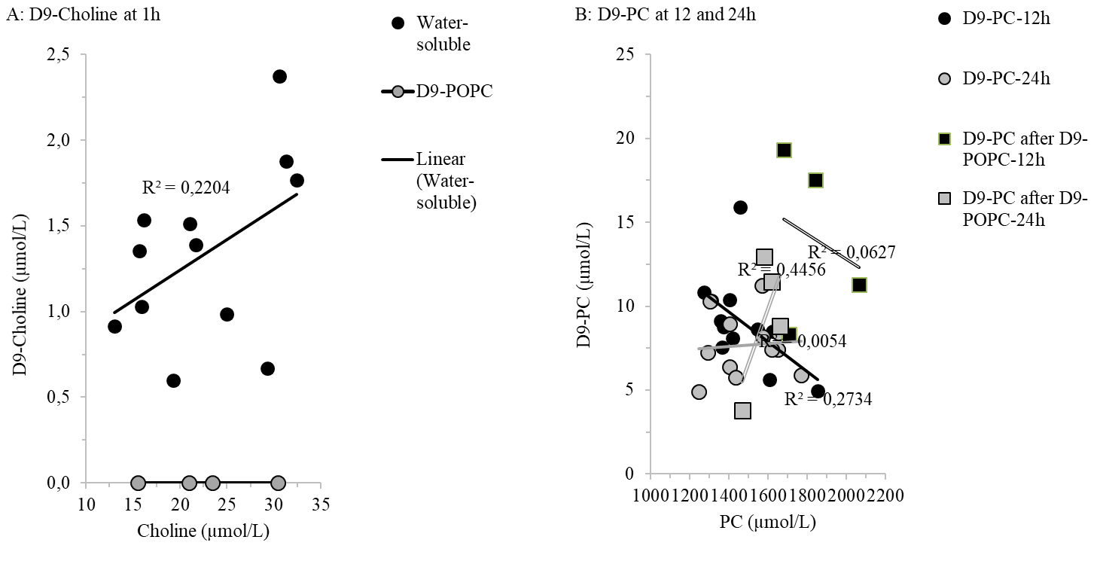
Supplementary Figure s4: Correlations of plasma concentrations of D9-choline relative to native choline at 1h (A) and of D9-PC relative to native PC at 12 and 24h after D9-choline supplementation (B) of 32 preterm study infants Abbreviations: h= hour, D9: deuterium labeled, PC= phosphatidylcholine, D9-POPC= D9-palmitoyl-oleoyl-phosphatidylcholine.

