Incidence and risk factors for venous thromboembolism in the Cancer-VTE Registry stomach cancer subcohort

Journal: Gastric Cancer

Takaki Yoshikawa¹, Takeshi Sano², Masanori Terashima³, Kensei Yamaguchi⁴, Etsuro Bando³, Ryohei Kawabata^{5,6}, Hiroshi Yabusaki⁷, Hisashi Shinohara⁸, Mari S Oba^{9,10}, Tetsuya Kimura¹¹, Atsushi Takita¹², Mitsuru Sasako¹³

- Department of Gastric Surgery, National Cancer Center Hospital, 5-1-1 Tsukiji, Chuo-ku, Tokyo 104-0045, Japan
- Department of Gastroenterological Surgery, Cancer Institute Hospital of the Japanese Foundation for Cancer Research, Tokyo, Japan
- Division of Gastric Surgery, Shizuoka Cancer Center, Shizuoka, Japan
- Department of Gastroenterological Chemotherapy, Cancer Institute Hospital of the Japanese Foundation for Cancer Research, Tokyo, Japan
- Department of Surgery, Osaka Rosai Hospital, Sakai, Japan
- Department of Surgery, Sakai City Medical Center, Sakai, Japan
- Department of Gastroenterological Surgery, Niigata Cancer Center Hospital, Niigata, Japan
- Department of Gastroenterological Surgery, Division of Upper GI, Hyogo Medical University, Nishinomiya, Japan
- Department of Medical Statistics, Toho University, Tokyo, Japan
- Department of Clinical Data Science, Clinical Research & Education Promotion Division, National Center of Neurology and Psychiatry, Tokyo, Japan
- Primary Medical Science Department, Daiichi Sankyo Co., Ltd., Tokyo, Japan
- Data Intelligence Department, Daiichi Sankyo Co., Ltd., Tokyo, Japan
- Department of Surgery, Yodogawa Christian Hospital, Osaka, Japan

Corresponding author
Takaki Yoshikawa
Department of Gastric Surgery, National Cancer Center Hospital
Postal address: 5-1-1 Tsukiji, Chuo-ku, Tokyo 104-0045, Japan
Tel: +81-3-3542-2511
E-mail: tayoshik@ncc.go.jp
Online Resource 1. Univariable and multivariable analysis of factors correlated with VTE prevalence at baseline
Factor |  | N | Events,  n (%) | Univariable |  |  | Multivariable
 |  |  |  | OR | 95% CI | p value | OR | 95% CI | p value
Sex | Male | 1,287 | 60 (4.7) | Ref | - | - | Ref | - | -
 | Female | 609 | 71 (11.7) | 2.70 | 1.89–3.86 | < 0.001 | 2.55 | 1.64–3.95 | < 0.001
Age, years | < 65 | 483 | 11 (2.3) | Ref | - | - | Ref | - | -
 | ≥ 65 | 1,413 | 120 (8.5) | 3.98 | 2.13–7.45 | < 0.001 | 3.35 | 1.51–7.47 | 0.003
BMI | ≥ 25 | 364 | 17 (4.7) | 0.61 | 0.36–1.04 | 0.069 | 0.58 | 0.31–1.10 | 0.094
 | 18.5 to < 25 | 1,282 | 95 (7.4) | Ref | - | - | Ref | - | -
 | < 18.5 | 249 | 19 (7.6) | 1.03 | 0.62–1.72 | 0.904 | 0.73 | 0.39–1.37 | 0.326
CrCL, mL/min | > 50 | 1,486 | 87 (5.9) | Ref | - | - | Ref | - | -
 | ≤ 50 | 364 | 38 (10.4) | 1.87 | 1.26–2.80 | 0.002 | 0.67 | 0.41–1.12 | 0.126
Bed rest for 4 days or more | No | 1,872 | 128 (6.8) | Ref | - | - | Ref | - | -
 | Yes | 24 | 3 (12.5) | 1.95 | 0.57–6.61 | 0.286 | 0.38 | 0.05–2.84 | 0.347
History of VTE | No | 1,878 | 121 (6.4) | Ref | - | - | Ref | - | -
 | Yes | 18 | 10 (55.6) | 18.15 | 7.04–46.83 | < 0.001 | 24.97 | 7.52–82.88 | < 0.001
Clinical stage | II/III | 1,517 | 81 (5.3) | Ref | - | - | Ref | - | -
 | IV | 379 | 50 (13.2) | 2.70 | 1.86–3.91 | < 0.001 | 1.50 | 0.92–2.43 | 0.106
ECOG PS | 0 | 1,396 | 75 (5.4) | Ref | - | - | Ref | - | -
 | 1 | 420 | 40 (9.5) | 1.85 | 1.24–2.77 | 0.003 | 1.05 | 0.64–1.72 | 0.859
 | 2 | 80 | 16 (20.0) | 4.40 | 2.43–7.99 | < 0.001 | 1.77 | 0.87–3.60 | 0.116
Occurrence of tumor | Primary | 1,852 | 128 (6.9) | Ref | - | - | Ref | - | -
 | Recurrence | 44 | 3 (6.8) | 0.99 | 0.30–3.23 | 0.981 | 0.33 | 0.06–1.83 | 0.204
Lymph node metastasis | No | 635 | 27 (4.3) | Ref | - | - | - | - | -
 | Yes | 1,261 | 104 (8.2) | 2.02 | 1.31–3.13 | 0.002 | - | - | -
Distant metastasis | No | 1,529 | 80 (5.2) | Ref | - | - | - | - | -
 | Yes | 367 | 51 (13.9) | 2.92 | 2.02–4.24 | < 0.001 | - | - | -
Predominant histological type | Intestinalª/others^{b} | 1,432 | 104 (7.3) | Ref | - | - | Ref | - | -
 | Diffuse^{c} | 461 | 27 (5.9) | 0.79 | 0.51–1.23 | 0.302 | 0.88 | 0.51–1.52 | 0.655
Platelet count, 10⁹/L | < 350 | 1,523 | 97 (6.4) | Ref | - | - | Ref | - | -
 | ≥ 350 | 327 | 28 (8.6) | 1.38 | 0.89–2.14 | 0.153 | 1.30 | 0.74–2.29 | 0.362
Hb, g/dL | ≥ 10 | 1,461 | 82 (5.6) | Ref | - | - | Ref | - | -
 | < 10 | 389 | 43 (11.1) | 2.09 | 1.42–3.08 | < 0.001 | 0.81 | 0.48–1.35 | 0.421
WBC count,  10⁹/L | ≤ 11 | 1,787 | 121 (6.8) | Ref | - | - | Ref | - | -
 | > 11 | 63 | 4 (6.3) | 0.93 | 0.33–2.61 | 0.896 | 0.63 | 0.20–2.05 | 0.446
D-dimer, μg/mL | ≤ 1.2 | 1,196 | 17 (1.4) | Ref | - | - | Ref | - | -
 | > 1.2 | 450 | 104 (23.1) | 20.84 | 12.31–35.28 | < 0.001 | 18.92 | 10.42–34.36 | < 0.001
Adjustment factors for VTE risk at baseline were sex, age, BMI, CrCL, bed rest for 4 days or more, history of VTE, clinical stage, ECOG PS, occurrence of tumor, predominant histological type, platelet count, Hb, WBC count, and D-dimer at baseline.
ªComposite of papillary adenocarcinoma, tubular adenocarcinoma (well and moderately differentiated), and poorly differentiated adenocarcinoma (solid type).
^{b}Composite of special type and others.
^{c}Composite of poorly differentiated adenocarcinoma (non-solid type), signet-ring cell carcinoma, and mucinous adenocarcinoma.
BMI body mass index, CI confidence interval, CrCL creatinine clearance, ECOG PS Eastern Cooperative Oncology Group performance status, Hb hemoglobin, OR odds ratio, Ref reference, VTE venous thromboembolism, WBC white blood cell

Online Resource 2. Event components during the follow-up period.
 | All (N = 1,896) |  | With VTE at baseline  (N = 131) |  | Without VTE at baseline  (N = 1,765)
 | n | Incidence rate, %  (95% CI) | n | Incidence rate, %  (95% CI) | n | Incidence rate, %  (95% CI)
Symptomatic PE | 0 | 0.0  (0.0–0.2) | 0 | 0.0  (0.0–2.8) | 0 | 0.0  (0.0–0.2)
Symptomatic DVT | 6 | 0.3  (0.1–0.7) | 0 | 0.0  (0.0–2.8) | 6 | 0.3  (0.1–0.7)
Asymptomatic PE | 6 | 0.3  (0.1–0.7) | 0 | 0.0  (0.0–2.8) | 6 | 0.3  (0.1–0.7)
Asymptomatic DVT | 15 | 0.8  (0.4–1.3) | 3 | 2.3  (0.5–6.5) | 12 | 0.7  (0.4–1.2)
Major bleeding | 12 | 0.6  (0.3–1.1) | 5 | 3.8  (1.3–8.7) | 7 | 0.4  (0.2–0.8)
Clinically relevant  non-major bleeding | 18 | 0.9  (0.6–1.5) | 5 | 3.8  (1.3–8.7) | 13 | 0.7  (0.4–1.3)
Cerebral infarction | 11 | 0.6  (0.3–1.0) | 0 | 0.0  (0.0–2.8) | 11 | 0.6  (0.3–1.1)
TIA | 2 | 0.1  (0.0–0.4) | 0 | 0.0  (0.0–2.8) | 2 | 0.1  (0.0–0.4)
SEE | 0 | 0.0  (0.0–0.2) | 0 | 0.0  (0.0–2.8) | 0 | 0.0  (0.0–0.2)
CI confidence interval, DVT deep vein thrombosis, PE pulmonary embolism, SEE systemic embolic event, TIA transient ischemic attack, VTE venous thromboembolism

(a)
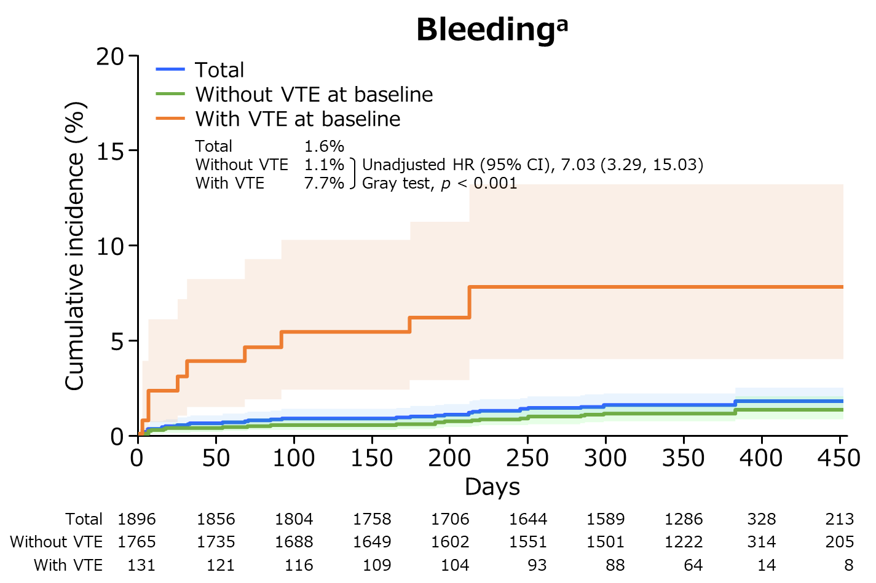
(b)
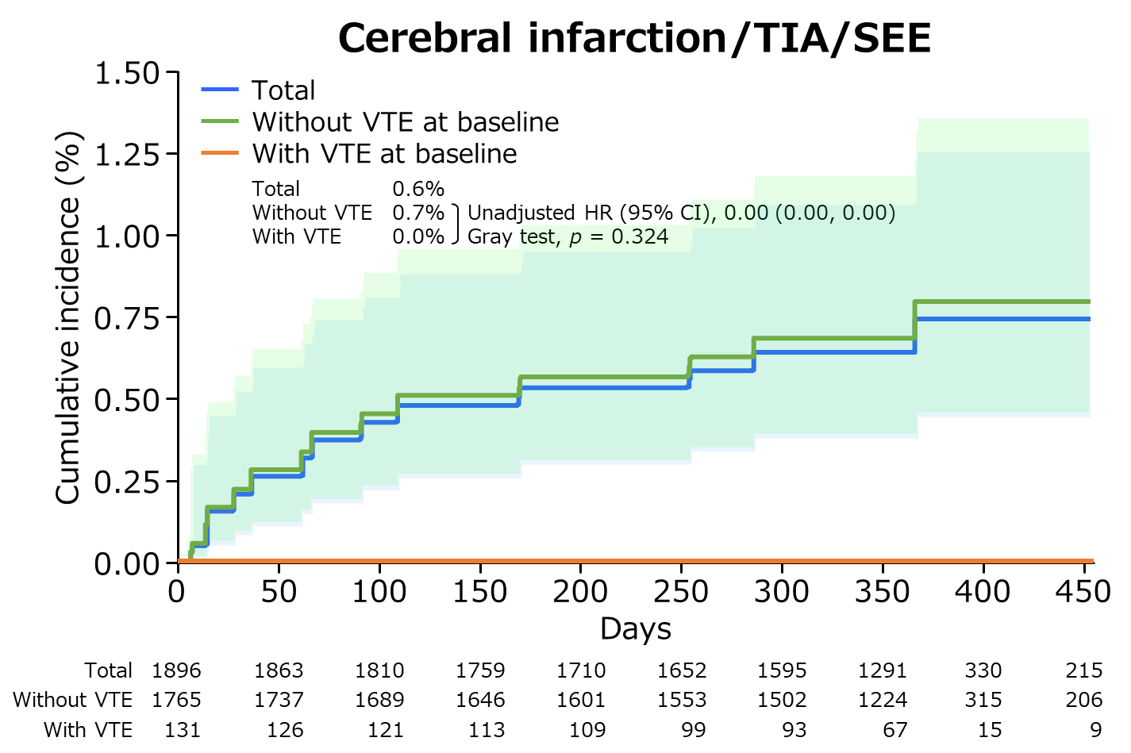
Online Resource 3 Cumulative incidence of events (time-to-event analysis). (a) bleeding events, and (b) cerebral infarction/TIA/SEE.
The Gray test was used to calculate p values. Lightly shaded areas represent 95% CIs.
ªIncluded major bleeding and clinically relevant non-major bleeding events.
CI confidence interval, HR hazard ratio, SEE systemic embolic event, TIA transient ischemic attack, VTE venous thromboembolism.

Online Resource 4. Univariable analysis of risk factors for composite VTE during the follow-up period
Factor |  | N | Events,  n (%) | Univariable
 |  |  |  | HR | 95% CI | p value
Sex | Male | 1,287 | 14 (1.1) | Ref | - | -
 | Female | 609 | 12 (2.0) | 1.84 | 0.85–3.97 | 0.123
Age, years | < 65 | 483 | 8 (1.7) | Ref | - | -
 | ≥ 65 | 1,413 | 18 (1.3) | 0.77 | 0.34–1.78 | 0.545
CrCL, mL/min | > 50 | 1,486 | 19 (1.3) | Ref | - | -
 | ≤ 50 | 364 | 2 (0.5) | 0.44 | 0.10–1.89 | 0.270
Bed rest for 4 days or more | No | 1,872 | 26 (1.4) | Ref | - | -
 | Yes | 24 | 0 (0.0) | <0.01 | <0.01–<0.01 | <0.001
History of VTE | No | 1,878 | 25 (1.3) | Ref | - | -
 | Yes | 18 | 1 (5.6) | 4.28 | 0.55–33.00 | 0.164
ECOG PS | 0 | 1,396 | 17 (1.2) | Ref | - | -
 | 1 | 420 | 7 (1.7) | 1.37 | 0.57–3.29 | 0.480
 | 2 | 80 | 2 (2.5) | 2.19 | 0.51–9.44 | 0.294
Occurrence of tumor | Primary | 1,852 | 24 (1.3) | Ref | - | -
 | Recurrence | 44 | 2 (4.5) | 3.52 | 0.83–14.97 | 0.088
Lymph node metastasis | No | 635 | 11 (1.7) | Ref | - | -
 | Yes | 1,261 | 15 (1.2) | 0.69 | 0.32–1.51 | 0.354
Distant metastasis | No | 1,529 | 18 (1.2) | Ref | - | -
 | Yes | 367 | 8 (2.2) | 1.86 | 0.81–4.28 | 0.143
Platelet count, 10⁹/L | < 350 | 1,523 | 19 (1.2) | Ref | - | -
 | ≥ 350 | 327 | 2 (0.6) | 0.49 | 0.11–2.10 | 0.336
Hb, g/dL | ≥ 10 | 1,461 | 17 (1.2) | Ref | - | -
 | < 10 | 389 | 4 (1.0) | 0.89 | 0.30–2.65 | 0.836
WBC count,  10⁹/L | ≤ 11 | 1,787 | 20 (1.1) | Ref | - | -
 | > 11 | 63 | 1 (1.6) | 1.46 | 0.20–10.93 | 0.711
D-dimer, μg/mL | ≤ 1.2 | 1,196 | 14 (1.2) | Ref | - | -
 | > 1.2 | 450 | 10 (2.2) | 1.95 | 0.87–4.39 | 0.106
Variables presented in this table were not used in the multivariate analysis of risk factors for composite VTE during the follow-up period.
CI confidence interval, CrCL creatinine clearance, ECOG PS Eastern Cooperative Oncology Group performance status, Hb hemoglobin, HR hazard ratio, Ref reference, VTE venous thromboembolism, WBC white blood cell

