Supplementary Data

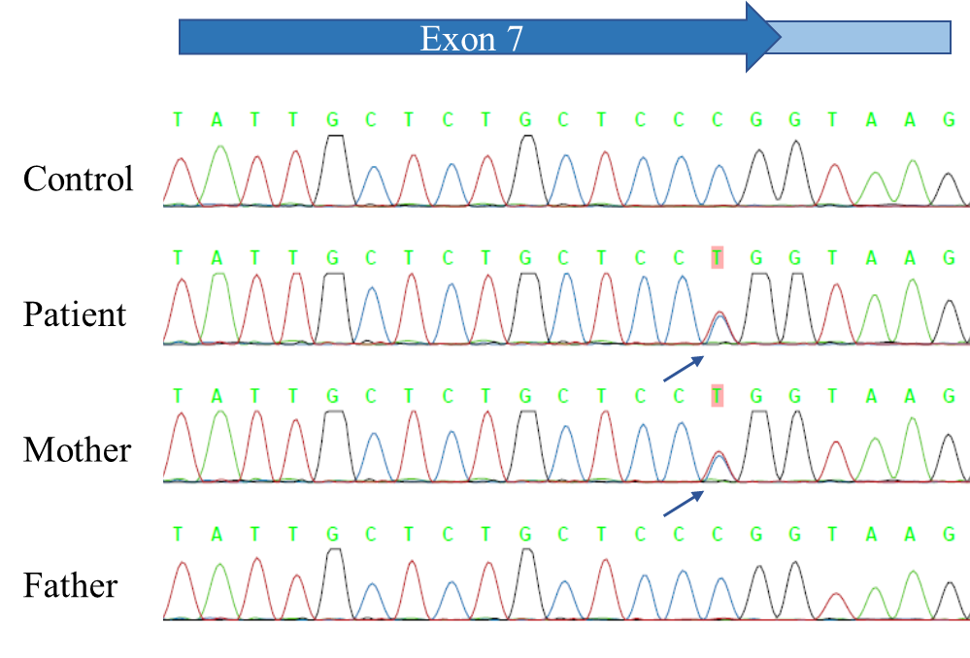

Supplementary Figure 1. Sequence results
In the sequences of both the patient and his mother, a COQ6 gene (NM_0182476.2) (c.782 C>T) [p.(Pro261Leu)] mutation was detected. This mutation has previously been reported.

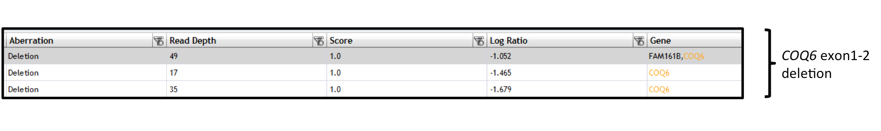
Supplementary Figure 2. Pair analysis results of the patient using targeted sequence data
Upon calculation with the SureCall application, calling of exons 1 and 2 in the COQ6 gene was performed. The log ratio of the region was under −1. We thus suspected that, in this region, the patient had one allele.

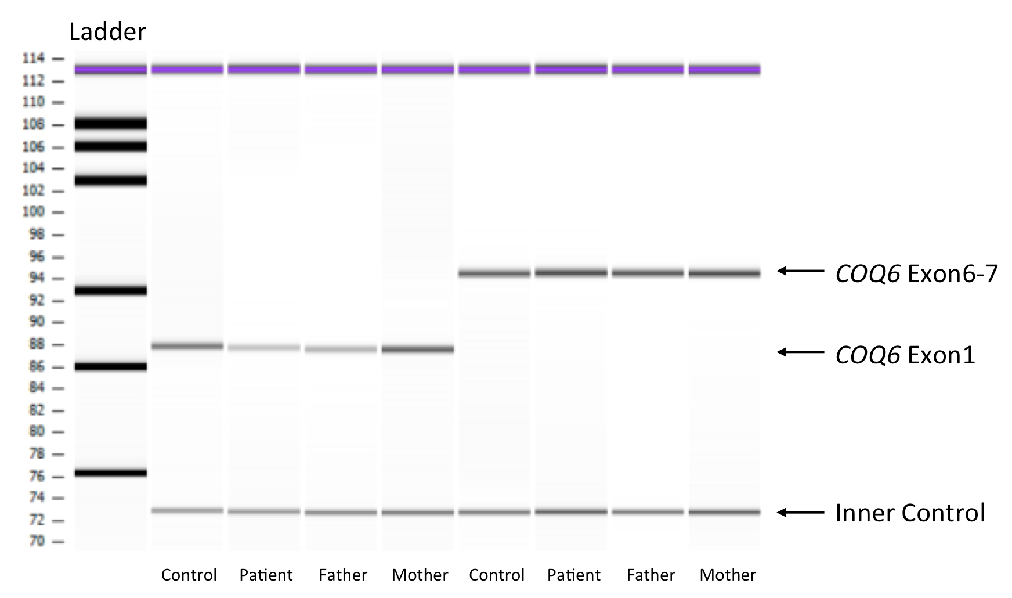

Supplementary Figure 3. Semi-qPCR results of the patient
Semi-qPCR showed that the bands of the patient and his father representing COQ6 exon 1 were weaker than the other bands. The quantitative ratios (relative to the internal control) were 0.49 (the patient) and 0.49 (his father), while for almost all of the other bands, the quantitative ratio was almost 1.0. Thus, both the patient and his father had a large heterozygous deletion in exon 1 of COQ6.

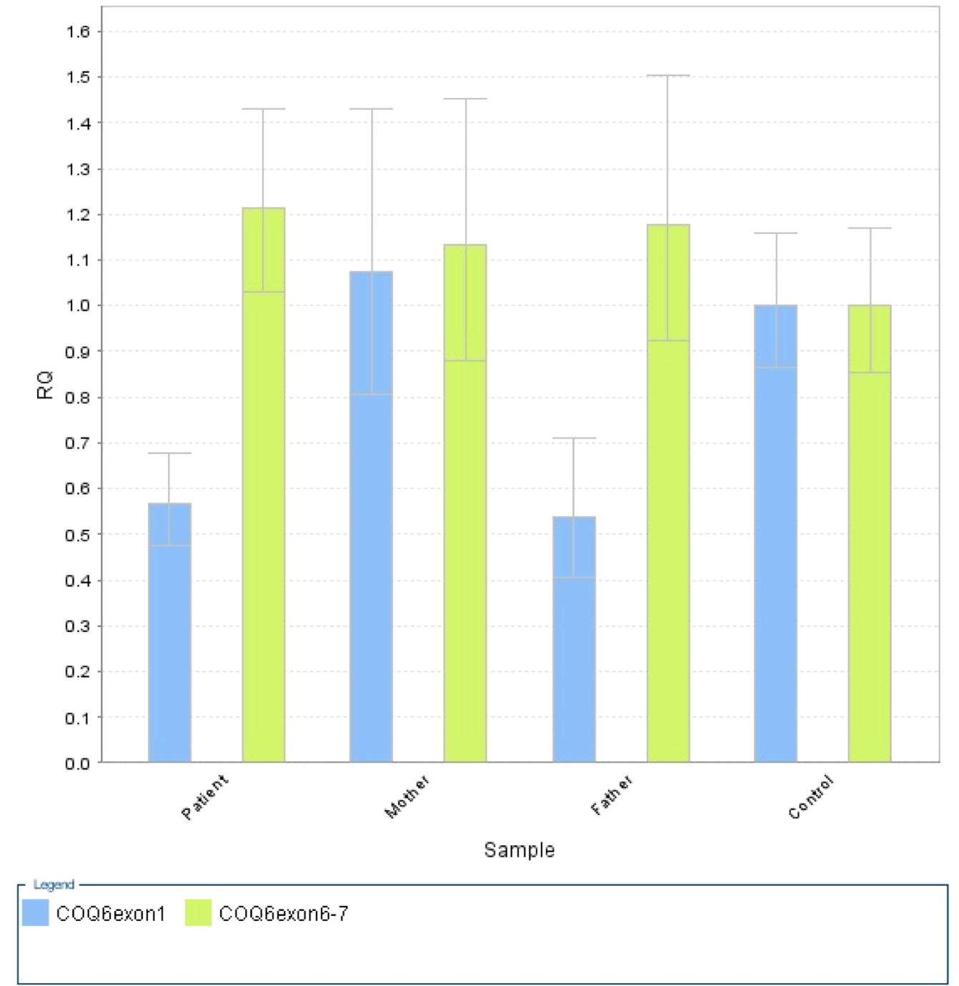
Supplementary Figure 4. Quantitative PCR results of the patient
qPCR showed that the signals in the patient and his father representing COQ6 exon 1 were weaker than those in his mother and the control. The quantitative ratio (relative to the internal control) was almost half., while for almost all of the other exons, the quantitative ratio was almost 1.0. Thus, both the patient and his father had a large heterozygous deletion in exon 1 of COQ6.

Supplemental Table S1 Gene list for the targeted sequencing

