Appendix
Table A1: Search terms.

Figure A1: Study selection flowchart of randomized controlled trials
Figure A2: League plot of different treatment regimens for the primary efficacy outcome from the network meta-analysis
Figure A3: League plot of different treatment regimens for 50% response rates from the network meta-analysis
Figure A4: League plot of different treatment regimens for 75% response rates from the network meta-analysis
Figure A5: League plot of different treatment regimens for the primary safety outcome from the network meta-analysis
Figure A6: League plot of different treatment regimens for the secondary safety outcome from the network meta-analysis
Figure A7. Risk of bias summary of included trials.
Figure A8: Risk of bias graph of included trials.
Figure A9: GRADE summary for the primary outcomes.

Table A1: Search Strategy

OVID Medline (adapted for other databases)
1 | exp Migraine Disorders/
2 | (Migraine* OR Migraine Headache* OR Sick Headache* OR Disorder*, Migraine* OR Headache*, Migraine*).ab,kw,ti
3 | 1 or 2
4 | (eptinezumab OR ALD403).mp
5 | (Galcanezumab OR LY2951742).mp
6 | (erenumab OR AMG334).mp
7 | (fremanezumab OR TEV-48125).mp
8 | 4 or 5 or 6 or 7
9 | 3 and 8
10 | exp randomized controlled trial/
11 | exp controlled clinical trial/
12 | (randomly OR randomized OR placebo OR trial OR groups).ab,kw,ti
13 | 10 or 11 or 12
14 | exp animals/
15 | exp human/
16 | 14 not 15
17 | 13 not 16
18 | 9 and 17

Figure A1: Study selection flowchart of randomized controlled trials

Figure A2: League plot of different treatment regimens for the primary efficacy outcome from the network meta-analysis

Figure A3: League plot of different treatment regimens for 50% response rates from the network meta-analysis

Figure A4: League plot of different treatment regimens for 75% response rates from the network meta-analysis

Figure A5: League plot of different treatment regimens for the primary safety outcome from the network meta-analysis

Figure A6: League plot of different treatment regimens for the secondary safety outcome from nine-node network meta-analysis

Figure A7. Risk of bias summary of included trials.

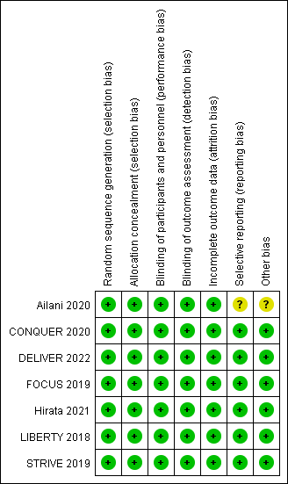

Figure A8: Risk of bias graph of included trials.

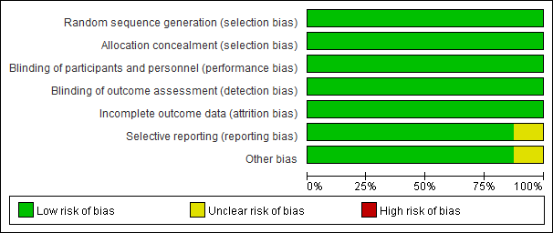

Figure A9: GRADE summary for the primary outcomes.

