Docking to COX-2 (PDB: 4COX)
Compound | 2D interactions diagram | Vina score [kcal/mol]
Dexamethasone | 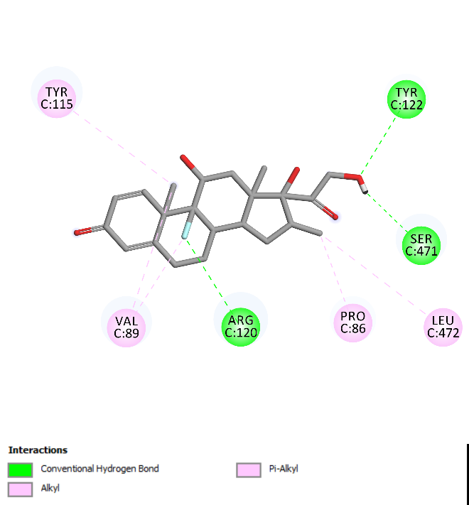 | -8.7
Betulin | 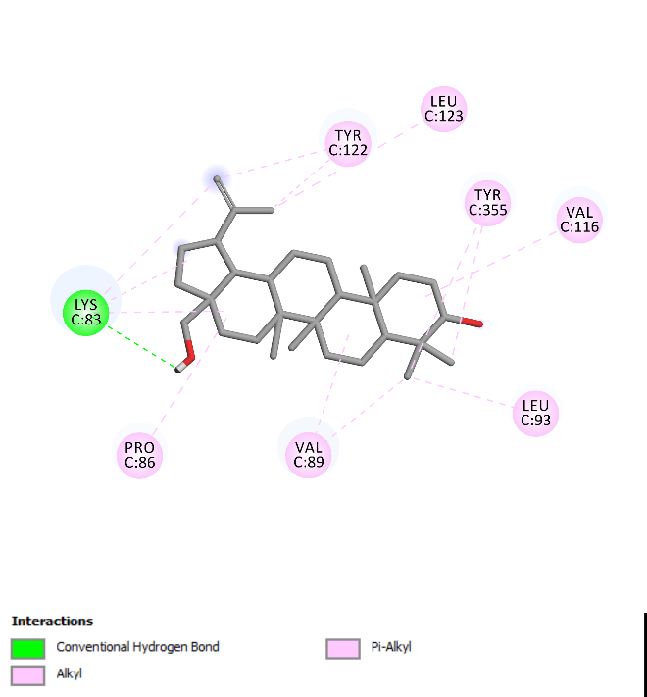 | -8.0
Betulinic acid | 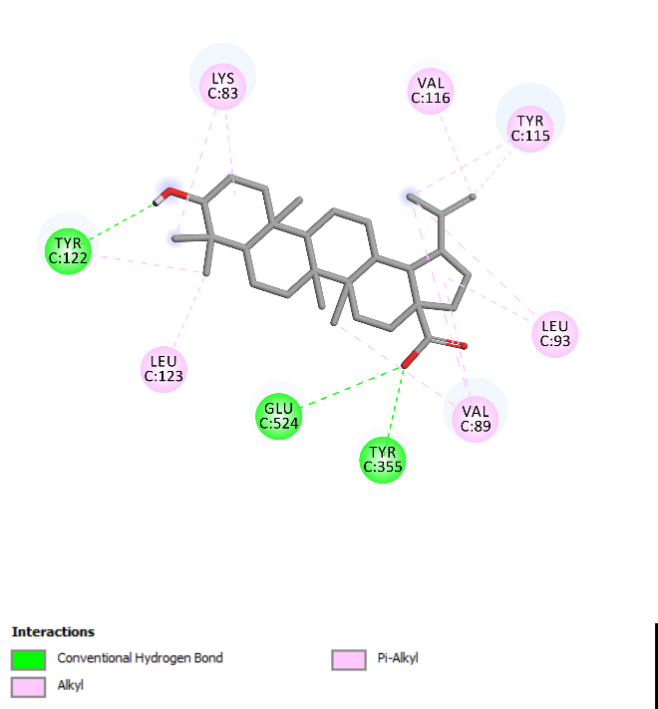 | -8.4
BE-Dab-NH₂ | 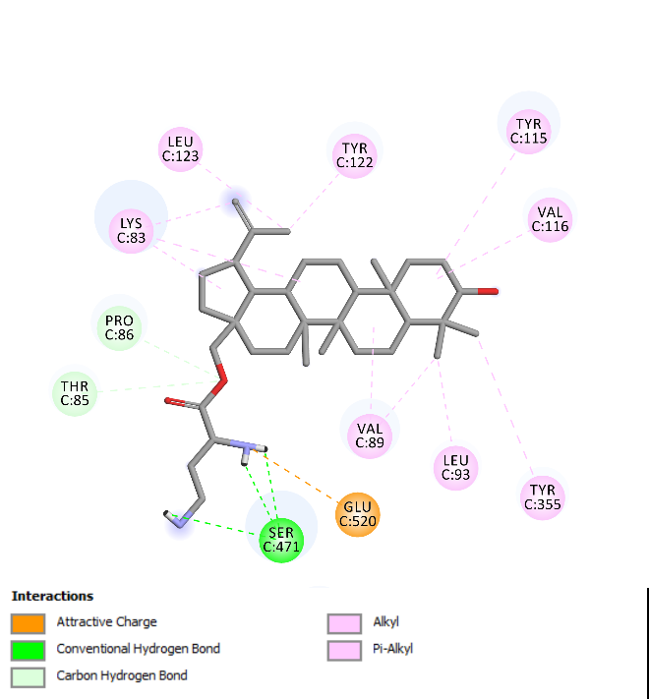 | -7.6
BE-Dap-NH₂ | 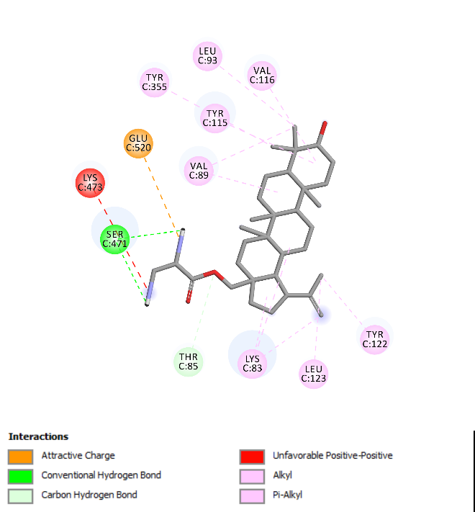 | -7.7
BE-Orn-NH₂ | 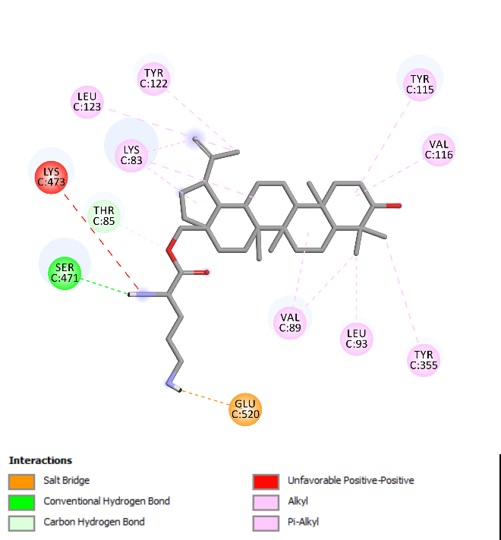 | -7.7
BE-Lys-NH₂ | 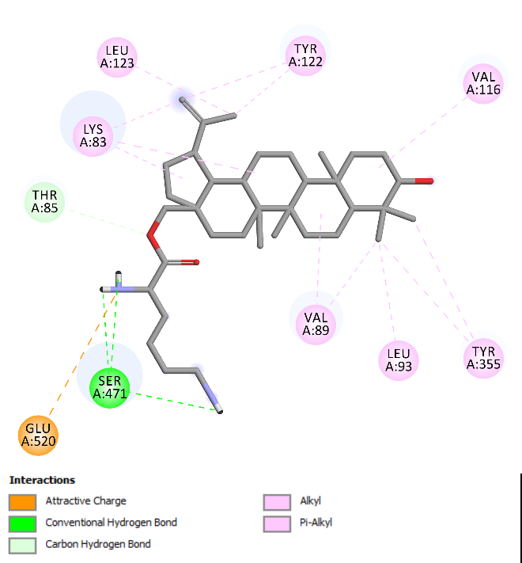 | -7.6
Indomethacin | 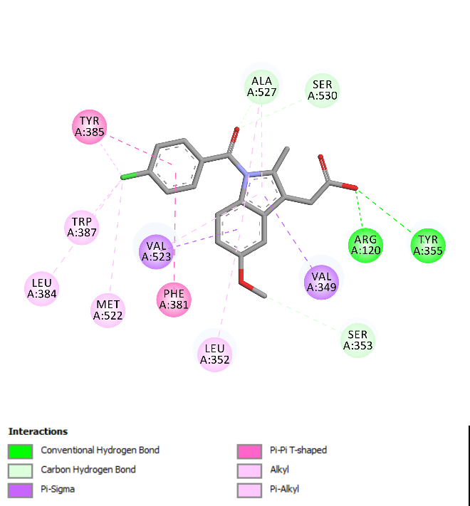 | -8.7

