Online Supplemental Material 2 - Clinician Provided Documentation
Bedside practitioners were tasked to assess the need for corrective intervention based on their evaluation of patient-ventilator asynchrony. As clinicians trained in providing critical care to patients they were expected to understand patient-ventilator asynchrony and its effects. Prior to making a clinical assessment of the perceived patient-ventilator asynchrony all practitioners were given instructional documentation. The instructional documentation included a summary of the manuscript by Thille et al.¹ A second instructional documentation was included with illustrative examples of patient-ventilator asynchrony categories separated into the three categories of patient-ventilator asynchrony used in this study. The waveform examples came from the data in the development phase of the project. The waveform examples illustrate the pressure and flow waveform data as well as the patient-ventilator asynchrony category as assigned by the panel of experts.

References
- Thille AW, Rodriguez P, Cabello B, Lellouche F, Brochard L. Patient-ventilator asynchrony during assisted mechanical ventilation. Intensive Care Med. 2006 Oct;32(10):1515-22.

Figure 2: Facemask pressure, flow, and tidal volume waveforms used to exemplify patient breathing asynchrony and their respective categories for the suggested need of clinical intervention.

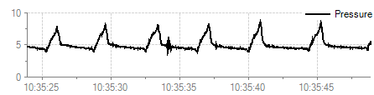
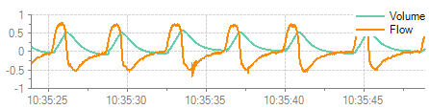
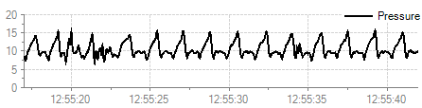
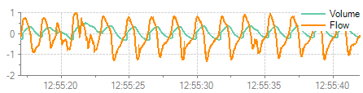
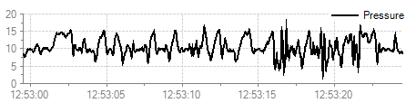
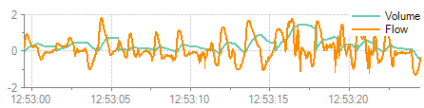
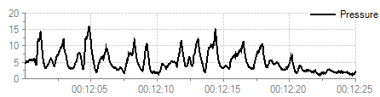
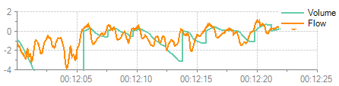
Figure 2:

Mild patient-ventilator asynchrony
- Occasional missed triggers or short-term irregular breathing patterns
- Asynchrony does not require altering care

No patient-ventilator asynchrony
- Ventilator appears to match the patient
- Asynchrony does not need to be addressed

Rank 2

Moderate patient-ventilator asynchrony
- Apparent mismatch between patient and ventilator
- Asynchrony should be addressed

Rank 3

Severe patient-ventilator asynchrony
- Difficult to detect breathing
- Appears to be potential problems obtaining sufficient ventilation
- Asynchrony is severe requiring intervention

Category 1
Category 2
Category 3

