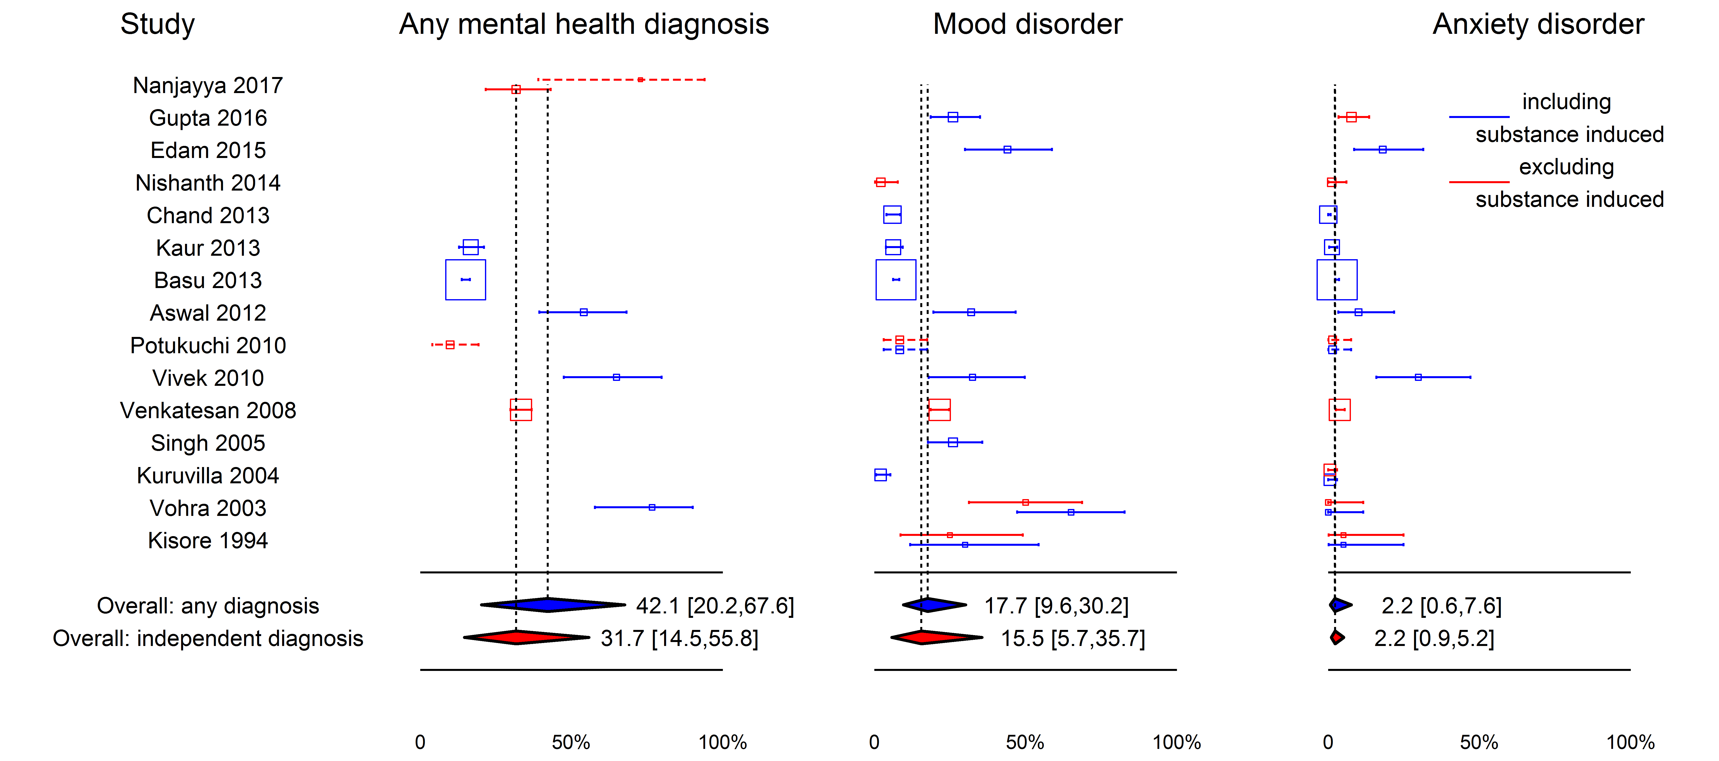
Supplementary Figure 1. Random-effects model quantifying estimated overall rates of diagnosis of any mental health disorder, any mood disorder, and any anxiety disorder in Indian individuals with any AUD, broken up by assessments that explicitly exclude substance-induced disorders (red lines and polygons) and those that include substance-induced disorders or do not specify (blue lines and polygons). Horizontal axis gives percent in population receiving the appropriate diagnosis; error bars indicate 95% confidence interval. Point estimates of diagnosis rates are shown with a square whose area is proportional to the square root of the sample size.

