Supplementary Appendix

Figure 1: Egger’s Tests for small-study effects:

Surgical Studies
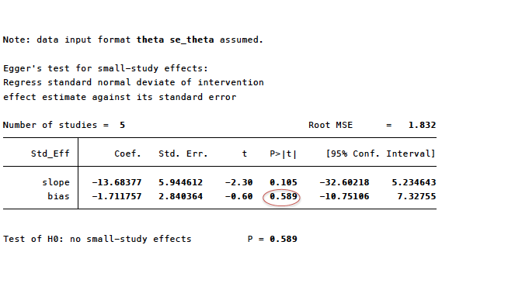
Non-surgical studies
