Supplementary Appendix
Figure 2: Funnel plots for publication bias

Surgical studies

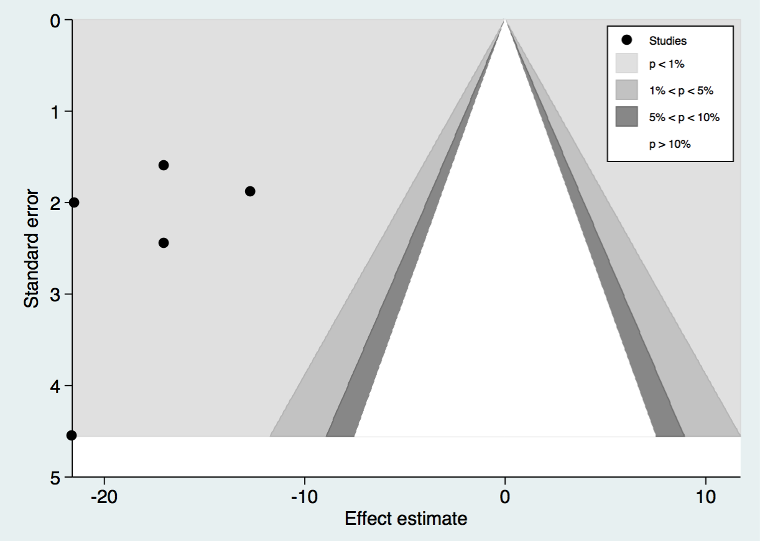

Non-surgical studies

