Supplementary Material I

Supplementary material. Process map of the clinic.

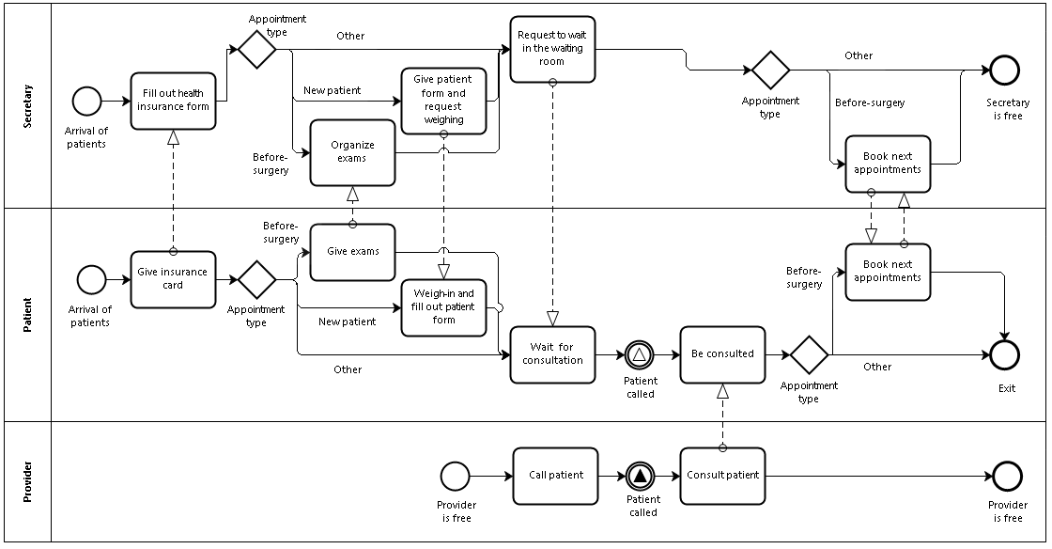
The patient flow starts with the patient’s arrival, which can be punctual or not. The administrative staff asks the patients for their insurance card. On their first visit, the patients need to fill out the patient form. If the patients are a before-surgery return, they have to give the exams to the secretary. After that, the patient is requested to wait for consultation. The provider calls the patients based on the scheduled order. The consultation time has different behaviors for each patient type.

