A
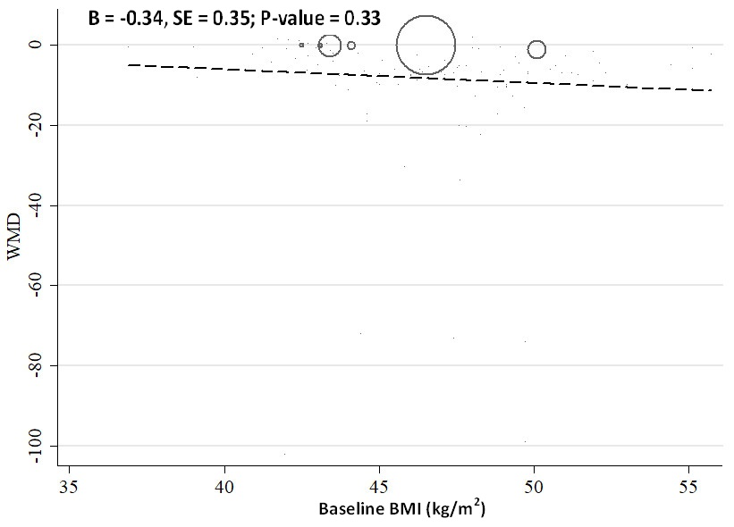
B
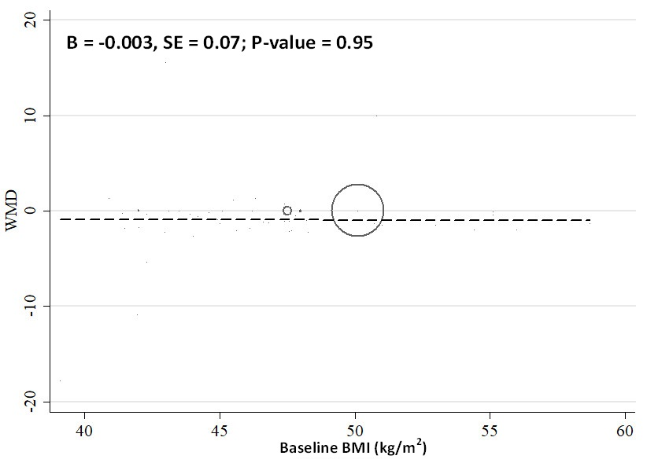
C
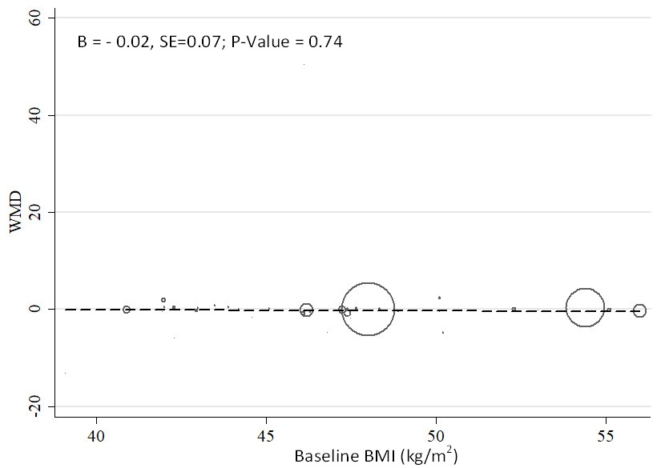
Supplemental Figure 4: Random-effects meta-regression plots of the association between baseline BMI (kg/m²) and means of (A) CRP, (B) IL-6, (C) and TNF-α.

