Supplementary Material
Pharmacokinetics and Safety of Vortioxetine in the Chinese Population
Journal: Advances in Therapy
Jia Miao, Gang Wang, Jie Hou, Johan Areberg, Yan Zhao, Astrid-Maria Højer, Anders Ettrup Corresponding Author: Jia Miao
West China Hospital, Sichuan University, Chengdu, China
Email: miaosiyi1971@163.com

Supplementary Methodology
Assessment of Goodness-of-Fit
Diagnostic plots of the observed versus predicted dependent variable, conditional weighted residuals versus the predicted dependent variable, conditional weighted residuals versus time, individual weighted residuals versus the predicted dependent variable, histograms of conditional weighted residuals, and Q-Q plot of the conditional weighted residuals were used to assess the goodness-of-fit. In addition, the standard errors of the estimated parameter values given by NONMEM®, and the confidence intervals for the interindividual variability, and the residual errors were checked.
Predictability
The normalized prediction distribution error (NPDE) estimated using NONMEM® was used to assess predictability. A model describes the data well when the predicted discrepancies are evenly distributed. Prediction distribution errors are obtained after de-correlation of both the observations and the simulated Y with respect to the empirical mean and variance obtained in the simulations. They are then normalized by using the inverse of the cumulative density function of N(0, 1). The distribution of the NPDE values was investigated graphically to determine whether they could be described by an N(0, 1) distribution. Prediction-corrected visual predictive check plots were constructed to evaluate model predictability. The 95% confidence intervals (2.5% and 97.5% percentiles) of simulated concentrations were plotted together with prediction-corrected observed concentrations after single dosing. The shrinkage, estimated using NONMEM® for the individually estimated concentrations (epsilon shrinkage) and parameters (eta shrinkage), was investigated. Although no formal criterion exists, a maximum value of 20% was used to conclude “no shrinkage.”

Supplementary Figures and Legends

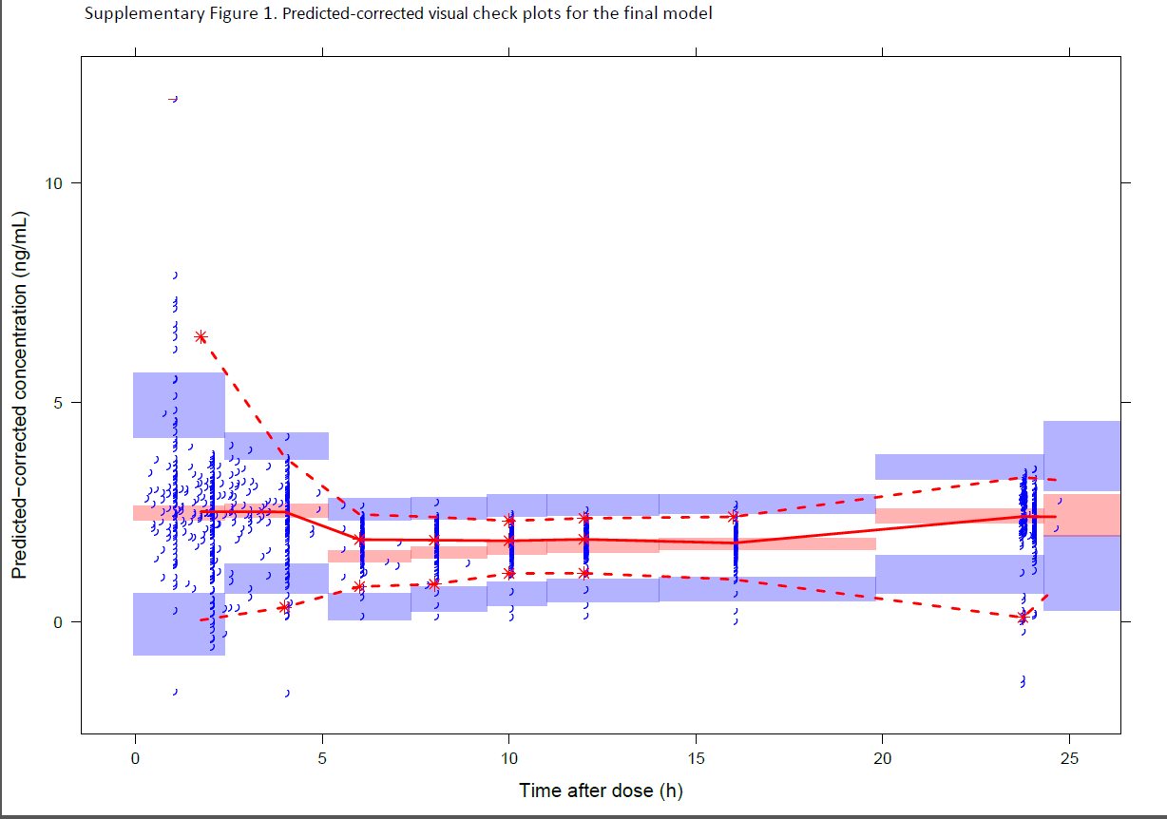

Supplementary Fig. S1 Predicted-corrected visual check plots for the final model.
The solid red line represents the median observed plasma concentration (prediction-corrected); the semitransparent red field represents the simulation-based 95% confidence interval for the median. The observed 5% and 95% percentiles are presented with dashed red lines, and the 95% confidence intervals for the corresponding model-predicted percentiles are shown as semitransparent blue fields. The observed plasma concentrations (prediction-corrected) are represented by blue arcs.

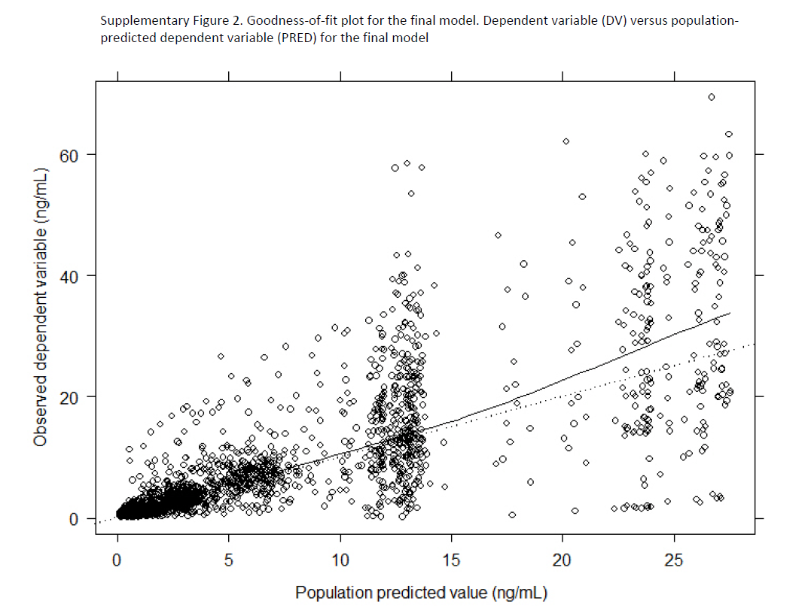
.

Supplementary Fig. S2 Goodness-of-fit plot for the final model.
Dependent variable versus population-predicted dependent variable for the final model. Solid lines represent trend lines; dotted lines represent unity lines.

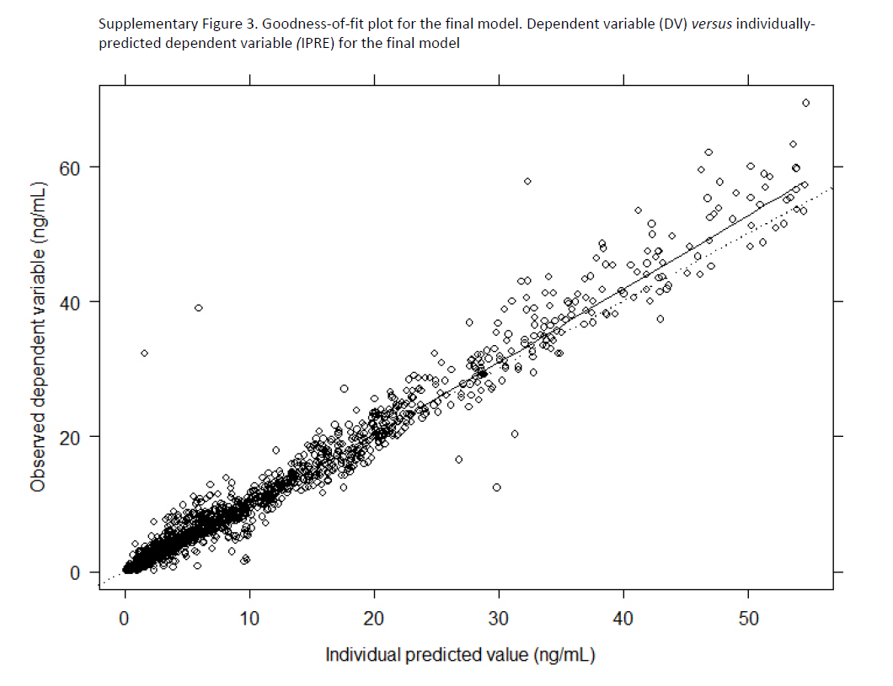

Supplementary Fig. S3 Goodness-of-fit plot for the final model.
Dependent variable versus individually predicted dependent variable for the final model. Solid lines represent trend lines; dotted lines represent unity lines.

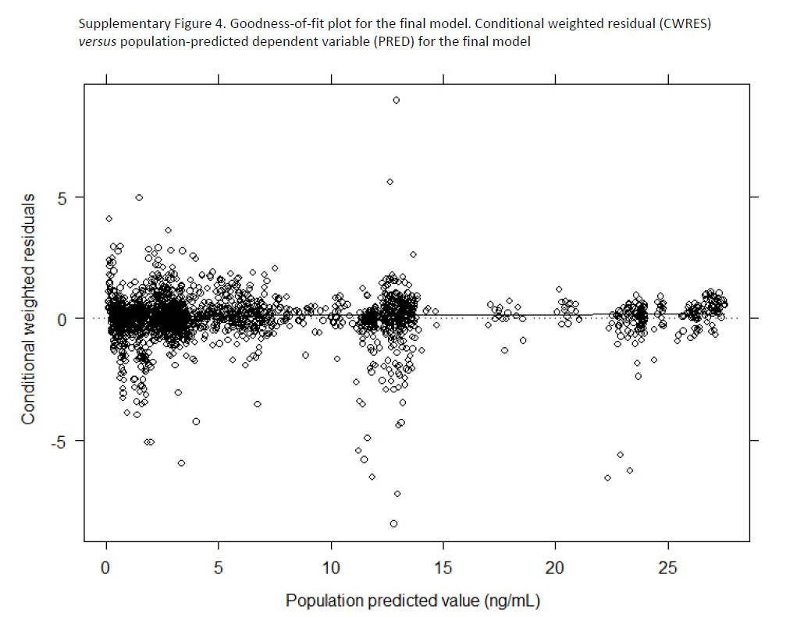

Supplementary Fig. S4 Goodness-of-fit plot for the final model.
Conditional weighted residual versus population-predicted dependent variable for the final model. Solid lines represent trend lines; dotted lines represent unity lines.

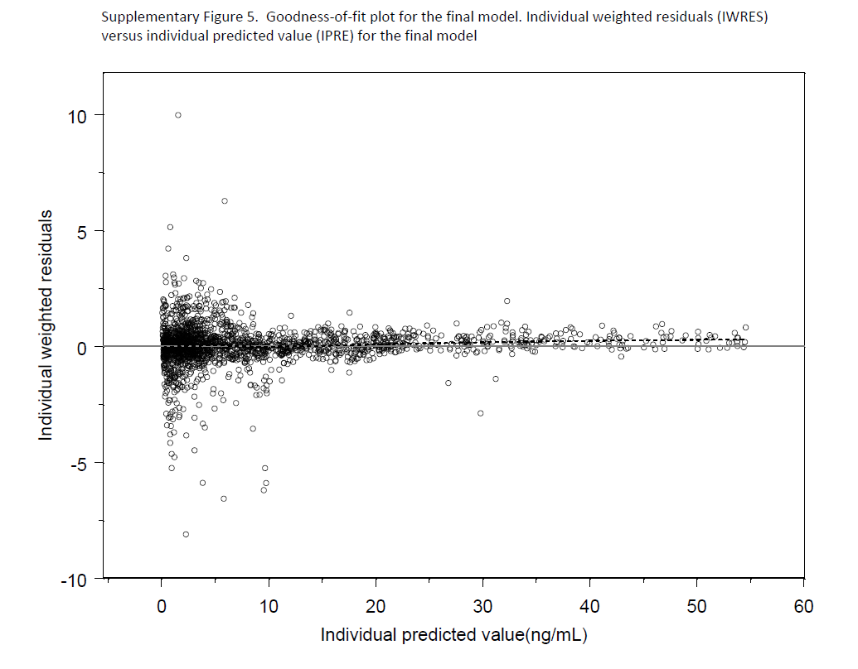

Supplementary Fig. S5 Goodness-of-fit plot for the final model.
Individual weighted residuals versus individual predicted value for the final model. Solid lines represent trend lines; dotted lines represent unity lines.

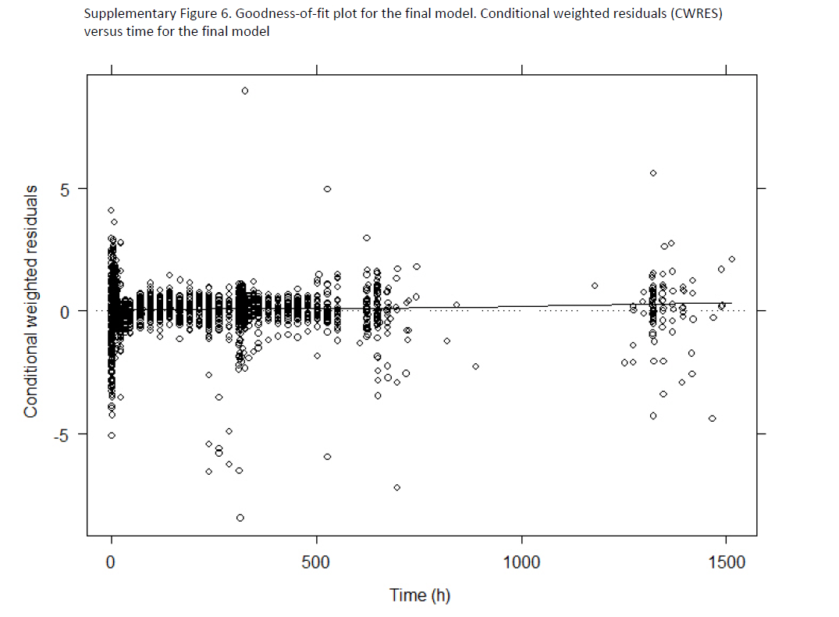

Supplementary Fig. S6 Goodness-of-fit plot for the final model.
Conditional weighted residuals versus time for the final model. Solid lines represent trend lines; dotted lines represent unity lines.

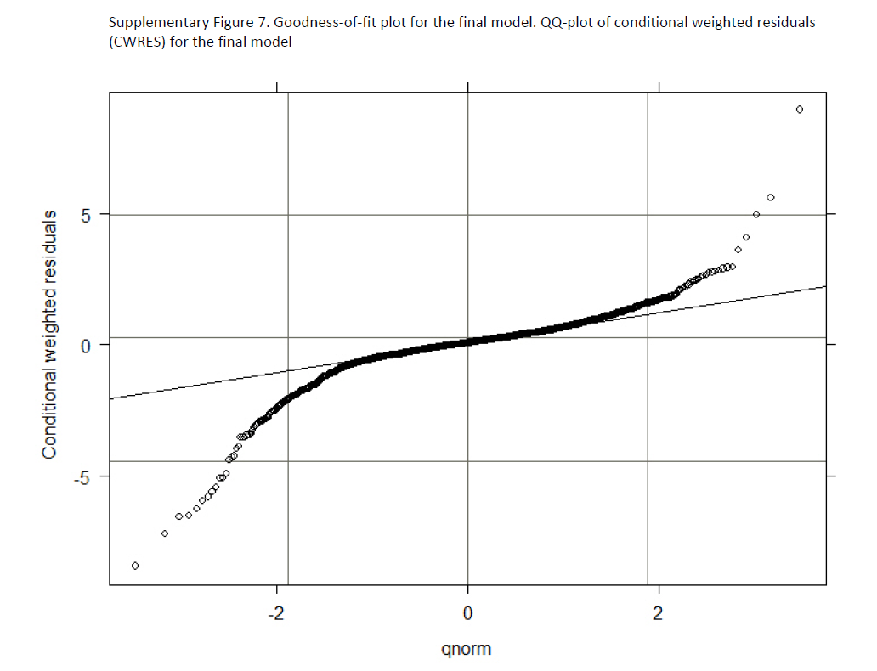

Supplementary Fig. S7 Goodness-of-fit plot for the final model.
Q-Q plot of conditional weighted residuals for the final model. Solid lines represent trend lines; dotted lines represent unity lines.

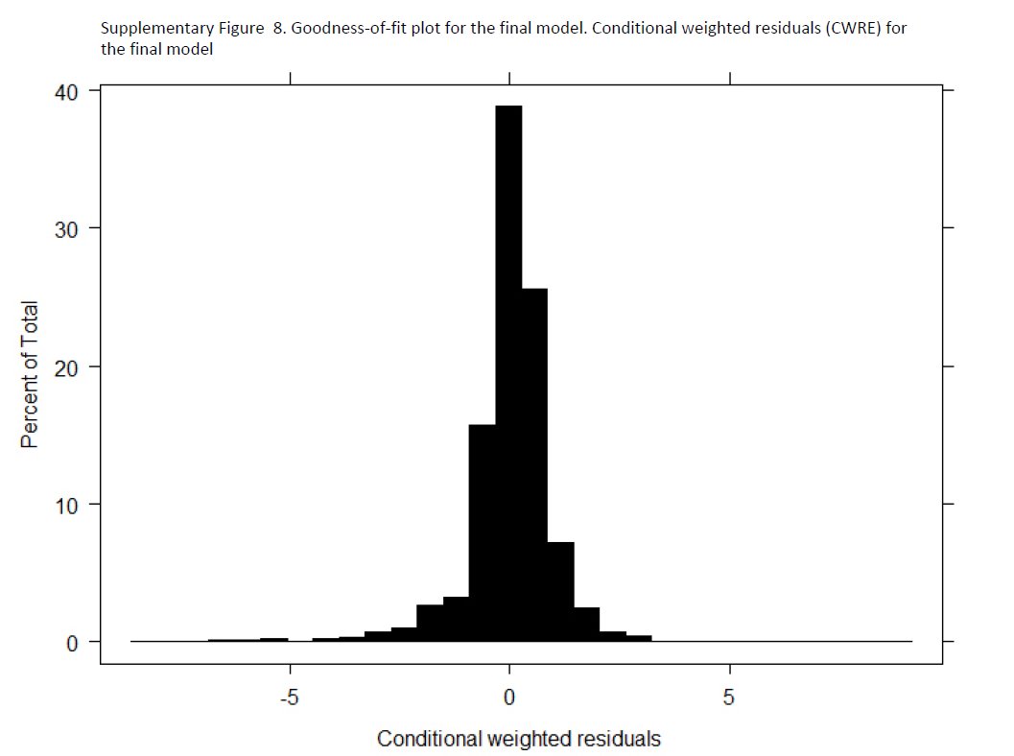

Supplementary Fig. S8 Goodness-of-fit plot for the final model.
Conditional weighted residuals for the final model.

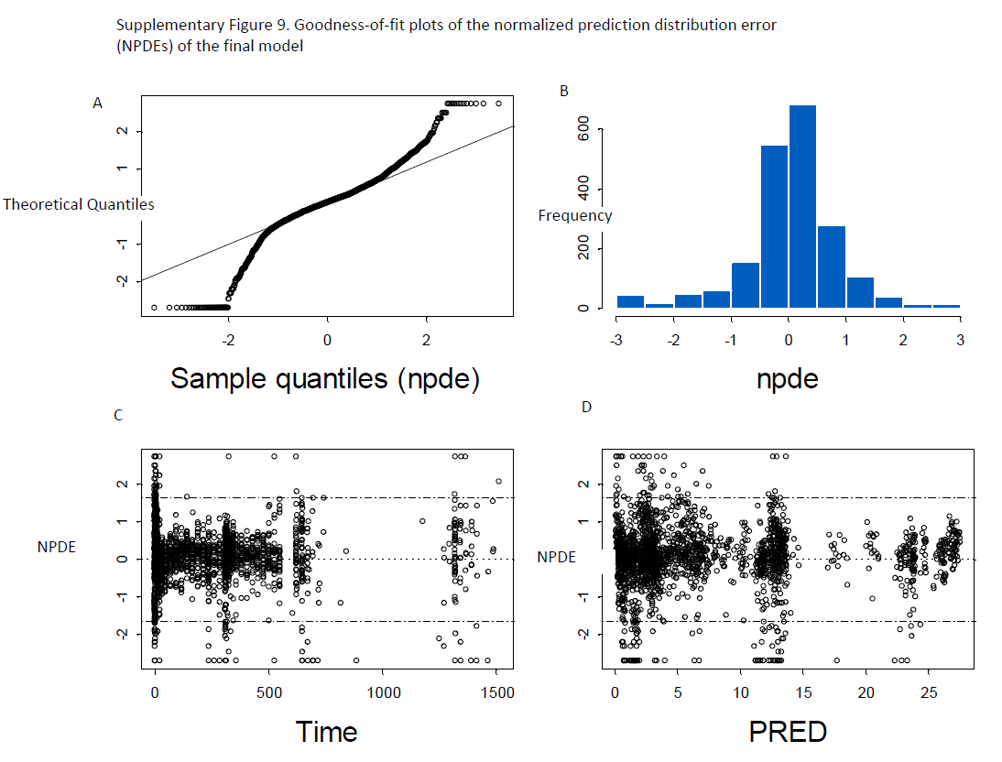

Supplementary Fig. S9 Goodness-of-fit plots of the NPDE.
NPDEs of the final model: (A) Q-Q plot of the NPDE, (B) histogram of the NPDE, (C) NPDE versus time after the first dose, (D) NPDE versus PRED. NPDE, normalized prediction distribution errors; PRED, population-predicted concentration.

