Supplemental Figure 1. Modified Algorithm to Identify Patients

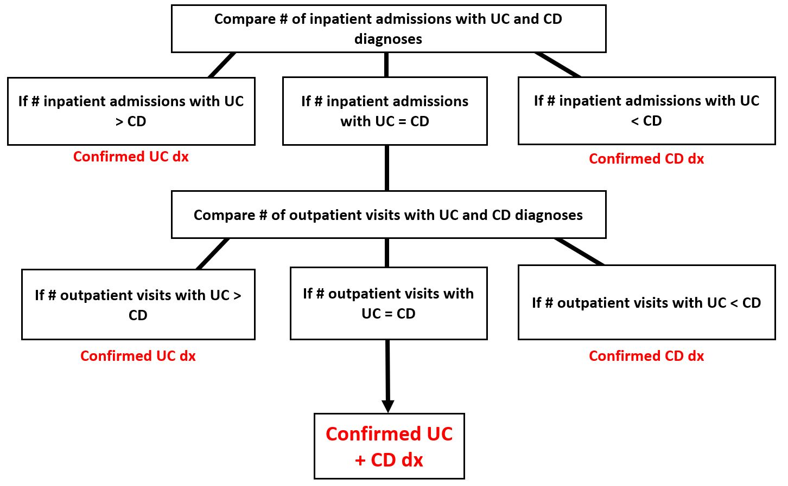
CD: Crohn's disease; Dx: diagnosis; UC: ulcerative colitis.

