Figure S1. Markov states.

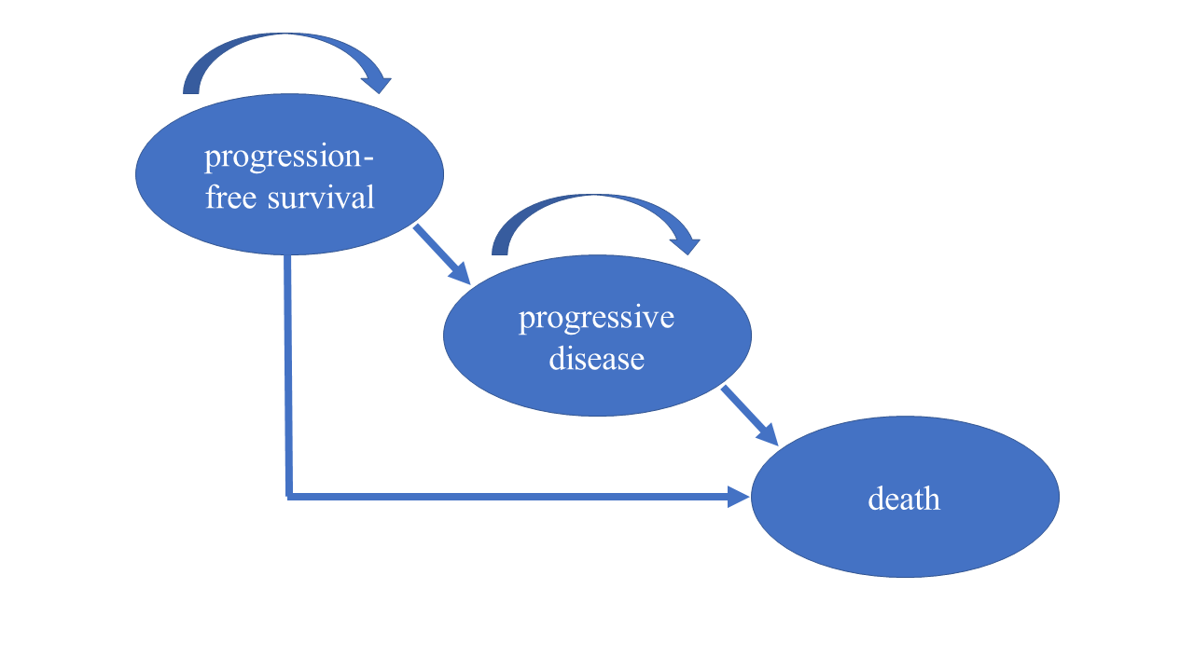
Used to illustrate the disease development process of metastatic NSCLC.

Figure S2. Reconstructed Kaplan-Meier survival curves along with ﬁtted Weibull survival curves for OS and PFS for the atezolizumab plus chemotherapy and chemotherapy arms. Internal model validation.
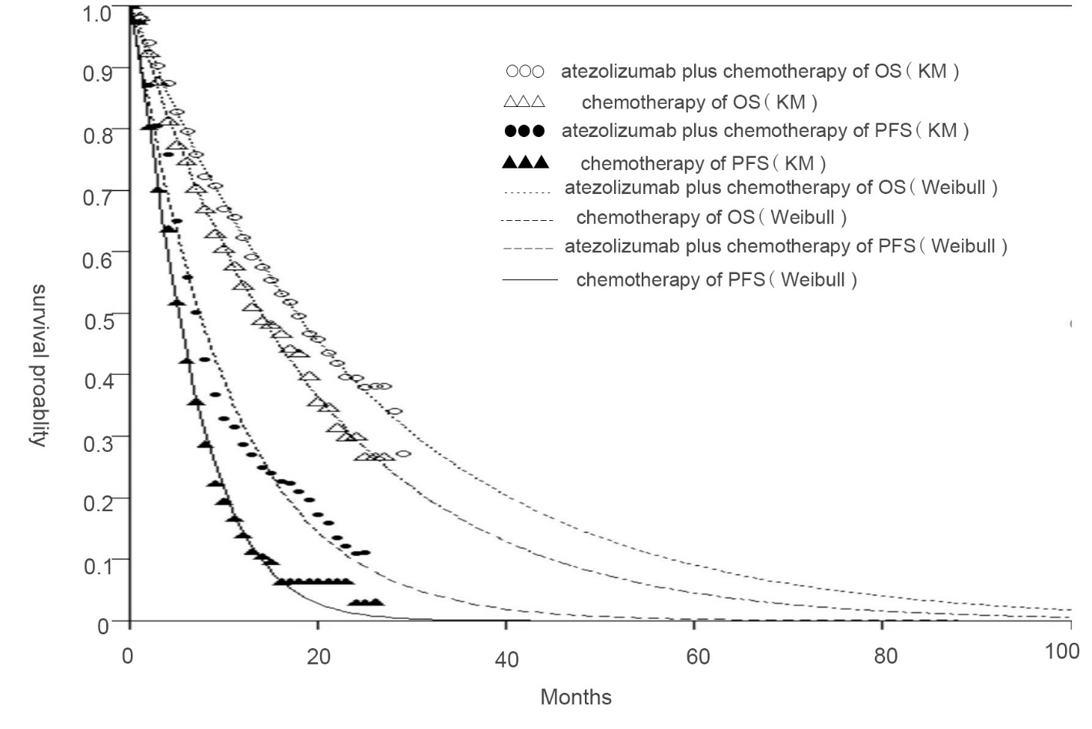
Abbreviation: OS, overall survival; PFS, progression-free survival; KM, Kaplan-Meier.

Figure S3. The results of Monte Carlo probabilistic sensitivity analysis.
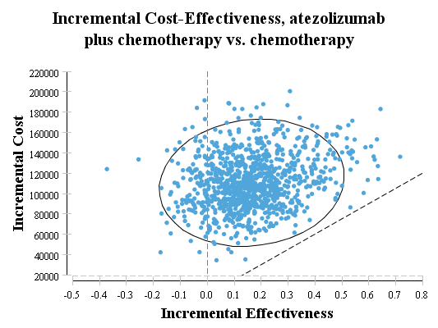

Table S1. Results of subgroup analyses.
Subgroup | PFS HR (95% CI) | OS HR (95% CI) | ICER per QALY (95% CI) | Cost-effectiveness probability at WTP $150 000/QALY
Sex
Female | 0.59(0.45-0.78) | 0.66(0.46-0.93) | 488404.58(386453.12-2507557.45) | 0
Male | 0.67(0.54-0.85) | 0.87(0.66-1.15) | 1034303.78(495352.29-(-217927.49)) | 0
Age
＜65 years | 0.64(0.5-0.82) | 0.79(0.58-1.08) | 681526.79(439881.55-(-495094.80)) | 0
≥65 years | 0.64(0.5-0.82) | 0.78(0.58-1.05) | 657330.99(439881.55-(-732146.93)) | 0
ECOG PS
0 | 0.59(0.44-0.78) | 0.85(0.59-1.22) | 894944.91(455661.45-(-133526.05)) | 0
1 | 0.68(0.54-0.86) | 0.77(0.58-1.00) | 631486.93(434236.51-(-1682526.51)) | 0
Tobacco use history
Never | 0.63(0.35-1.12) | 0.55(0.26-1.19) | 405707.81(336453.83-(-55072.44)) | 0.2%
Current or previous | 0.64(0.53-0.77) | 0.81(0.65-1.02) | 738129.83(487700.,67-(-1434018.73)) | 0
No liver metastasis at enrolment | 0.59(0.49-0.71) | 0.73(0.57-0.92) | 570682.99(435169.68-1821413.62) | 0
Liver metastasis at enrolment | 0.93(0.59-1.47) | 1.04(0.63-1.72) | - 645551.24(462623.30-（-785797.41)) | 0
PD-L1-high | 0.51(0.34-0.77) | 0.84(0.51-1.39) | 843183.26(427320.85-（-430438.24)） | 0
PD-L1-low | 0.61(0.43-0.85) | 0.70(0.45-1.08) | 528090.68(385276.07-(-460420.55)) | 0
PD-L1-negative | 0.72(0.56-0.91) | 0.81(0.61-1.08) | 735111.34(451589.34-(-400367.92)) | 0
Abbreviation: CI, confidence interval; ICER, incremental cost-effectiveness ratio; LY, life-year; OS HR, overall survival hazard ratio; PFS HR, progression-free survival hazard ratio; ECOG PS, Eastern Cooperative Oncology Group performance status; PD-L1, programmed death ligand 1; QALY, quality-adjusted life-year; WTP, Willingness-to-pay.

