Title
Real-world bleeding and ischemic events in Asian patients on P2Y12 inhibitors after percutaneous coronary intervention: A national claims data analysis
Authors:
Yonggu Lee MD PhD^{1*}, Young-Hyo Lim MD PhD^{1*}, Yongwhi Park MD PhD², Jinho Shin MD PhD¹
¹Division of Cardiology, College of Medicine, Hanyang University, Seoul, Republic of Korea
²Department of Internal Medicine, Gyeongsang National University School of Medicine and Gyeongsang National University Changwon Hospital, Changwon, Republic of Korea

Complete author information:
*Yonggu Lee, MD, PhD.; Co-First author
Division of Cardiology, Department of Internal Medicine, College of Medicine, Hanyang University
222 Wangsimni-ro, Seongdong-gu, Seoul 133-792, Republic of Korea
E-mail: hmedi97@naver.com
*Young-Hyo Lim, MD, PhD.; Co-First author
Division of Cardiology, Department of Internal Medicine, College of Medicine, Hanyang University
222 Wangsimni-ro, Seongdong-gu, Seoul 133-792, Republic of Korea
E-mail: mdoim@hanmail.net
Yongwhi Park, MD, PhD.
Department of Internal Medicine, Gyeongsang National University School of Medicine and Gyeongsang National University Changwon Hospital
11, Samjeongja-ro, Changwon 51472, Republic of Korea
E-mail: angio2000@hanmail.net
Jinho Shin, MD, Ph D.; Corresponding author
Division of Cardiology, Department of Internal Medicine, College of Medicine, Hanyang University
222 Wangsimni-ro, Seongdong-gu, Seoul 133-792, Republic of Korea
E-mail: jhs2003@hanyang.ac.kr
Telephone: +82-2-2290-8764 / Fax: +82-2-2299-0278
Table S1. Relevant codes and operational definition of the inclusion/exclusion criteria
Criteria | Class | Code | Operational definition
Inclusion criteria
PCI | Procedure | M6561, M6562, M6563, M6564, M6551, M6552, M6571, M6572 | ≥1 admission (stay ≥1 day) with defined procedure code during the index period
DAPT
Aspirin | Drug | 111001ACE, 111001ATB, 111001ATE | ≥1 outpatient department visit with defined drug code after PCI during the index period
Clopidogrel | Drug | 136901ATB, 492501ATB, 495201ATB, 498801ATB, 501501ATB, 517900ACE, 517900ATE, 667500ACE
Ticagrelor | Drug | 615901ATB, 615902ATB
Prasugrel | Drug | 597301ATB, 597302ATB
Exclusion criteria
PCI | Procedure | M6561, M6562, M6563, M6564, M6551, M6552, M6571, M6572 | ≥1 claim with defined procedure code during the baseline period
CABG | Procedure | O1641, O1642, O1647, OA641, OA642, OA647
P2Y12 inhibitors
Clopidogrel | Drug | 136901ATB, 492501ATB, 495201ATB, 498801ATB, 501501ATB, 517900ACE, 517900ATE, 667500ACE | ≥1 claim with defined drug code during the baseline period
Ticagrelor | Drug | 615901ATB, 615902ATB
Prasugrel | Drug | 597301ATB, 597302ATB
Vitamin K antagonists (WHO-ATC: B01AA)
Warfarin | Drug | 249103ATB, 249105ATB | ≥1 claim with defined drug code during the baseline and follow-up period
Platelet aggregation inhibitors(B01AC)
Ticlopidine | Drug | 498900ATB, 239201ATB, 239202ATB | ≥1 claim with defined drug code during the baseline and follow-up period
Cilostazol | Drug | 133201ACR, 133201ATB, 133201ATR, 133202ATB, 133203ATR, 506100ATB
Sarpogrelate | Drug | 226101ATB, 226103ATR
Triflusal | Drug | 244101ACH, 244102ACH
Indobufen | Drug | 174701ATB
Beraprost | Drug | 116201ATB, 116202ATB
Selexipag | Drug | 652301ATB, 652302ATB, 652303ATB
Factor Xa inhibitors (B01AF)
Rivaroxaban | Drug | 511401ATB, 511402ATB, 511403ATB, 511404ATB | ≥1 claim with defined drug code during the baseline and follow-up period
Apixaban | Drug | 617001ATB, 617002ATB
Edoxaban | Drug | 643601ATB, 643602ATB, 643603ATB
Direct thrombin inhibitors (B01AE)
Dabigatran | Drug | 613701ACH, 613702ACH | ≥1 claim with defined drug code during the baseline and follow-up period
Chronic hepatic failure | Diagnosis | K721 | ≥1 admission (stay ≥1 day) with defined diagnosis code as primary -5th diagnosis during the baseline period
Chronic kidney disease stage 4-5 | Diagnosis | N184, N185
DAPT, dual antiplatelet therapy; PCI, percutaneous coronary intervention; CABG, coronary artery bypass graft; WHO-ATC, World Health Organization Anatomical Therapeutic Chemical classification system. The drugs and procedures were coded according to Health Insurance Review and Assessment reimbursement codes. The diagnosis was coded according to the Korea Classification of Disease code modification of the International Classification of Disease-10 code.

Table S2. Relevant codes for and definitions of bleeding and MACCE
Outcomes | Class | Code | Definition
Bleeding
Cerebral bleeding | Diagnosis | I60, I61, I62, S064, S065, S066 | ≥1 claim with defined diagnosis code as primary or secondary diagnosis
Gastrointestinal bleeding | Diagnosis | K250, K252, K254, K260, K262, K264, K270, K272, K280, K282, K920, K921, K922, I850, K228, K256, K266, K274, K276, K284, K286,  K290, K625, K661
Respiratory track bleeding | Diagnosis | J942, R04
Urogenital bleeding | Diagnosis | R31
Unspecified bleeding | Diagnosis | D50, D62
Transfusion | Procedure | X1001, X1002, X2011, X2012, X2021, X2022, X2031, X2032, X2041, X2042, X2051, X2052, X2061, X2062, X2071, X2072, X2081, X2082, X2091, X2092, X2101, X2102, X2111, X2112, X2121, X2122, X2131, X2132, X2141, X2142, X2501, X2502, X2504, X2505, X2506, X2507, X2511, X2512, X2513, X2514, X2515, X2516 | ≥1 claim with defined procedure code
MACCE
All-cause death | Diagnosis | I461, R96, R98, R99 | ≥1 claim with defined diagnosis code as primary or secondary diagnosis
 | Treatment results code | 4 | ≥1 claim with defined treatment results code
Stroke | Diagnosis | I60, I61, I62, I63, I64 | ≥1 admission (stay ≥1 day) with defined diagnosis code as primary or secondary diagnosis
MI | Diagnosis | I21, I22 | ≥1 admission (stay ≥1 day) with defined diagnosis code as primary or secondary diagnosis or with defined procedure code of revascularization
Revascularization
PCI | Procedure | M6551, M6552, M6561, M6562, M6563, M6564, M6571, M6572 | ≥1 claim with defined procedure code
CABG | Procedure | O1641, O1642, O1647, OA641, OA642, OA647
MACCE |  | All- cause death + Stroke + MI + Revascularization+ | Each definition was described as above
NACE |  | Bleeding + MACCE | Each definition was described as above
MACCE, major adverse cardiac or cerebral event; NACE, net adverse clinical event; MI, myocardial infarction; PCI, percutaneous coronary intervention; CABG, coronary artery bypass graft. The procedures were coded according to Health Insurance Review and Assessment reimbursement codes. The diagnosis was coded according to Korea Classification of Disease code modification of the International Classification of Disease-10 code.

Table S3. Baseline characteristics before stabilized inverse probability of treatment weighting adjustment
 | CDAPT  (n=37,500) | TDAPT  (n=15,723) | PDAPT  (n=3,974) | p-value
Age, years | 64.5±12.0 | 59.3 ±11.5 | 56.9±9.9 | <0.001
18 to < 45 | 1,849 (4.9) | 1,536 (9.8) | 427 (10.7) | <0.001
45 to < 55 | 6,260 (16.7) | 4,069 (25.9) | 1,173 (29.5)
55 to < 65 | 10,447 (27.9) | 5,110 (32.5) | 1,447 (36.4)
65 to < 75 | 10,297 (27.5) | 3,240 (20.6) | 811 (20.4)
75+ | 8,647 (23.1) | 1,768 (11.2) | 116 (2.9)
Men | 25,735 (68.6) | 12,952 (82.4) | 3,475 (87.4) | <0.001
Charlson Comorbidity Index | 1.76±1.85 | 1.25±1.56 | 1.25±1.51 | <0.001
0, 1 | 19,829 (52.9) | 10,231 (65.1) | 2,538 (63.9) | <0.001
2 | 6,289 (16.8) | 2,435 (15.5) | 630 (15.9)
3 | 5,845 (15.6) | 1,774 (11.3) | 506 (12.7)
4 + | 5,537 (14.8) | 1,283 (8.2) | 300 (7.5)
Comorbidity during the baseline period
Hypertension | 20,169 (53.8) | 6,451 (41.0) | 1,580 (39.8) | <0.001
Hyperlipidemia | 12,761 (34.0) | 4,121 (26.2) | 1,053 (26.5) | <0.001
Diabetes | 10,839 (28.9) | 3,641 (23.2) | 872 (21.9) | <0.001
CKD stage 1-3 | 208 (0.6) | 63 (0.4) | 14 (0.4) | 0.028
CKD stage 4-5 | 157 (0.4) | 31 (0.2) | 4 (0.1) | <0.001
Stroke | 992 (2.6) | 193 (1.2) | 21 (0.5) | <0.001
Neoplasm | 180 (0.5) | 69 (0.4) | 12 (0.3) | 0.265
Number of stents implanted at the index PCI | 1.39±0.79 | 1.48±0.83 | 1.47±0.82 | <0.001
0, 1 | 25,568 (68.2) | 10,183 (64.8) | 2,584 (65.0) | <0.001
2 | 8,410 (22.4) | 3,705 (23.6) | 935 (23.5)
3+ | 3,522 (9.4) | 1,835 (11.7) | 455 (11.4)
Concomitant medication within 60 days before the index date
ACE inhibitor and ARBs | 25,269 (67.4) | 11,315 (72.0) | 2,776 (69.9) | <0.001
β blockers | 24,481 (65.3) | 11,933 (75.9) | 2,885 (72.6) | <0.001
CCBs | 9,972 (26.6) | 2,696 (17.1) | 760 (19.1) | <0.001
Statins | 33,922 (90.5) | 14,832 (94.3) | 3,674 (92.5) | <0.001
Loop diuretics | 5,187 (13.8) | 1,800 (11.4) | 352 (8.9) | <0.001
Diabetes medication | 9,196 (24.5) | 3,654 (23.2) | 896 (22.5) | 0.001
NSAIDs | 9,674 (25.8) | 3,124 (19.9) | 719 (18.1) | <0.001
PPIs | 11,627 (31.0) | 5,301 (33.7) | 1,064 (26.8) | <0.001
Concomitant medication within 60 days after the index date
ACE inhibitor and ARBs | 23,491 (62.6) | 10,616 (67.5) | 2,618 (65.9) | <0.001
β blockers | 24,773 (66.1) | 12,439 (79.1) | 2,922 (73.5) | <0.001
CCBs | 6,869 (18.3) | 1,639 (10.4) | 488 (12.3) | <0.001
Statins | 33,054 (88.1) | 14,351 (91.3) | 3,506 (88.2) | <0.001
Loop diuretics | 5,057 (13.5) | 1,894 (12.0) | 339 (8.5) | <0.001
Diabetes medication | 9,363 (25.0) | 3,803 (24.2) | 929 (23.4) | 0.026
NSAIDs | 7,648 (20.4) | 2,379 (15.1) | 569 (14.3) | <0.001
PPIs | 10,254 (27.3) | 4,571 (29.1) | 975 (24.5) | <0.001
MI at the index PCI | 15,550 (41.5) | 12,071 (76.8) | 2,532 (63.7) | <0.001
History of bleeding | 12,073 (32.2) | 3,758 (23.9) | 965 (24.3) | <0.001
History of low dose aspirin usage | 14,313 (38.2) | 3,443 (21.9) | 1,001 (25.2) | <0.001
Index year
2014 | 12,861 (34.3) | 3,997 (25.4) | 1,419 (35.7) | <0.001
2015 | 12,002 (32.0) | 5,088 (32.4) | 1,498 (37.7)
2016 | 12,637 (33.7) | 6,638 (42.2) | 1,057 (26.6)
Insurance type
Health insurance | 35,669 (95.1) | 15,214 (96.8) | 3,841 (96.7) | <0.001
Medical aid | 1,831 (4.9) | 509 (3.2) | 133 (3.3)
Medical specialty at the index PCI
Internal medicine | 37,214 (99.2) | 15,706 (99.9) | 3,972 (99.9) | <0.001
Others | 286 (0.8) | 17 (0.1) | 2 (0.1)
Hospital type at the index PCI
Tertiary hospital | 16,929 (45.1) | 7,212 (45.9) | 2,087 (52.5) | <0.001
General hospital | 20,333 (54.2) | 8,453 (53.8) | 1,796 (45.2)
Hospital | 204 (0.5) | 53 (0.3) | 91 (2.3)
General practitioner | 34 (0.1) | 5 (0.0) | 0 (0.0)
CDAPT, clopidogrel-based dual antiplatelet therapy; TDAPT, ticagrelor-based dual antiplatelet therapy; PDAPT, prasugrel-based dual antiplatelet therapy; CKD, chronic kidney disease; PCI, percutaneous coronary intervention; ACE, angiotensin-converting enzyme; ARBs, angiotensin II receptor blockers; CCBs, calcium channel blocker; NSAIDs, nonsteroidal anti-inflammatory drugs; PPIs, proton-pump inhibitors; MI, myocardial infarction. The inverse probability of treatment weight was calculated using covariates such as age, sex, comorbidity, number of stents implanted at the index PCI, history of bleeding, concomitant drugs, hospital type at the index PCI, index year, and insurance type. Values are presented as n (%). P-values were derived from the individual chi-square test or Fisher’s exact test.

Table S4. Incidence rated and hazard ratios of bleeding, MACCE, and NACE in the MI subgroup
 | Crude incidence rate (per 1000 person-years) |  |  |  | sIPTW weighted hazard ratio
 | CDAPT | TDAPT | PDAPT |  | TDAPT vs. CDAPT |  | PDAPT vs. CDAPT
 | (n=15,500) | (n=12,071) | (n=2,532) |  | HR (95% CI) | p-value | HR (95% CI) | p-value
1-year follow-up
Any bleeding | 100.0 | 119.1 | 87.1 |  | 1.31 (1.19-1.43) | <0.000 | 1.07 (0.90-1.26) | 0.440
Cerebral bleeding | 9.7 | 6.5 | 4.4 |  | 0.84 (0.60-1.19) | 0.324 | 1.62 (1.04-2.53) | 0.033
Gastrointestinal bleeding | 29.5 | 34.5 | 27.6 |  | 1.25 (1.06-1.48) | 0.008 | 0.99 (0.73-1.35) | 0.945
Respiratory track bleeding | 21.4 | 45.1 | 35.7 |  | 2.19 (1.86-2.58) | <.0001 | 1.64 (1.23-2.18) | 0.001
Urogenital bleeding | 17.3 | 17.4 | 12.3 |  | 1.03 (0.82-1.29) | 0.807 | 0.80 (0.51-1.24) | 0.312
Unspecified bleeding | 24.9 | 19.8 | 10.8 |  | 1.06 (0.87-1.29) | 0.599 | 0.56 (0.35-0.89) | 0.014
Bleeding with admission | 22.8 | 29.0 | 20.1 |  | 1.54 (1.28-1.85) | <0.000 | 0.97 (0.67-1.39) | 0.848
Bleeding with transfusion | 10.7 | 15.6 | 8.8 |  | 1.90 (1.48-2.45) | <0.000 | 0.94 (0.54-1.65) | 0.830
Bleeding with transfusion ≥ 2 packs | 4.1 | 6.0 | 5.4 |  | 1.95 (1.30-2.94) | 0.001 | 1.62 (.79-3.33) | 0.190
MACCE | 144.2 | 145.4 | 139.3 |  | 1.10 (1.02-1.19) | 0.019 | 0.96 (0.83-1.10) | 0.532
All-cause death | 4.8 | 2.4 | 0.5 |  | 0.74 (0.44-1.27) | 0.280 | 0.10 (0.01-1.28) | 0.077
Stroke | 8.0 | 5.3 | 4.9 |  | 0.94 (0.65-1.37) | 0.748 | 0.70 (0.34-1.43) | 0.322
MI | 89.0 | 89.8 | 90.0 |  | 1.12 (1.02-1.24) | 0.024 | 1.01 (0.85-1.21) | 0.888
Revascularization | 43.6 | 47.8 | 43.9 |  | 1.09 (0.94-1.25) | 0.259 | 0.93 (0.72-1.20) | 0.571
NACE | 239.5 | 259.4 | 222.2 |  | 1.19 (1.12-1.26) | <0.000 | 0.99 (0.88-1.11) | 0.826
Prolonged follow-up
Any bleeding | 85.9 | 113.0 | 82.9 |  | 1.32 (1.21-1.44) | <0.000 | 1.06 (0.91-1.24) | 0.461
Cerebral bleeding | 7.3 | 6.4 | 4.0 |  | 0.94 (0.68-1.31) | 0.729 | 1.60 (1.03-2.48) | 0.036
Gastrointestinal bleeding | 26.0 | 33.0 | 26.8 |  | 1.27 (1.09-1.49) | 0.002 | 1.01 (0.76-1.35) | 0.922
Respiratory track bleeding | 18.1 | 41.1 | 33.9 |  | 2.10 (1.80-2.45) | <0.000 | 1.67 (1.28-2.19) | 0.000
Urogenital bleeding | 15.3 | 16.6 | 10.9 |  | 1.00 (0.80-1.24) | 0.991 | 0.72 (0.47-1.11) | 0.142
Unspecified bleeding | 22.1 | 19.2 | 11.7 |  | 1.06 (0.88-1.28) | 0.527 | 0.60 (0.40-0.91) | 0.017
Bleeding with admission | 21.6 | 28.6 | 20.6 |  | 1.61 (1.36-1.91) | <0.000 | 1.02 (0.74-1.43) | 0.890
Bleeding with transfusion | 10.4 | 15.4 | 8.4 |  | 1.97 (1.57-2.48) | <0.000 | 0.92 (0.54-1.55) | 0.742
Bleeding with transfusion ≥ 2 packs | 3.9 | 6.0 | 4.4 |  | 1.91 (1.32-2.78) | 0.001 | 1.37 (0.68-2.78) | 0.382
MACCE | 127.5 | 158.0 | 153.5 |  | 1.22 (1.13-1.31) | <0.000 | 1.09 (0.96-1.24) | 0.170
All-cause death | 4.1 | 2.2 | 0.8 |  | 0.72 (0.43-1.21) | 0.215 | 0.18 (0.03-1.09) | 0.063
Stroke | 7.0 | 6.1 | 4.8 |  | 1.27 (0.92-1.76) | 0.147 | 0.74 (0.38-1.47) | 0.390
MI | 75.4 | 96.9 | 93.1 |  | 1.23 (1.12-1.35) | <0.000 | 1.11 (0.94-1.30) | 0.209
Revascularization | 40.2 | 52.0 | 54.0 |  | 1.21 (1.07-1.37) | 0.003 | 1.14 (0.92-1.42) | 0.223
NACE | 210.8 | 265.9 | 232.2 |  | 1.25 (1.18-1.33) | <0.000 | 1.07 (0.97-1.19) | 0.194
CDAPT, clopidogrel-based dual antiplatelet therapy; TDAPT, ticagrelor-based dual antiplatelet therapy; PDAPT, prasugrel-based dual antiplatelet therapy; MACCE, major adverse cardiac or cerebral event; NACE, net adverse clinical event; MI, myocardial infarction; sIPTW, stabilized inverse probability of treatment weighting; HR, hazard ratio; CI, confidence interval. The inverse probability of treatment weight was calculated using covariates such as age, sex, comorbidity, number of stents implanted at the index PCI, history of bleeding, concomitant drugs, hospital type at the index PCI, index year, and insurance type. The P-value was derived from weighted Cox proportional hazard regression with sIPTW and covariates such as age, sex, comorbidity, number of stents implemented at the index PCI, history of bleeding, concomitant drugs, index year, and insurance type. The CDAPT group was used as the reference group.

Table S5. Incidence rates and hazard ratios of MACCE using a proxy definition of death
 | Crude incidence rate (per 1,000 person-years) |  |  |  | sIPTW weighted hazard ratio
 | CDAPT | TDAPT | PDAPT |  | TDAPT vs. CDAPT |  | PDAPT vs. CDAPT
 | (n=37,500) | (n=15,723) | (n=3,974) |  | HR (95% CI) | p-value | HR (95% CI) | p-value
1-year follow-up
MACCE | 99.9 | 130.8 | 117.0 |  | 1.11 (1.04-1.19) | 0.002 | 1.00 (0.89-1.13) | 0.956
All-cause death using proxy | 5.1 | 4.2 | 1.9 |  | 1.21 (0.90-1.62) | 0.203 | 0.39 (0.16-0.92) | 0.031
Stroke | 8.0 | 5.1 | 3.7 |  | 0.78 (0.59-1.04) | 0.092 | 0.42 (0.21-0.80) | 0.009
MI | 41.7 | 72.3 | 60.7 |  | 1.17 (1.06-1.28) | 0.002 | 1.05 (0.89-1.24) | 0.596
Revascularization | 45.9 | 49.4 | 50.4 |  | 1.09 (0.99-1.21) | 0.087 | 1.09 (0.92-1.28) | 0.340
Prolonged follow-up
MACCE | 89.7 | 142.1 | 125.6 |  | 1.25 (1.17-1.32) | <0.000 | 1.09 (0.98-1.21) | 0.113
All-cause death using proxy | 4.4 | 4.1 | 1.8 |  | 1.18 (0.89-1.56) | 0.242 | 0.38 (0.17-0.86) | 0.020
Stroke | 6.8 | 5.8 | 3.5 |  | 1.06 (0.84-1.36) | 0.614 | 0.42 (0.22-0.79) | 0.007
MI | 35.0 | 77.3 | 61.8 |  | 1.28 (1.18-1.40) | <0.000 | 1.13 (0.97-1.32) | 0.105
Revascularization | 43.3 | 54.6 | 57.2 |  | 1.23 (1.13-1.35) | <0.000 | 1.17 (1.01-1.35) | 0.042
CDAPT, clopidogrel-based dual antiplatelet therapy; TDAPT, ticagrelor-based dual antiplatelet therapy; PDAPT, prasugrel-based dual antiplatelet therapy; MACCE, major adverse cardiac or cerebral event; MI, myocardial infarction; sIPTW, stabilized inverse probability of treatment weighting; HR, hazard ratio; CI, confidence interval. The inverse probability of treatment weight was calculated using covariates such as age, sex, comorbidity, number of stents implanted at the index PCI, history of bleeding, concomitant drugs, hospital type at the index PCI, index year, and insurance type. The P-value was derived from weighted Cox proportional hazard regression with sIPTW and covariates such as age, sex, comorbidity, number of stents implemented at the index PCI, history of bleeding, concomitant drugs, index year, and insurance type. The CDAPT group was used as the reference group.

Figure S1. Distribution of propensity score and sIPTW estimates according to study group
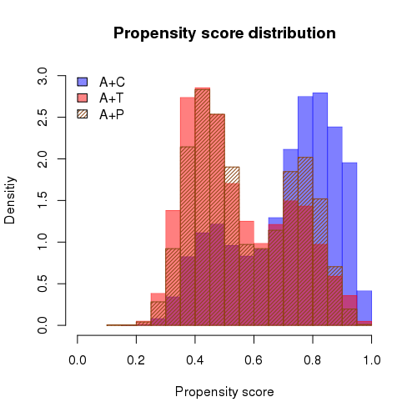
a. Distribution of propensity score b. Distribution of sIPTW estimates

A+C, clopidogrel-based dual antiplatelet therapy; A+T, ticagrelor-based dual antiplatelet therapy; A+P, prasugrel-based dual antiplatelet therapy; sIPTW, stabilized inverse probability of treatment weighting. The sIPTW estimate was calculated using logistic regression with patient age, sex, comorbidity, number of stents implanted at the index percutaneous coronary intervention (PCI), history of bleeding, concomitant medications, hospital type at the index PCI, index year, and insurance type as covariates.

Figure S2. Stabilized inverse probability of treatment weighting-adjusted Kaplan-Meier survival curves for components of MACCE
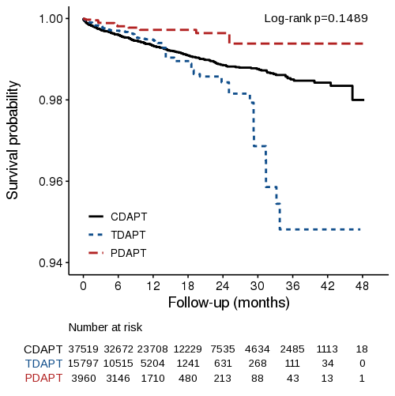
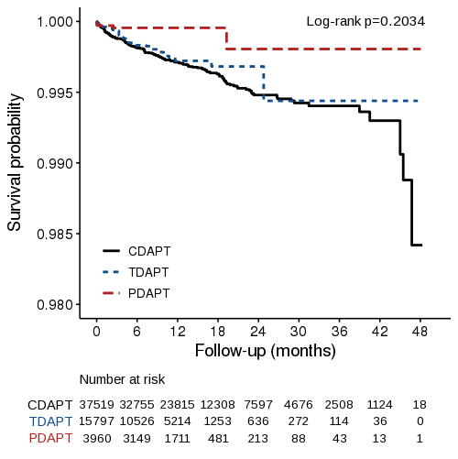
a. All-cause death b. Stroke

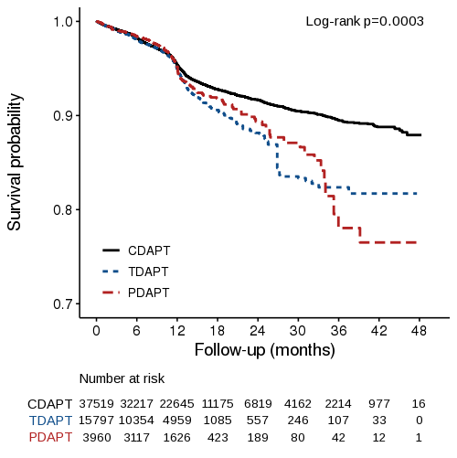
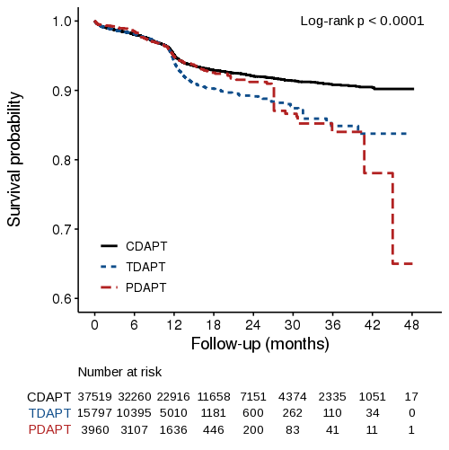
c. Myocardial infarction d. Revascularization

CDAPT, dual antiplatelet therapy with clopidogrel + aspirin; TDAPT, dual antiplatelet therapy with ticagrelor + aspirin; PDAPT, dual antiplatelet therapy with prasugrel + aspirin. The stabilized inverse probability of treatment weighting estimate was calculated using logistic regression with patient age, sex, comorbidity, number of stents implanted at the index percutaneous coronary intervention (PCI), history of bleeding, concomitant medications, hospital type at the index PCI, index year, and insurance type as covariates.
Figure S3. Stabilized inverse probability of treatment weighting-adjusted Kaplan-Meier survival curve for discontinuation
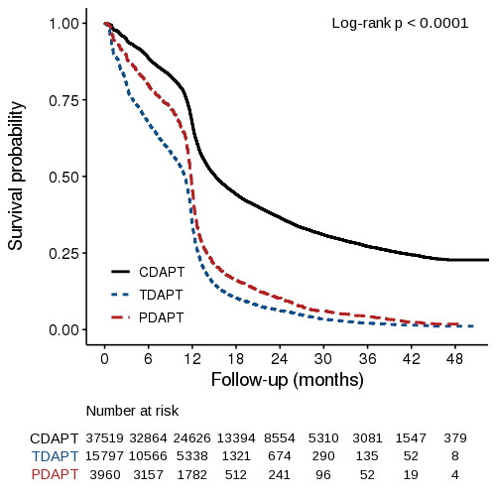
CDAPT, clopidogrel-based dual antiplatelet therapy; TDAPT, ticagrelor-based dual antiplatelet therapy; PDAPT, prasugrel-based dual antiplatelet therapy.

