SUPPLEMENTARY MATERIALS

Characterization of a real-world response variable and comparison with RECIST-based response rates from clinical trials in advanced NSCLC
Xinran Ma; Lawrence Bellomo; Kelly Magee; Caroline S. Bennette; Olga Tymejczyk; Meghna Samant; Melisa Tucker; Nathan Nussbaum; Bryan E. Bowser; Joshua S. Kraut; Ariel Bulua Bourla

Supplementary Methods
Part 2 Cohort Selection Criteria. This cohort included patients with a diagnosis of aNSCLC at age 18 or above between January 1, 2011 and April 1, 2019, at least two EHR-documented clinical visits on or after January 1, 2011, and received at least one line of therapy. Patients who had incomplete historical treatment data or who initiated the therapy of interest on or after October 1, 2018 were excluded to allow sufficient follow-up time.
Development of the rwR variable, EHR document review. Imaging tests performed within 2 weeks of each other were considered one single assessment time point, since unique assessments of a patient’s disease burden may encompass multiple imaging tests performed in close succession (e.g., a chest CT followed by a brain MRI one week later) and documented in a single synthesized entry.
Landmark analyses to investigate correlation between rwR and rwPFS, as well as the correlation between rwR and rwOS. Multivariable Cox models were employed, adjusting for age, stage at initial diagnosis, histology, and smoking status. We estimated hazard ratios (HRs) of responders compared with non-responders (patients with and without a complete or partial response) for rwOS and rwPFS by line settings, with/without requiring real world confirmation for response status. When confirmation was required, responders included patients who had a complete or partial response by landmark time and had an immediate subsequent assessment of complete or partial response or stable disease. The rest were reclassified as non-responders. Landmark time points were computed after initiation of treatment of interest, to account for immortal time bias.
Comparison to published ORR results. We identified all randomized clinical trials that supported FDA approvals of anticancer therapies for aNSCLC from January 1, 2015 to December 31, 2017 (N=11 trials, 22 arms). This time period was chosen to include a range of trials with enrollment time periods expected to overlap with datasets in our study database at the time of analyses. We excluded trial arms where identifying patients receiving comparable care in real-world settings was deemed infeasible, for example due to unavailability of trial protocol or availability of <30 patients in the real-world cohort (i.e., trial arms not reflective of real-world standard of care).
In the process of applying eligibility criteria, common missing EHR data precluding matching trial-related eligibility criteria included: process-related activities (e.g., providing tumor tissue or signing consent forms), prior adverse events and their resolution before treatment, history of adjuvant and neoadjuvant therapy, and subjective estimations of expected prognosis or study adherence.
Application of the inverse odds weights approach, analogous to propensity score modeling, is feasible in the absence of patient-level trial data, and weights the real-world patients to achieve cohort-level balance.

Supplementary Figure 1. Patient selection flow for the study cohorts (STROBE diagram)

Flatiron Health longitudinal de-identified database
Two clinic visits since 1/1/2011
aNSCLC diagnosis at age >18 before 7/1/2018
Underwent NGS testing

N=4,845
Two clinic visits since 1/1/2011
aNSCLC at age >18 between 1/1/2011 and 4/1/2019

N=54,325
Had structured activity within 90 days after the advanced diagnosis date
N=4,273
Received at least one line of therapy
N=3,588
Had at least 30 days of follow-up time since line of therapy start
N=3,482
Manually abstracted EHR information available
N=3,248
Had structured activity within 90 days after the advanced diagnosis date
N=49,309
Received therapy of interest before 10/1/2018
N=4,552*
Aligned with the corresponding trial I/E criteria
N=4,934*
Manually abstracted EHR information available
N=1,224*,†
Had at least one EHR-documented disease burden assessment
N=962*
Part 1 cohort
Part 2 cohort

*Pooled N of distinct patients form 12 rw cohorts. It is possible for an individual to be included in more than one rw cohort due to receiving therapies of interest for different trials. †A random sample of patients was abstracted for Part 2 cohort, considering that abstraction of all patients who received therapies of interest was not feasible due to the time, cost, and resources required.

Supplementary Figure 2. Best response analysis in part 1 of the study, overall and by line of therapy.

Best response among Part 1 cohort patients with at least one radiographic assessment documented in EHR (n=2775 patients, 4651 patient-lines).

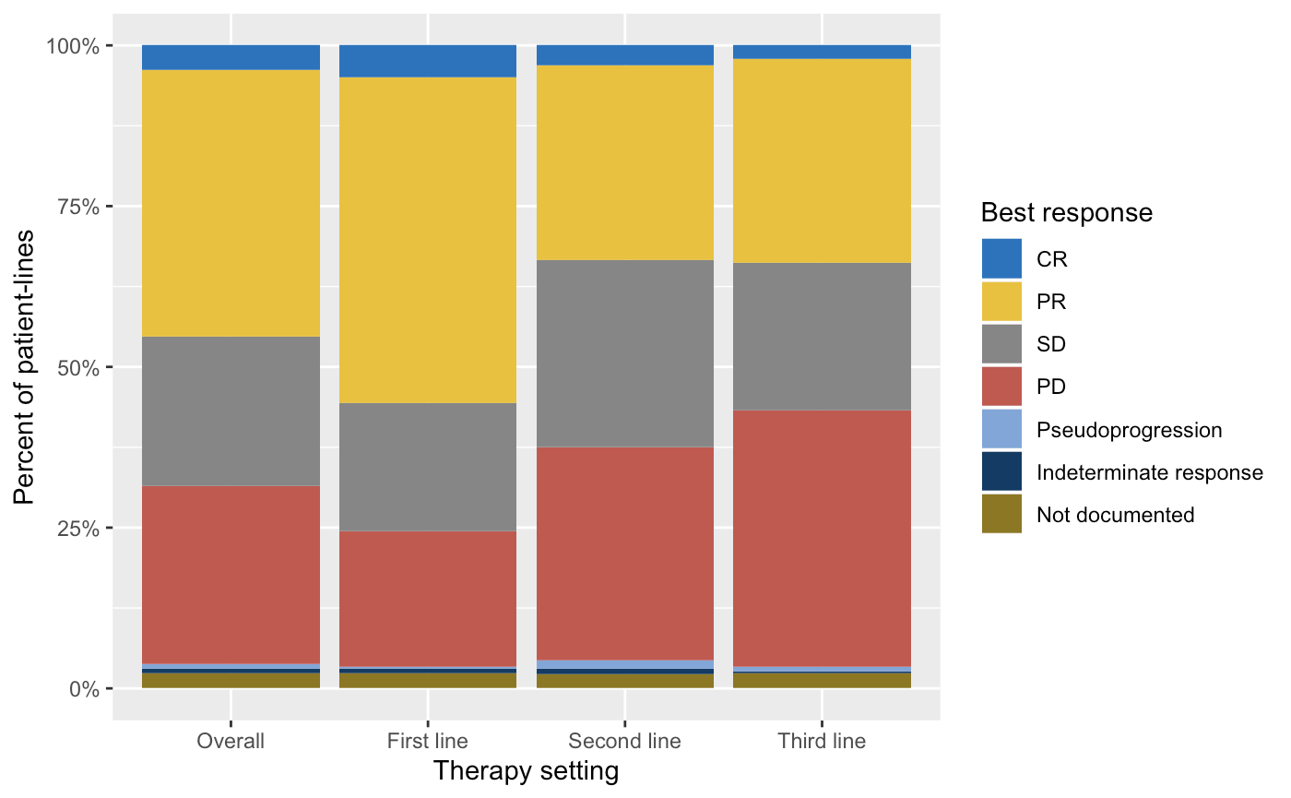
CR, real-world complete response; PR, real-world partial response; SD, real-world stable disease; PD, real-world progressive disease; Pseudoprogression, real-world pseudoprogression.

Supplementary Figure 3. Association of response with progression and mortality by line and therapeutic class.

Adjusted hazard ratios and 95% confidence intervals of rwOS and rwPFS comparing responders with non-responders by line setting and therapy class subgroups. In these exploratory analyses, models are adjusted for age at advanced diagnosis, smoking status, histology, and stage at initial diagnosis. For rwOS, the results were largely consistent with the primary analysis (hazard ratios for line 3 or above not calculated due to small subcohort sizes). For rwPFS, responders at 3 months had a lower risk of progression or death compared to non-responders in both line 1 and line 2 PD-1/PD-L1-based therapy cohort, and line 2 targeted therapy cohort. When requiring confirmation, responders at 3 months had a lower risk of progression than non-responders in all line settings, although in the line 2 anti-VEGF-based therapy and chemotherapy cohort point estimates trended in the direction of lower risk of progression or death for responders with confidence intervals overlapping 1. In the 6-month landmark analysis, associations with a decreased risk of progression or death for responders with or without requiring confirmation were consistently found in PD-1/PD-L1 based therapies.

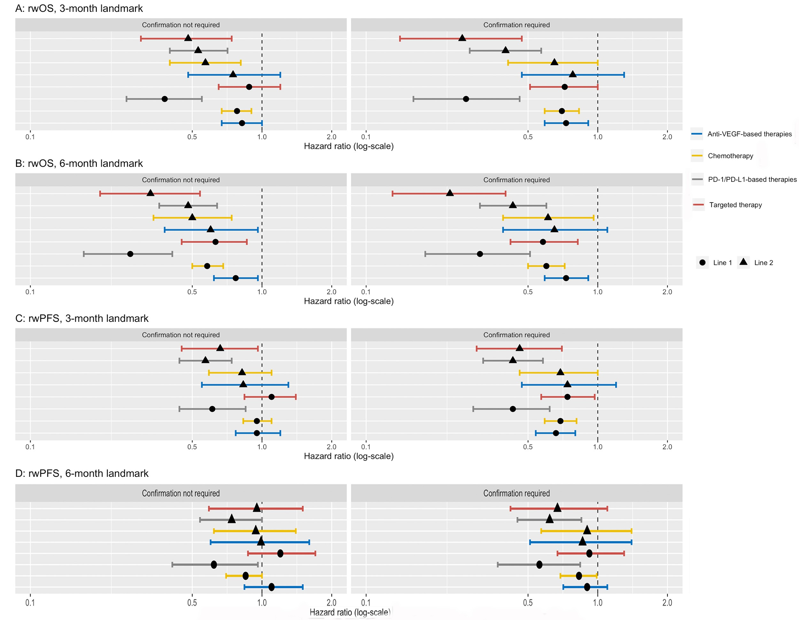

Supplementary Table 1: Background information about the registrational trials used for RR comparison purposes
 | ALEX | AURA | CheckMate-017 | CheckMate-057 | KEYNOTE-021 | KEYNOTE-024 | OAK
Treatment arms  Experimental (E)/Control (C) | Alectinib/Crizotinib | Osimertinib/Pemetrexed + carboplatin or cisplatin | Nivolumab/Docetaxel | Nivolumab/Docetaxel | Pembrolizumab + Carboplatin + Pemetrexed/Carboplatin + Pemetrexed | Pembrolizumab/Investigator’s choice of platinum-based chemotherapy | Atezolizumab/Docetaxel
N, E/C | 126/114 | 279/140 | 135/137 | 292/290 | 60/63 | 154/151 | 425/425
Trial ORR (95% CI), E/C | 82.9 (76.0-88.5)/  75.5 (67.8-82.1) | 71 (65-76)/  31 (24-40) | 20 (14-28)/  9 (5-15) | 19 (15-24)/  12 (9-17) | 55 (42–68)/  29 (18–41) | 44.8 (36.8-53.0)/  27.8 (20.8, 35.7) | 13.6/  13.4
Trial arm feasible for benchmarking | Both arms | E only | Both arms | Both arms | Both arms | E only | Both arms
Key eligibility criteria applied to select rw cohort | Treatment-naive ALK-positive aNSCLC  ECOG PS not greater than 2, including missing ECOG  Adequate renal, and hematologic function*  No prior history of HIV or Hepatitis B/C based on ICD codes | Non-squamous cell aNSCLC EGFR T790M-positive  Progressed following prior therapy with a first generation EGFR TKI agent  ECOG PS not greater than 1, including missing ECOG  Adequate renal, and hematologic function*  No history of HIV or Hepatitis B/C based on ICD codes | Squamous cell NSCLC with Stage IIIB/IV disease or with recurrent or progressive disease  Progressed in one prior platinum doublet-based chemotherapy regimen  ECOG PS not greater than 1, including missing ECOG  No prior therapy with Docetaxel, anti-PD-1, anti-PD-L1, anti-PD-L2, anti-CD137, or anti-CTLA-4 antibody (including ipilimumab)  Adequate renal, and hematologic function*  No history of HIV or Hepatitis B/C based on ICD codes | Non-squamous cell NSCLC with Stage IIIB/IV disease or with recurrent or progressive disease  Progressed in one prior platinum doublet-based chemotherapy regimen  ECOG PS not greater than 2, including missing ECOG  No prior therapy with Docetaxel, anti-PD-1, anti-PD-L1, anti-PD-L2, anti-CD137, or anti-CTLA-4 antibody (including ipilimumab)  Adequate renal, and hematologic function*  No history of HIV or Hepatitis B/C based on ICD codes | Chemotherapy-naive Non-squamous cell NSCLC with Stage IIIB/IV disease  No targetable EGFR or ALK genetic aberrations  ECOG PS not greater than 1, including missing ECOG  Adequate renal, and hematologic function*  No history of HIV or Hepatitis B/C based on ICD codes | Previously untreated aNSCLC patients with PD-L1 expression on at least 50% of tumor cells  No targetable EGFR or ALK genetic aberrations  ECOG PS not greater than 1, including missing ECOG  Adequate renal, and hematologic function*  No history of HIV or Hepatitis B/C based on ICD codes | Stage IIIB, Stage IV, or recurrent NSCLC  Had one to two previous cytotoxic chemotherapy regimens (one or more platinum based combination therapies) for stage IIIB or IV disease  ECOG PS not greater than 1, including missing ECOG  No prior treatment with Docetaxel, CD137 agonists, anti-CTLA4, anti-PD-1, or anti-PD-L1 therapeutic antibody or pathway-targeting agents  Adequate renal, and hematologic function*  No history of HIV or Hepatitis B/C based on ICD codes
CTLA-4=cytotoxic-T-lymphocyte-associated antigen 4; ECOG PS=Eastern Cooperative Oncology Group performance status; HIV=human immunodeficiency virus; PD-1=programmed cell death-1; PD-L1(2)=programmed cell death-ligand 1(2)
*As determined by lab testing values in the corresponding study protocol

Supplementary Table 2. Inter-abstractor agreement in the assignment of response categories
- Best response assignment agreement, without required confirmation
 |  | Abstractor 2
 |  | CR | PR | SD | PD | Pseudoprogression | Indeterminate | Not documented
Abstractor 1 | CR | 17 (4.4%) | 4 (1.0%) | 5 (1.3%) | 0 (0.0%) | 0 (0.0%) | 0 (0.0%) | 0 (0.0%)
 | PR | 6 (1.6%) | 138 (35.9%) | 22 (5.7%) | 3 (0.8%) | 0 (0.0%) | 1 (0.3%) | 1 (0.3%)
 | SD | 3 (0.8%) | 13 (3.4%) | 64 (16.7%) | 3 (0.8%) | 0 (0.0%) | 1 (0.3%) | 0 (0.0%)
 | PD | 0 (0.0%) | 3 (0.8%) | 5 (1.3%) | 86 (22.4%) | 1 (0.3%) | 0 (0.0%) | 0 (0.0%)
 | Pseudoprogression | 0 (0.0%) | 0 (0.0%) | 0 (0.0%) | 0 (0.0%) | 1 (0.3%) | 0 (0.0%) | 0 (0.0%)
 | Indeterminate | 0 (0.0%) | 0 (0.0%) | 0 (0.0%) | 1 (0.3%) | 0 (0.0%) | 0 (0.0%) | 0 (0.0%)
 | Not documented | 0 (0.0%) | 0 (0.0%) | 1 (0.3%) | 0 (0.0%) | 1 (0.3%) | 0 (0.0%) | 4 (1.0%)

- Best response assignment agreement, with required confirmation
 |  | Abstractor 2
 |  | CR | PR | SD | PD | Pseudoprogression | Indeterminate | Not documented
Abstractor 1 | CR | 6 (1.6%) | 2 (0.5%) | 5 (1.3%) | 0 (0.0%) | 0 (0.0%) | 0 (0.0%) | 0 (0.0%)
 | PR | 5 (1.3%) | 71 (18.5%) | 12 (3.1%) | 1 (0.3%) | 0 (0.0%) | 0 (0.0%) | 0 (0.0%)
 | SD | 2 (0.5%) | 10 (2.6%) | 144 (37.5%) | 13 (3.4%) | 0 (0.0%) | 2 (0.5%) | 1 (0.3%)
 | PD | 0 (0.0%) | 2 (0.5%) | 10 (2.6%) | 91 (23.7%) | 0 (0.0%) | 0 (0.0%) | 0 (0.0%)
 | Pseudoprogression | 0 (0.0%) | 0 (0.0%) | 0 (0.0%) | 0 (0.0%) | 0 (0.0%) | 0 (0.0%) | 0 (0.0%)
 | Indeterminate | 0 (0.0%) | 0 (0.0%) | 0 (0.0%) | 1 (0.3%) | 0 (0.0%) | 0 (0.0%) | 0 (0.0%)
 | Not documented | 0 (0.0%) | 0 (0.0%) | 1 (0.3%) | 1 (0.3%) | 0 (0.0%) | 0 (0.0%) | 4 (1.0%)

Supplementary Table 3. Part 2 rwRR analysis results in specific clinical settings corresponding with registrational trials, in the context of the published results

Benchmark trial | Clinical setting/treatment | Real-world cohorts |  | Published clinical trial cohorts
 |  | N | rwRR % (95% CI)ª | N | ORR % (95% CI)
KEYNOTE-024 | 1L IO, PD-L1+/ Pembrolizumab | 72 | 42.5 (31.1, 54.8) | 69 | 44.8 (36.8, 53.0)
ALEX | 1L, ALK rearrang/ Alectinib | 60 | 81.2 (69.1, 89.3) | 152 | 82.9 (76.0, 88.5)
 | 1L, ALK rearrang/ Crizotinib | 145 | 65.8 (51.5, 77.7) | 151 | 75.5 (67.8, 82.1)
KEYNOTE-021 | 1L / Pembrolizumab + Carboplatin + Pemetrexed | 121 | 43.7 (34.3, 53.5) | 60 | 55 (42, 68)
 | 1L/ Carboplatin + Pemetrexed | 83 | 37.6 (27.3, 49.2) | 63 | 29 (18, 41)
CheckMate-057 | 2L+ IO, non-squam/ Nivolumab | 83 | 17.6 (10.4, 28.4) | 292 | 19 (15, 24)
 | 2L+ Chemo, non-squam/ Docetaxel | 97 | 10.9 (5.7, 19.8) | 290 | 12 (9, 17)
CheckMate-017 | 2L+ IO, squam/ Nivolumab | 86 | 29.5 (20.6, 40.4) | 135 | 20 (14, 28)
 | 2L+ Chemo, squam/ Docetaxel | 53 | 9.8 (4.1, 21.6) | 137 | 9 (5, 15)
OAK | 2L+ IO/ Atezolizumab | 58 | 11.1 (4.9, 23.0) | 425 | 14 (NR)
 | 2L+ Chemo/ Docetaxel | 117 | 12.3 (7.4, 19.8) | 425 | 13 (NR)
AURA-3 | 2L+ , EGFRmt/ Osimertinib | 97 | 62.2 (47.7, 74.8) | 279 | 71 (65, 76)
1L=first line; 2L=second line; ALK=anaplastic lymphoma kinase; CI=confidence interval; EGFR=epidermal growth factor receptor; IO=immuno-oncology; NR=not reported; PD-L1=programmed cell death-ligand 1; rwRR-real-world response rate
ªWeighted, confirmed rwRR refers to the analysis based on ‘confirmed responses’ (as opposed to all responses) observed in the cohorts after weights were used. This is the one listed in all cases except ALEX and AURA-3 (for which the trial protocol did not specify confirmed responses)

