Supporting Information

Efficacy of Vibegron and Mirabegron for Overactive Bladder:
A Systematic Literature Review and Indirect Treatment Comparison

Contents
Supplementary Table 1…………………………………………………………………...……….2
Supplementary Table 2……………………………………………………………………………3
Supplementary Table 3……………………………………………………………………………4
Supplementary Table 4……………………………………………………………………………6
Supplementary Table 5……………………………………………………………………………7
Supplementary Table 6……………………………………………………………………………8
Supplementary Figure 1…………………………………………………………………………...9
Supplementary Figure 2………………………………………………………………………….10
Supplementary Figure 3………………………………………………………………………….11
Supplementary Figure 4………………………………………………………………………….12
Supporting Information References……………………………………………………………...13

Supplementary Table 1. Systematic Literature Review Eligibility Criteria
Study Characteristic | Criteria
Population | Adults, ≥18 years, with a prior diagnosis of OAB; no restrictions on sex, race, or other demographic characteristics
Interventions | β₃-adrenergic receptor agonist (vibegron 75 mg, mirabegron 25/50 mg)
Comparators | Placebo or active controls
Outcomes | Daily number of total urinary incontinence episodes, daily number of micturitions, volume voided per micturition
Timing | ≥12 weeks of exposure
Study design | Phase 3, randomized, double-blind, controlled trials
Language | English
OAB, overactive bladder.

Supplementary Table 2. Data Extraction
Data Item | Description
Source | Authors, citation, corresponding author contact details
Study design | Randomized, double-blind, controlled phase 3 clinical trial with placebo or active controls; time points: baseline and weeks 4, 12, and 52
Population | Total number of participants, inclusion and exclusion criteria, OAB type (ie, wet vs dry at baseline), age, sex, ethnicity, country
Analysis | Measures assessed (eg, change from baseline, missing data methods)
Confounding factors | If applicable since studies are randomized
Drug interventions | Drug name(s), dosage, frequency, duration of treatment
Outcome assessment | Manner of assessment; outcomes of interest: mean daily number of total urinary incontinence episodes, mean daily number of micturitions, volume voided per micturition
Control interventions | Placebo or active control
Results | Number of participants in each intervention group; for each documented outcome of interest: sample size, missing participants, study measures of association, CIs, P values, statistical test used
Limitations | Limitations reported
Quality and bias assessments | Cochrane Risk of Bias Tool for randomized controlled trials
OAB, overactive bladder.
Supplementary Table 3. Baseline Characteristics for Total Incontinence Episodes, Micturitions, and Volume Voided
Study | Treatment | Total Incontinence Episodes,* No. | Micturitions,† No. | Volume Voided,† mL
Chapple et al 2013 [1], mean (SE) | Mirabegron 50 mg | 2.66 (0.12) | 11.13 (0.10) | 160.1 (2.09)
 | Tolterodine 4 mg ER | 2.42 (0.11) | 10.94 (0.09) | 160.1 (2.01)
Herschorn et al 2013 [2], mean (SE) | Placebo | NR | NR | NR
 | Mirabegron 25 mg | 2.65 (0.16) | 11.68 (0.15) | 165.2 (2.8)
 | Mirabegron 50 mg | 2.51 (0.15) | 11.66 (0.16) | 159.3 (2.5)
Khullar et al 2013 [3], mean (SE) | Placebo | 2.67 (0.14) | 11.71 (0.14) | NR
 | Mirabegron 50 mg | 2.83 (0.17) | 11.65 (0.14) | NR
 | Tolterodine 4 mg ER | 2.63 (0.15) | 11.55 (0.13) | NR
Nitti et al 2013 [4],  mean (SD) | Placebo | 3.0 (3.1) | 11.5 (3.3) | 157.5 (58.7)
 | Mirabegron 50 mg | 2.8 (2.7) | 11.8 (3.5) | 156.0 (58.7)
Yamaguchi et al 2014 [5], mean (SD) | Placebo | 1.91 (1.76) | 11.29 (2.75) | 146.8 (44.2)
 | Mirabegron 50 mg | 1.99 (2.05) | 11.15 (2.65) | 149.6 (46.4)
 | Tolterodine 4 mg ER | 1.89 (1.83) | 11.10 (2.57) | 145.9 (46.9)
Kuo et al 2015 [6],  mean (SD) | Placebo | 2.35 (2.70) | 12.59 (4.91) | 152.6 (55.0)
 | Mirabegron 50 mg | 2.37 (2.54) | 12.09 (4.11) | 147.8 (52.7)
 | Tolterodine 4 mg ER | 2.25 (2.78) | 12.13 (3.67) | 150.2 (57.2)
Herschorn et al 2017 [7], mean (SD) | Placebo | 3.41 (3.37) | 10.97 (2.86) | 157.9 (58.8)
 | Mirabegron 25 mg | 3.42 (3.40) | 10.81 (2.63) | 152.5 (61.0)
 | Mirabegron 50 mg | 3.18 (3.47) | 11.19 (3.27) | 155.3 (60.8)
Staskin et al 2020 [8], mean (SD)‡ | Placebo | 4.17 (3.82) | 11.75 (4.01) | 148.3 (60.7)
 | Vibegron 75 mg | 4.14 (3.63) | 11.31 (3.42) | 155.4 (63.1)
 | Tolterodine 4 mg ER | 4.06 (3.07) | 11.48 (3.15) | 147.0 (60.8)
ER, extended release; FAS, full analysis set; FAS-I, FAS for incontinence; NR, not reported.
*Analyzed in the FAS-I, broadly defined as all patients receiving ≥1 dose of double-blind study drug who had a baseline and ≥1 postbaseline assessment and ≥1 incontinence episode at baseline.
†Analyzed in the FAS, broadly defined as all patients receiving ≥1 dose of double-blind study drug who had a baseline and ≥1 postbaseline assessment.
‡Baseline values reported for the 12-week EMPOWUR trial. Baseline definitions for the extension trial differed for patients continuing active treatment vs patients who received placebo during the 12-week trial.

Supplementary Table 4. Differences in Effect Size of Change From Baseline for Vibegron, Mirabegron, and Tolterodine
Efficacy Endpoint | Week | Vibegron vs Mirabegron 25 mg |  | Vibegron vs Mirabegron 50 mg |  | Vibegron vs Tolterodine 4 mg ER
 |  | Effect Size (95% CI)* | P Value | Effect Size (95% CI)* | P Value | Effect Size (95% CI)* | P Value
Total incontinence episodes | 4 | ‒0.46 (‒0.89, ‒0.03) | 0.037 | ‒0.35 (‒0.67, ‒0.02) | 0.038 | ‒0.39 (‒0.73, ‒0.06) | 0.023
 | 12 | ‒0.32 (‒0.70, 0.06) | 0.1 | ‒0.31 (‒0.65, 0.03) | 0.074 | ‒0.44 (‒0.80, ‒0.07) | 0.02
 | 52 | N/A | ‒ | ‒0.85 (‒1.40, ‒0.30) | 0.003 | N/A | ‒
Micturitions | 4 | ‒0.42 (‒0.86, 0.02) | 0.059 | ‒0.17 (‒0.47, 0.14) | 0.279 | ‒0.28 (‒0.59, 0.03) | 0.076
 | 12 | ‒0.09 (‒0.47, 0.29) | 0.634 | 0.06 (‒0.26, 0.39) | 0.709 | ‒0.20 (‒0.56, 0.15) | 0.265
 | 52 | N/A | ‒ | ‒0.52 (‒1.25, 0.21) | 0.163 | N/A | ‒
Volume voided | 4 | N/A | ‒ | 8.34 (‒0.37, 17.05) | 0.06 | 8.94 (0.20, 17.69) | 0.045
 | 12 | 16.48 (8.13, 24.83) | 0 | 8.69 (1.37, 16.01) | 0.02 | 7.94 (‒0.77, 16.65) | 0.074
 | 52 | N/A | ‒ | 18.30 (1.16, 35.44) | 0.036 | N/A | ‒
ER, extended release; N/A, not available.
*Effect sizes are calculated using placebo-subtracted changes from baseline for weeks 4 and 12 and tolterodine-subtracted changes from baseline for week 52.
Supplementary Table 5. Summary of AEs Occurring in ≥5% of Patients and Reported in Each Short-Term Trial (Safety Analysis Sets)
AE, % | Herschorn et al  2013 [2] |  |  | Khullar et al  2013 [3] |  |  | Nitti et al 2013 [4] |  | Yamaguchi et al  2014 [5] |  |  | Kuo et al  2015 [6] |  |  | Staskin et al  2020 [8]
 | M25 | M50 | PBO | M50 | PBO | T4ER | M50 | PBO | M50 | PBO | T4ER | M50 | PBO | T4ER | V75 | PBO | T4ER
N | 432 | 440 | 433 | 493 | 494 | 495 | 442 | 453 | 379 | 379 | 375 | 366 | 366 | 371 | 545 | 540 | 430
Hypertension | 11.3 | 10.7 | 8.5 | 5.9 | 7.7 | 8.1 | 6.1 | 6.6 | * | * | * | * | * | * | * | * | *
UTI | * | * | * | * | * | * | * | * | * | * | * | * | * | * | 5.0 | 6.1 | 5.8
Dry mouth | * | * | * | * | * | 10.1 | * | * | * | * | 13.3 | * | * | 8.1 | * | * | 6.5
Nasopharyngitis | * | 5.7 | * | * | * | * | * | * | * | * | * | * | * | * | * | * | *
AE, adverse event; M25, mirabegron 25 mg; M50, mirabegron 50 mg; PBO, placebo; T4ER, tolterodine 4 mg extended release; UTI, urinary tract infection; V75, vibegron 75 mg.
*AE present in <5% of patients in treatment group.
Supplementary Table 6. Summary of AEs Occurring in ≥5% of Patients and Reported in Each Long-Term Trial (Safety Analysis Sets)
AE, % | Chapple et al  2013 [1] |  | Staskin et al  2021 [9]
 | Mirabegron  50 mg | Tolterodine  4 mg ER | Vibegron  75 mg | Tolterodine  4 mg ER
N | 812 | 812 | 273 | 232
Hypertension | 9.2 | 9.6 | 8.8 | 8.6
UTI | 5.9 | 6.4 | 6.6 | 7.3
Dry mouth | * | 8.6 | * | 5.2
Nasopharyngitis | * | * | * | 5.2
Headache | * | * | 5.5 | *
AE, adverse event; UTI, urinary tract infection.
*AE present in <5% of patients in both treatment groups.

Supplementary Figure 1. Network map of treatments for overactive bladder. Solid lines indicate a direct comparison between treatments; dashed line indicates an indirect comparison between treatments that can be made using the adjusted indirect treatment comparison method by Bucher et al [10]. Solid lines between vibegron and tolterodine and between mirabegron and tolterodine indicate a comparison at week 52. ER, extended release.

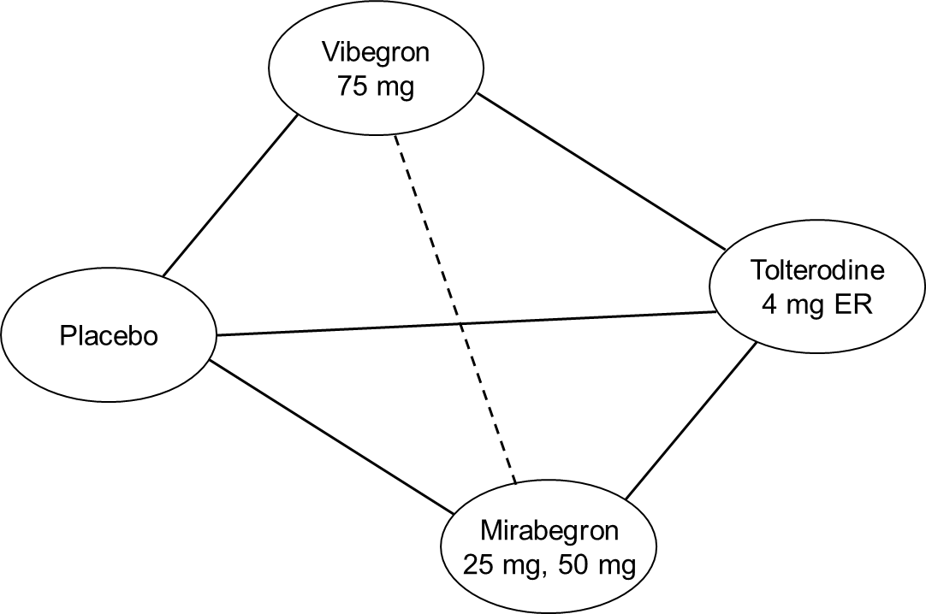

Supplementary Figure 2. Weighted average of change from baseline in total incontinence episodes for active treatment groups; n indicates the number of trials included in each assessment. Effect sizes at weeks 4 and 12 were calculated using placebo-subtracted changes from baseline; effect size at week 52 was calculated using tolterodine-subtracted changes from baseline. ER, extended release.

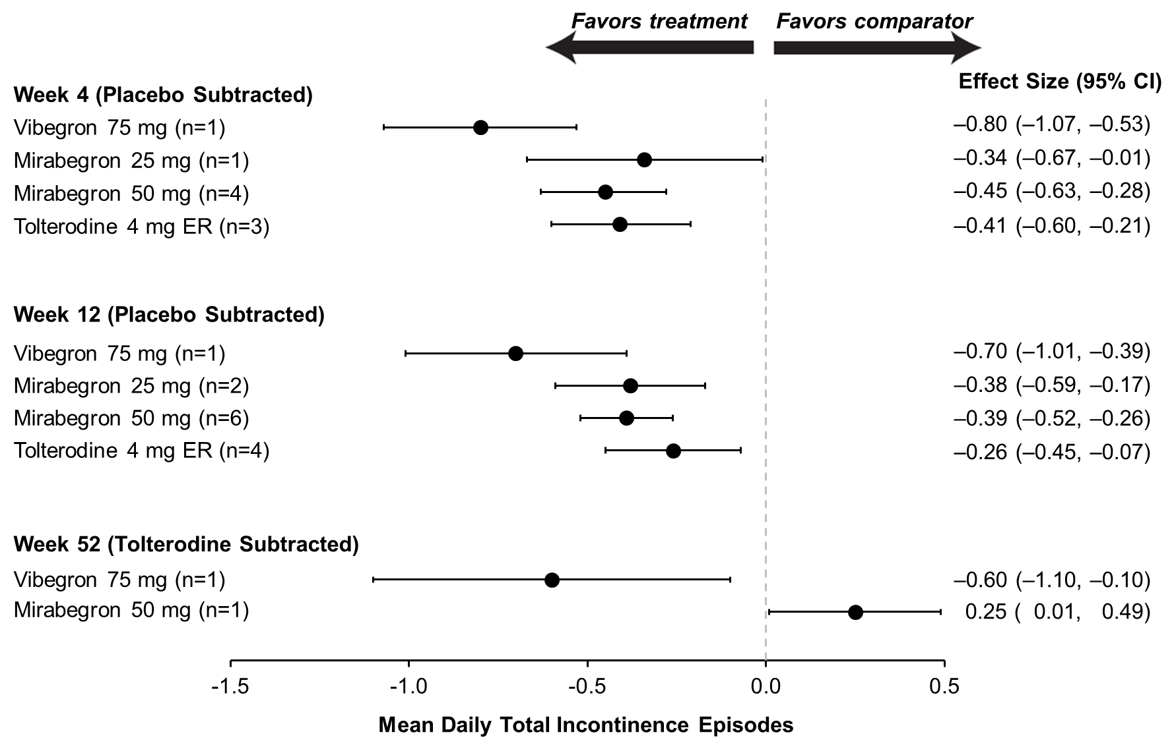

Supplementary Figure 3. Weighted average of change from baseline in mean daily micturitions for active treatment groups; n indicates the number of trials included in each assessment. Effect sizes at weeks 4 and 12 were calculated using placebo-subtracted changes from baseline; effect size at week 52 was calculated using tolterodine-subtracted changes from baseline. ER, extended release.

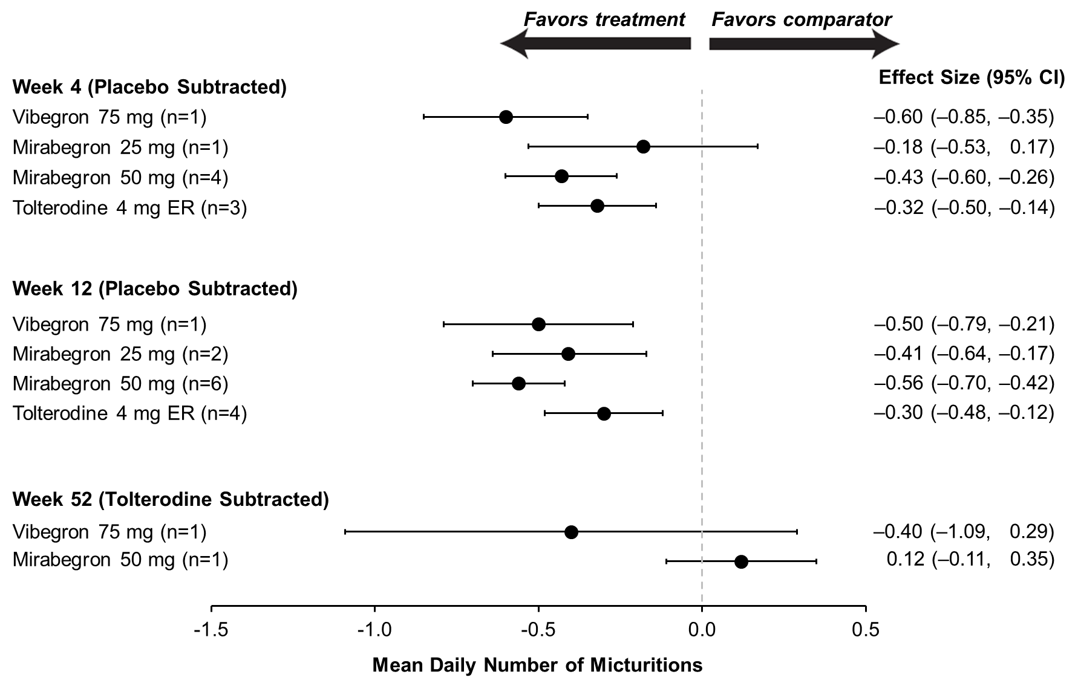

Supplementary Figure 4. Weighted average of change from baseline in volume voided per micturition (mL) for active treatment groups; n indicates the number of trials included in each assessment. Effect sizes at weeks 4 and 12 were calculated using placebo-subtracted changes from baseline; effect size at week 52 was calculated using tolterodine-subtracted changes from baseline. ER, extended release.

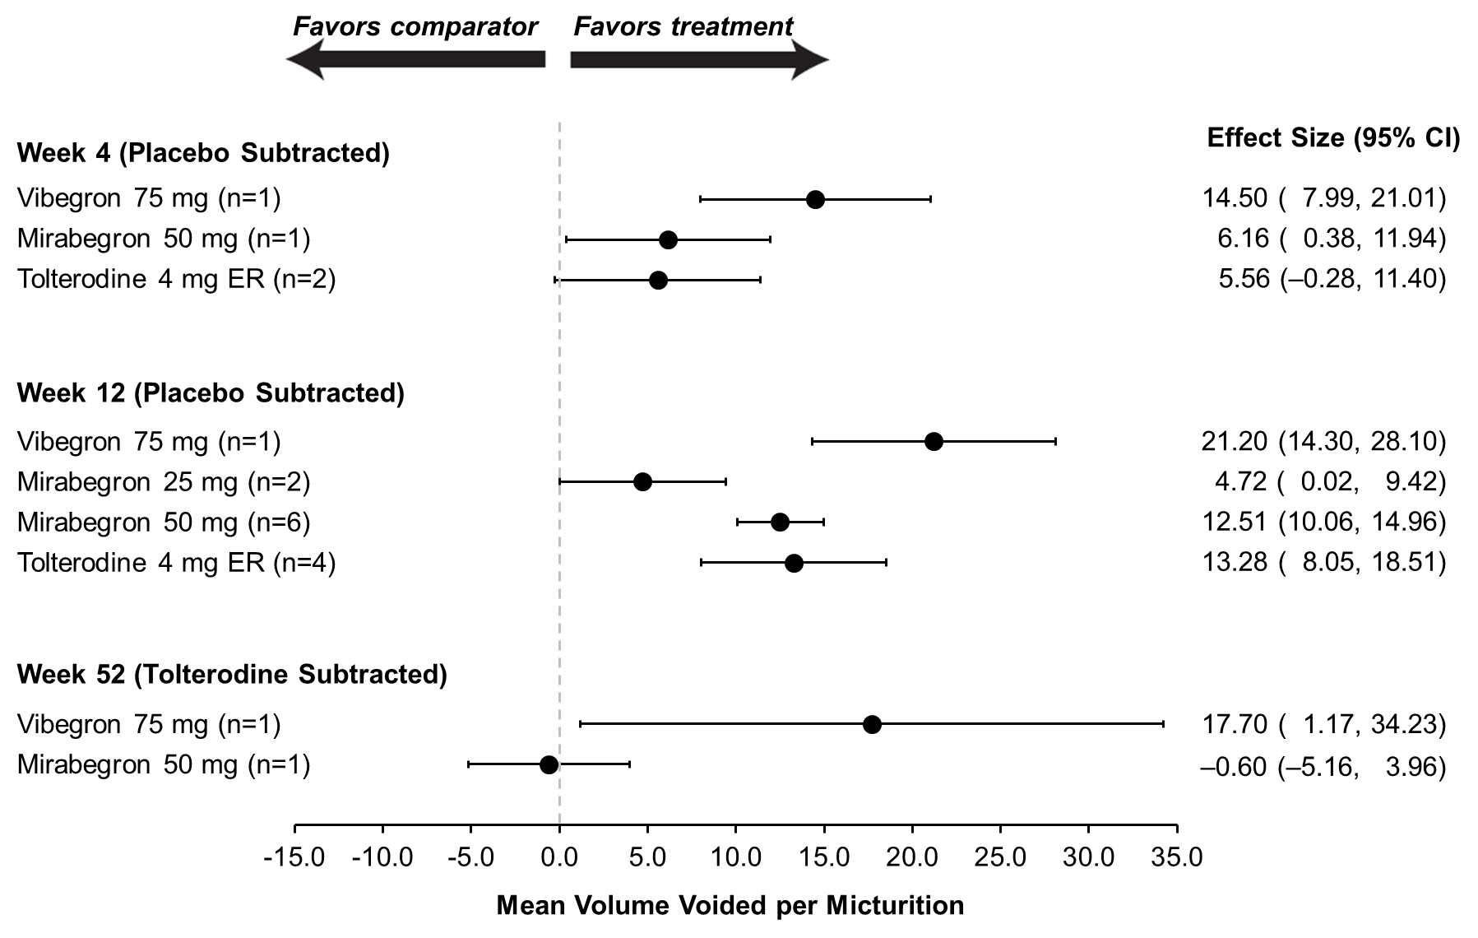

Supporting Information References
1. Chapple CR, Kaplan SA, Mitcheson D, et al. Randomized double-blind, active-controlled phase 3 study to assess 12-month safety and efficacy of mirabegron, a β₃-adrenoceptor agonist, in overactive bladder. Eur Urol. 2013;63(2):296-305.
2. Herschorn S, Barkin J, Castro-Diaz D, et al. A phase III, randomized, double-blind, parallel-group, placebo-controlled, multicentre study to assess the efficacy and safety of the β₃ adrenoceptor agonist, mirabegron, in patients with symptoms of overactive bladder. Urology. 2013;82(2):313-20.
3. Khullar V, Amarenco G, Angulo JC, et al. Efficacy and tolerability of mirabegron, a β₃-adrenoceptor agonist, in patients with overactive bladder: results from a randomised European-Australian phase 3 trial. Eur Urol. 2013;63(2):283-95.
4. Nitti VW, Auerbach S, Martin N, Calhoun A, Lee M, Herschorn S. Results of a randomized phase III trial of mirabegron in patients with overactive bladder. J Urol. 2013;189(4):1388-95.
5. Yamaguchi O, Marui E, Kakizaki H, et al. Phase III, randomised, double-blind, placebo-controlled study of the β₃-adrenoceptor agonist mirabegron, 50 mg once daily, in Japanese patients with overactive bladder. BJU Int. 2014;113(6):951-60.
6. Kuo HC, Lee KS, Na Y, et al. Results of a randomized, double-blind, parallel-group, placebo- and active-controlled, multicenter study of mirabegron, a β₃-adrenoceptor agonist, in patients with overactive bladder in Asia. Neurourol Urodyn. 2015;34(7):685-92.
7. Herschorn S, Chapple CR, Abrams P, et al. Efficacy and safety of combinations of mirabegron and solifenacin compared with monotherapy and placebo in patients with overactive bladder (SYNERGY study). BJU Int. 2017;120(4):562-75.
8. Staskin D, Frankel J, Varano S, Shortino D, Jankowich R, Mudd PN, Jr. International phase III, randomized, double-blind, placebo and active controlled study to evaluate the safety and efficacy of vibegron in patients with symptoms of overactive bladder: EMPOWUR. J Urol. 2020;204(2):316-24.
9. Staskin D, Frankel J, Varano S, Shortino D, Jankowich R, Mudd PN, Jr. Once-daily vibegron 75 mg for overactive bladder: Long-term safety and efficacy from a double-blind extension study of the international phase 3 trial (EMPOWUR). J Urol. 2021;205(5):1421-9.
10. Bucher HC, Guyatt GH, Griffith LE, Walter SD. The results of direct and indirect treatment comparisons in meta-analysis of randomized controlled trials. J Clin Epidemiol. 1997;50(6):683-91.

