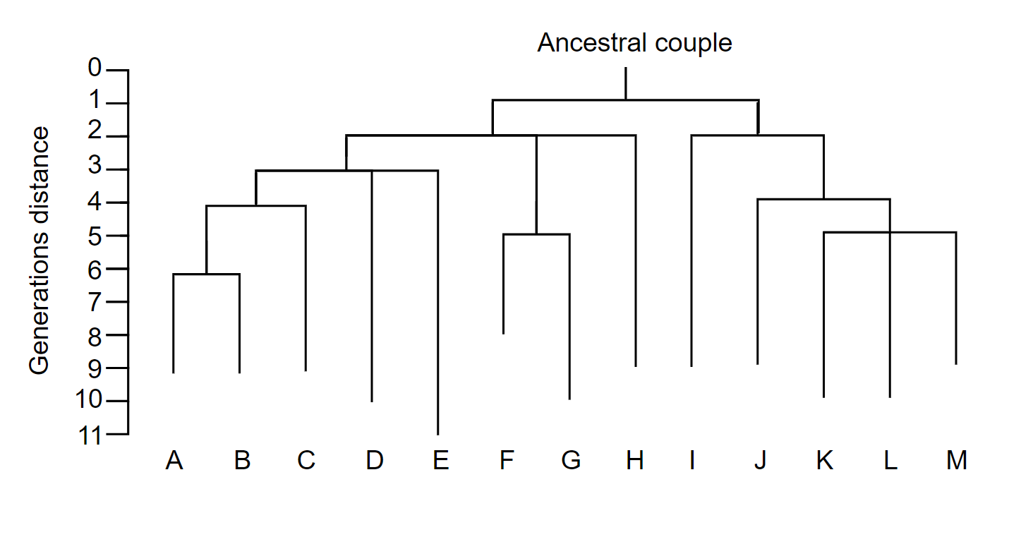
Figure S1 Dendrogram of relationship of probands to putative ancestral couple
Thirteen probands, labelled A-M, are clustered by genealogical distance from one another. Probands E, I, J, K, L and M were related via more than one path. In these cases, the median mortality of all ancestors linking a proband to the putative ancestral couple was used to determine the most likely path of mutation transmission.

