**Supplementary Figure 1**

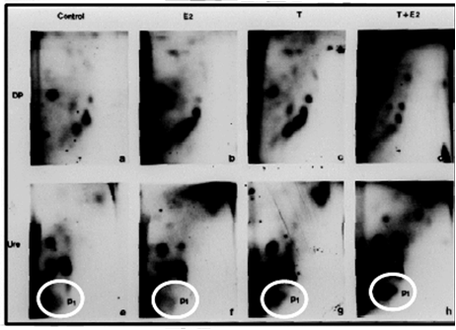**A**

**B**

Peripheral Dorsal Prostate

Periurethral Prostate Ducts

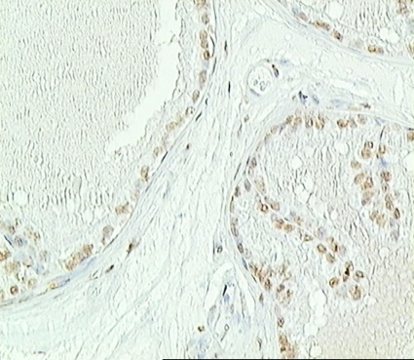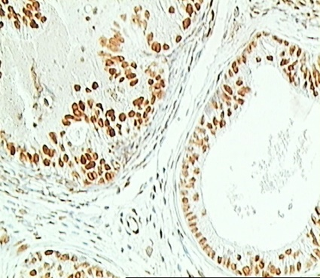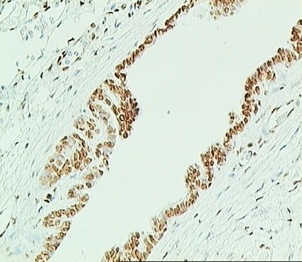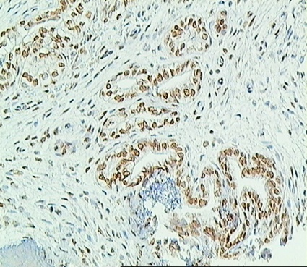

Periurethral Ducts

Periurethral Ducts

Periurethral Ducts

Periurethral Ducts

**Supplementary Figure 1 – (A)** A major DNA adduct spot (P1) detected by 32P-postlabeling in the periurethral duct region of the prostate (Ure), but not the dorsolateral prostate (DP) of NBL rats treated for 16 weeks with E2 plus T. **(B)** 8-OHdG immunostaining in the peripheral dorsal prostate and periurethral prostate ducts of NBL rats following 16 week treatment E2 plus T treatment.

Control

Control

T + E2

T + E2

T+E2

T+E2