Additional File
Title : Left atrial phasic function remodeling during its enlargement: A two-dimensional speckle-tracking echocardiography study
Chuyun Chen, Ying Yang*, Wei Ma, Litong Qi, Baowei Zhang, Yan Zhang

- Table S1. Associations of left atrial functional and structural characteristics in HT subgroup with normal LA size (n=389).
- Figure S1. 1:2 matching according to age, HT and CHD between Normal LA size group (16-34ml/ m²) and Severe LAE group (>48ml/ m²) (caliper width = 0.05).
- Table S2. Characteristics before and after Propensity Score-Matching according to age, HT and CHD between Normal LA size group and Severe LAE group.
- Table S3. Association of LA size with Strain in the Propensity Score-Matching Group (Normal LA size group and Severe LAE group).
- Figure S2. 1:1 matching according to age, HT and CHD between Normal LA size group (16-34ml/ m²) and Abnormal LA size group (Mild, Moderate and Severe LAE ) (>35ml/ m²) (caliper width = 0.05).
- Table S4. Characteristics before and after Propensity Score-Matching according to age, HT and CHD between Normal LA size group and Abnormal LA size group.
- Table S5: Association of LA size with Strain in the Propensity Score-Matched Group (Normal LA size group and Abnormal LA size group).

Table S1: Associations of left atrial functional and structural characteristics in HT subgroup with normal LA size (n=389).
Variables
 | Stot |  | Se
 | β | p | β | p
Age
Male
HR |  |  | -0.052 | 0.031
DM
Smoking | -2.299 | 0.009
Dyslipidemia
LAVI
LVSlong | 0.414 | <0.001 | 0.269 | 0.001
E/A
E’ |  |  | 0.708 | <0.001
A’ | 0.366 | 0.048
LAEF | 12.513 | 0.003 | 6.919 | 0.022
Adjusted R² | 0.147 |  | 0.193
HR Heart rate, DM Diabetes mellitus, LVSlong Left ventricle global longitudinal strain, LA left atrial ejection fraction

Figure S1: 1:2 matching according to age, HT and CHD between Normal LA size group (16-34ml/m²) and Severe LAE group (>48ml/m²) (caliper width = 0.01).

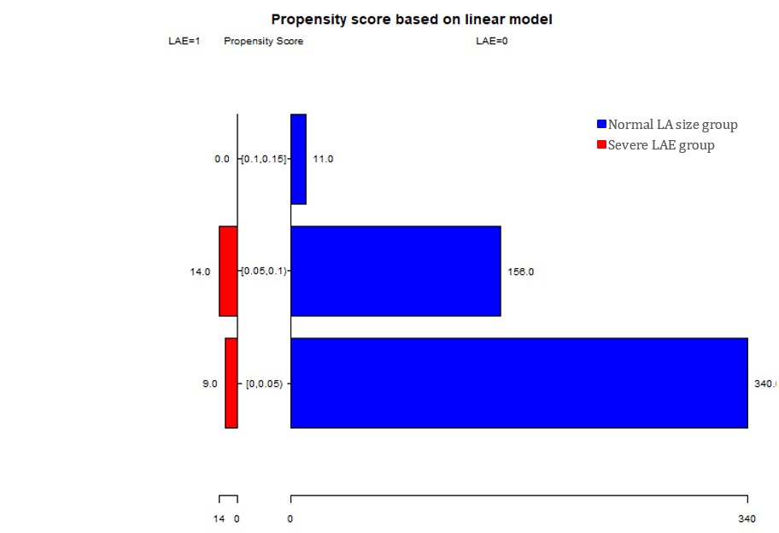
LAE =1 Severe LAE group (>48ml/m²), LAE =0 Normal LA size group (16-34ml/m²).

Table S2: Characteristics before and after Propensity Score-Matching according to age, HT and CHD between Normal LA size group and Severe LAE group.
 |  | Before Matching |  |  |  | After Matching
 |  | Normal LA size  (16-34ml/m²)  (n=507) | Severe LAE  (>48ml/m²)  (n=23) | Standized Difference | Normal LA size  (16-34ml/m²)  (n=46) |  | Severe LAE  (>48ml/m²)  (n=23) | Standized Difference
Age (year) |  | 65.96±9.11 | 70.65±7.90 | 0.55 | 67.15±9.57 |  | 70.65±7.90 | 0.40
HT |  | 76.73% | 82.61% | 0.15 | 69.60% |  | 82.60% | 0.31
CHD |  | 7.50% | 13.40% | 0.18 | 13.00% |  | 13.00% | 0.00
Stot |  | 21.74±5.97 | 17.75±4.71 | 0.74 | 22.16±6.39 |  | 17.75±4.71 | 0.79
Se |  | 9.90±4.58 | 9.20±3.06 | 0.18 | 9.69±4.35 |  | 9.20±3.06 | 0.13
Sa |  | 11.84±3.92 | 8.55±2.88 | 0.96 | 12.47±3.90 |  | 8.55±2.88 | 1.14
HT Hypertension, CHD Coronary Heart Disease.

Table S3: Association of LA size with Strain in the Propensity Score-Matching Group (Normal LA size group and Severe LAE group).
Group | Strain | Before Matching |  |  | After Matching
 |  | β (95%CI) | P | β (95%CI) |  | P
Normal LA size (16-34ml/m²) |  | ref |  | ref
Severe LAE (>48ml/m²) | Stot | -4.41 (-6.44, -2.38) | <0.001 | -3.92 (-6.03, -1.81) |  | <0.001
 | Se | -0.49 (-2.06, 1.08) | 0.543 | 0.13 (-1.35, 1.60) |  | 0.867
 | Sa | -3.92 (-5.14, -2.71) | <0.001 | -4.05 (-5.38, -2.72) |  | <0.001
Propensity score matching for age, hypertension(HT), and coronary heart disease (CHD).

Figure S2: 1:1 matching according to age, HT and CHD between Normal LA size group (16-34ml/m²) and Abnormal LA size group (Mild, Moderate and Severe LAE ) (>35ml/m²) (caliper width = 0.01).

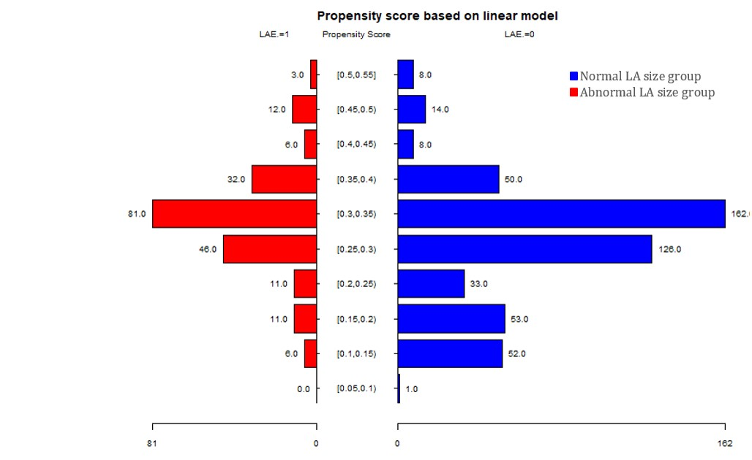
LAE. =1 Abnormal LA size group (>35ml/m²), LAE. =0 Normal LA size group (16-34ml/m²).

Table S4: Characteristics before and after Propensity Score-Matching according to age, HT and CHD between Normal LA size group and Abnormal LA size group.
 | Before Matching |  |  |  | After Matching
 | Normal LA size  (16-34ml/m2)  (n=507) | Abnormal LA size  (>35ml/m2) (n=208) | Standized Difference | Normal LA size  (16-34ml/m2)  (n=207) |  | Abnormal LA size  (>35ml/m2) (n=207) | Standized Difference
Age (year) | 65.96±9.11 | 68.02±8.07 | 0.24 | 67.13±8.41 |  | 68.02±8.09 | 0.11
HT | 76.73% | 88.94% | 0.33 | 86.00% |  | 88.90% | 0.09
CHD | 7.50% | 12.98% | 0.18 | 14.00% |  | 12.60% | 0.04
Stot | 21.74±5.97 | 20.35±5.09 | 0.25 | 20.84±5.88 |  | 20.36±5.10 | 0.09
Se | 9.90±4.58 | 9.84±3.85 | 0.01 | 9.17±4.22 |  | 9.84±3.86 | 0.17
Sa | 11.84±3.92 | 10.51±3.17 | 0.37 | 11.67±3.91 |  | 10.52±3.18 | 0.32
HT Hypertension, CHD Coronary Heart Disease.

Table S5: Association of LA size with Strain in the Propensity Score-Matched Group (Normal LA size group and Abnormal LA size group).
Group | Strain | Before Matching |  |  | After Matching
 |  | β (95%CI) | P | β (95%CI) |  | P
Normal LA size (16-34ml/m2) |  | ref |  | ref
Abnormal LA size (>35ml/m²) | Stot | -0.48 (-1.51, 0.56) | 0.367 | -0.37 (-1.40, 0.67) |  | 0.486
 | Se | 0.67 (-0.07, 1.42) | 0.076 | 0.75 (0.01, 1.50) |  | 0.048
 | Sa | -1.15 (-1.83, -0.48) | <0.001 | -1.12 (-1.79, -0.45) |  | 0.001
Propensity score matching for age, hypertension(HT), and coronary heart disease (CHD).

