Supplemental File 4: Additional results comparing across all four scenarios

Table of Contents
Supplemental File 4: Additional results comparing across all four scenarios 1
Coverage 2
Mean absolute percentage error (MAPE) 5
Probability of >20% difference 8

The contents of this Supplemental File can be accessed in an interactive tool available at: https://survsim.shinyapps.io/survsim

Coverage
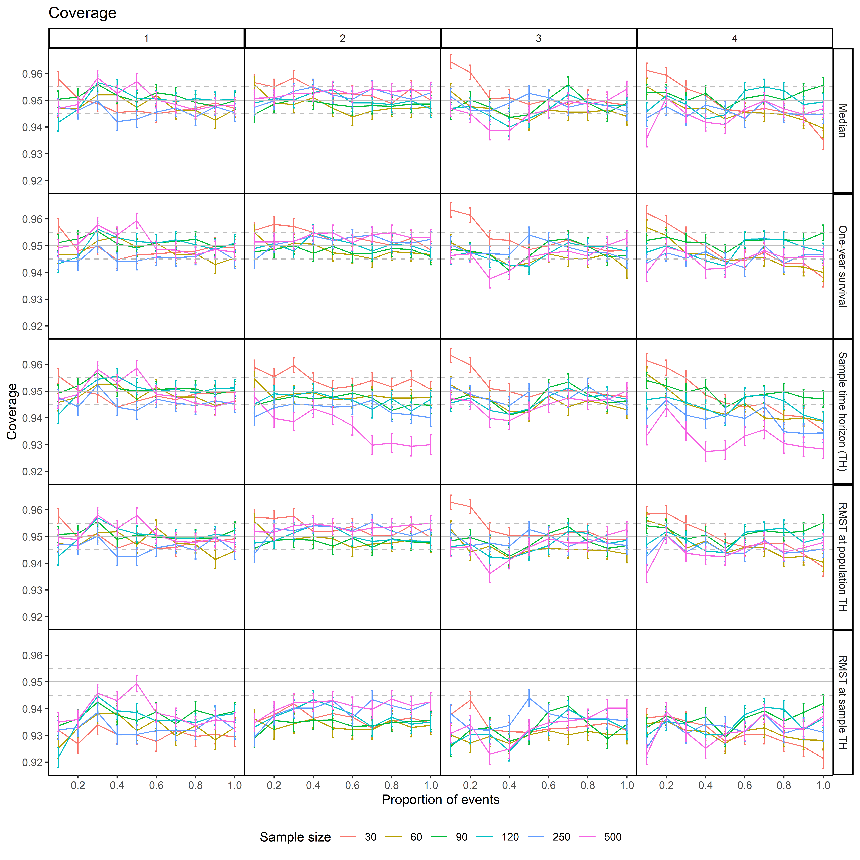Figure S4-1 Coverage at each sample size and level of proportion of events across scenarios when distribution correctly specified as exponential
Scenarios: 1- high event rate, short accrual
2- high event rate, long accrual
3- low event rate, short accrual
4- low event rate, long accrual
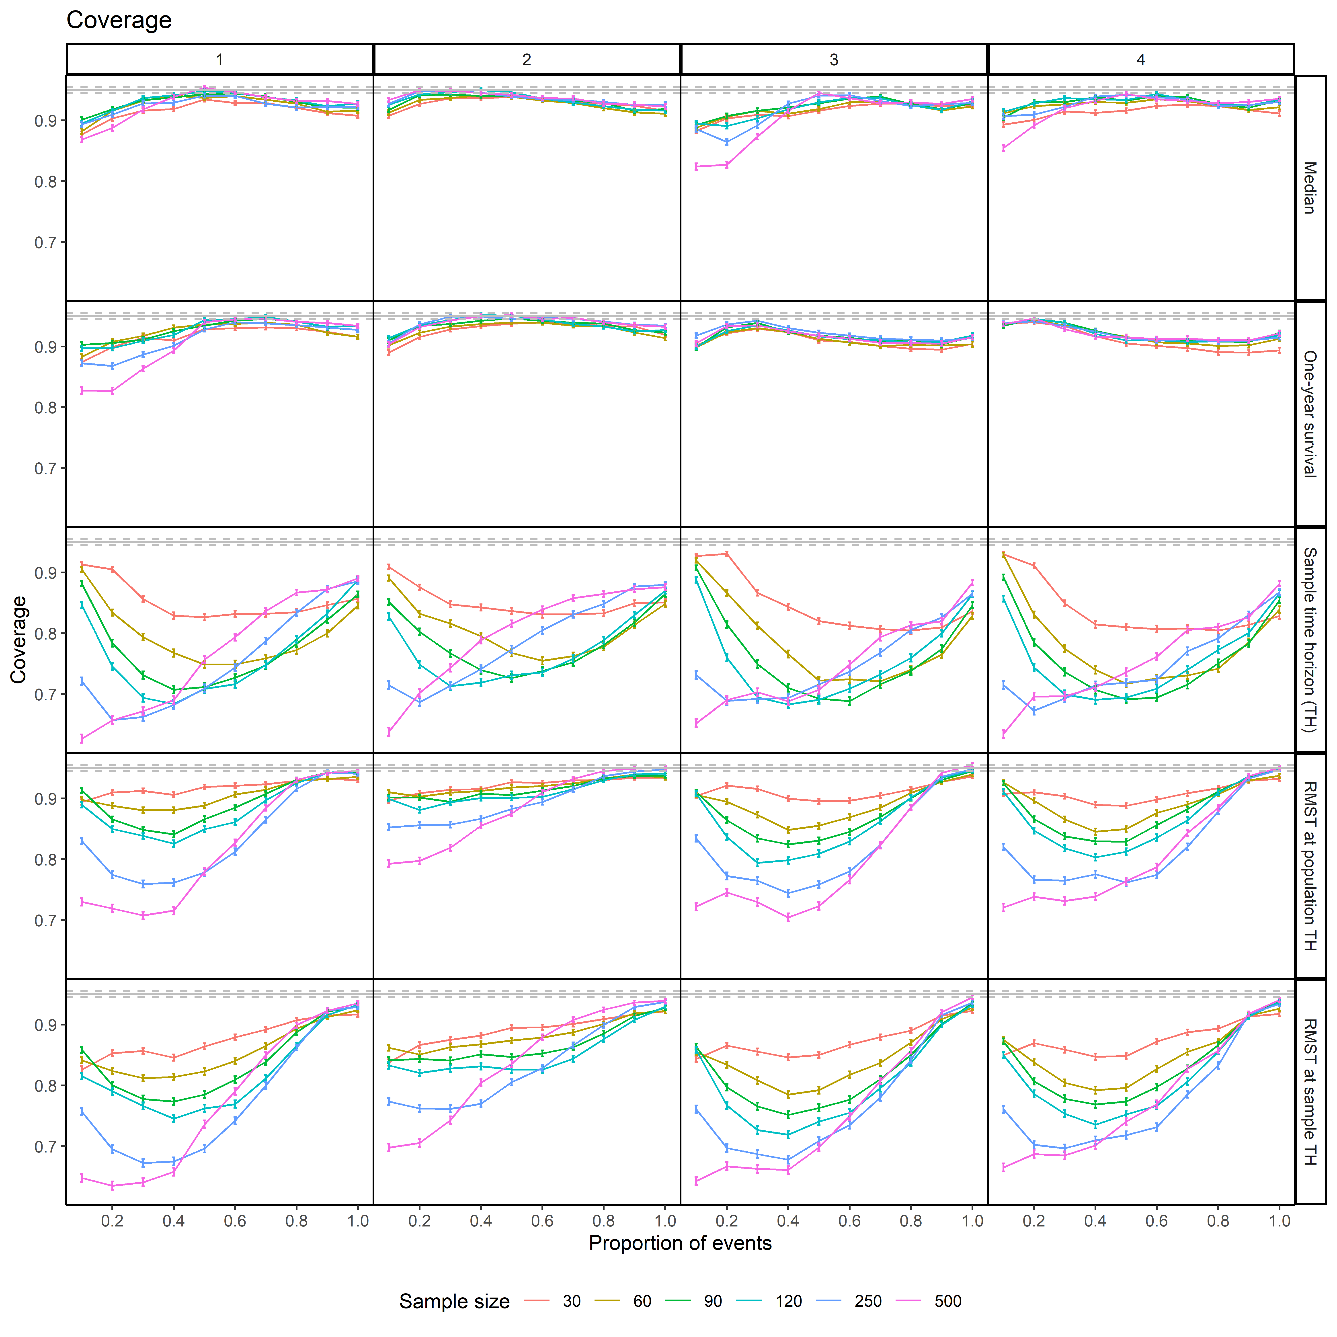
Figure S4-2 Coverage at each sample size and level of proportion of events across scenarios when distribution was chosen by AIC
Scenarios: 1- high event rate, short accrual
2- high event rate, long accrual
3- low event rate, short accrual
4- low event rate, long accrual
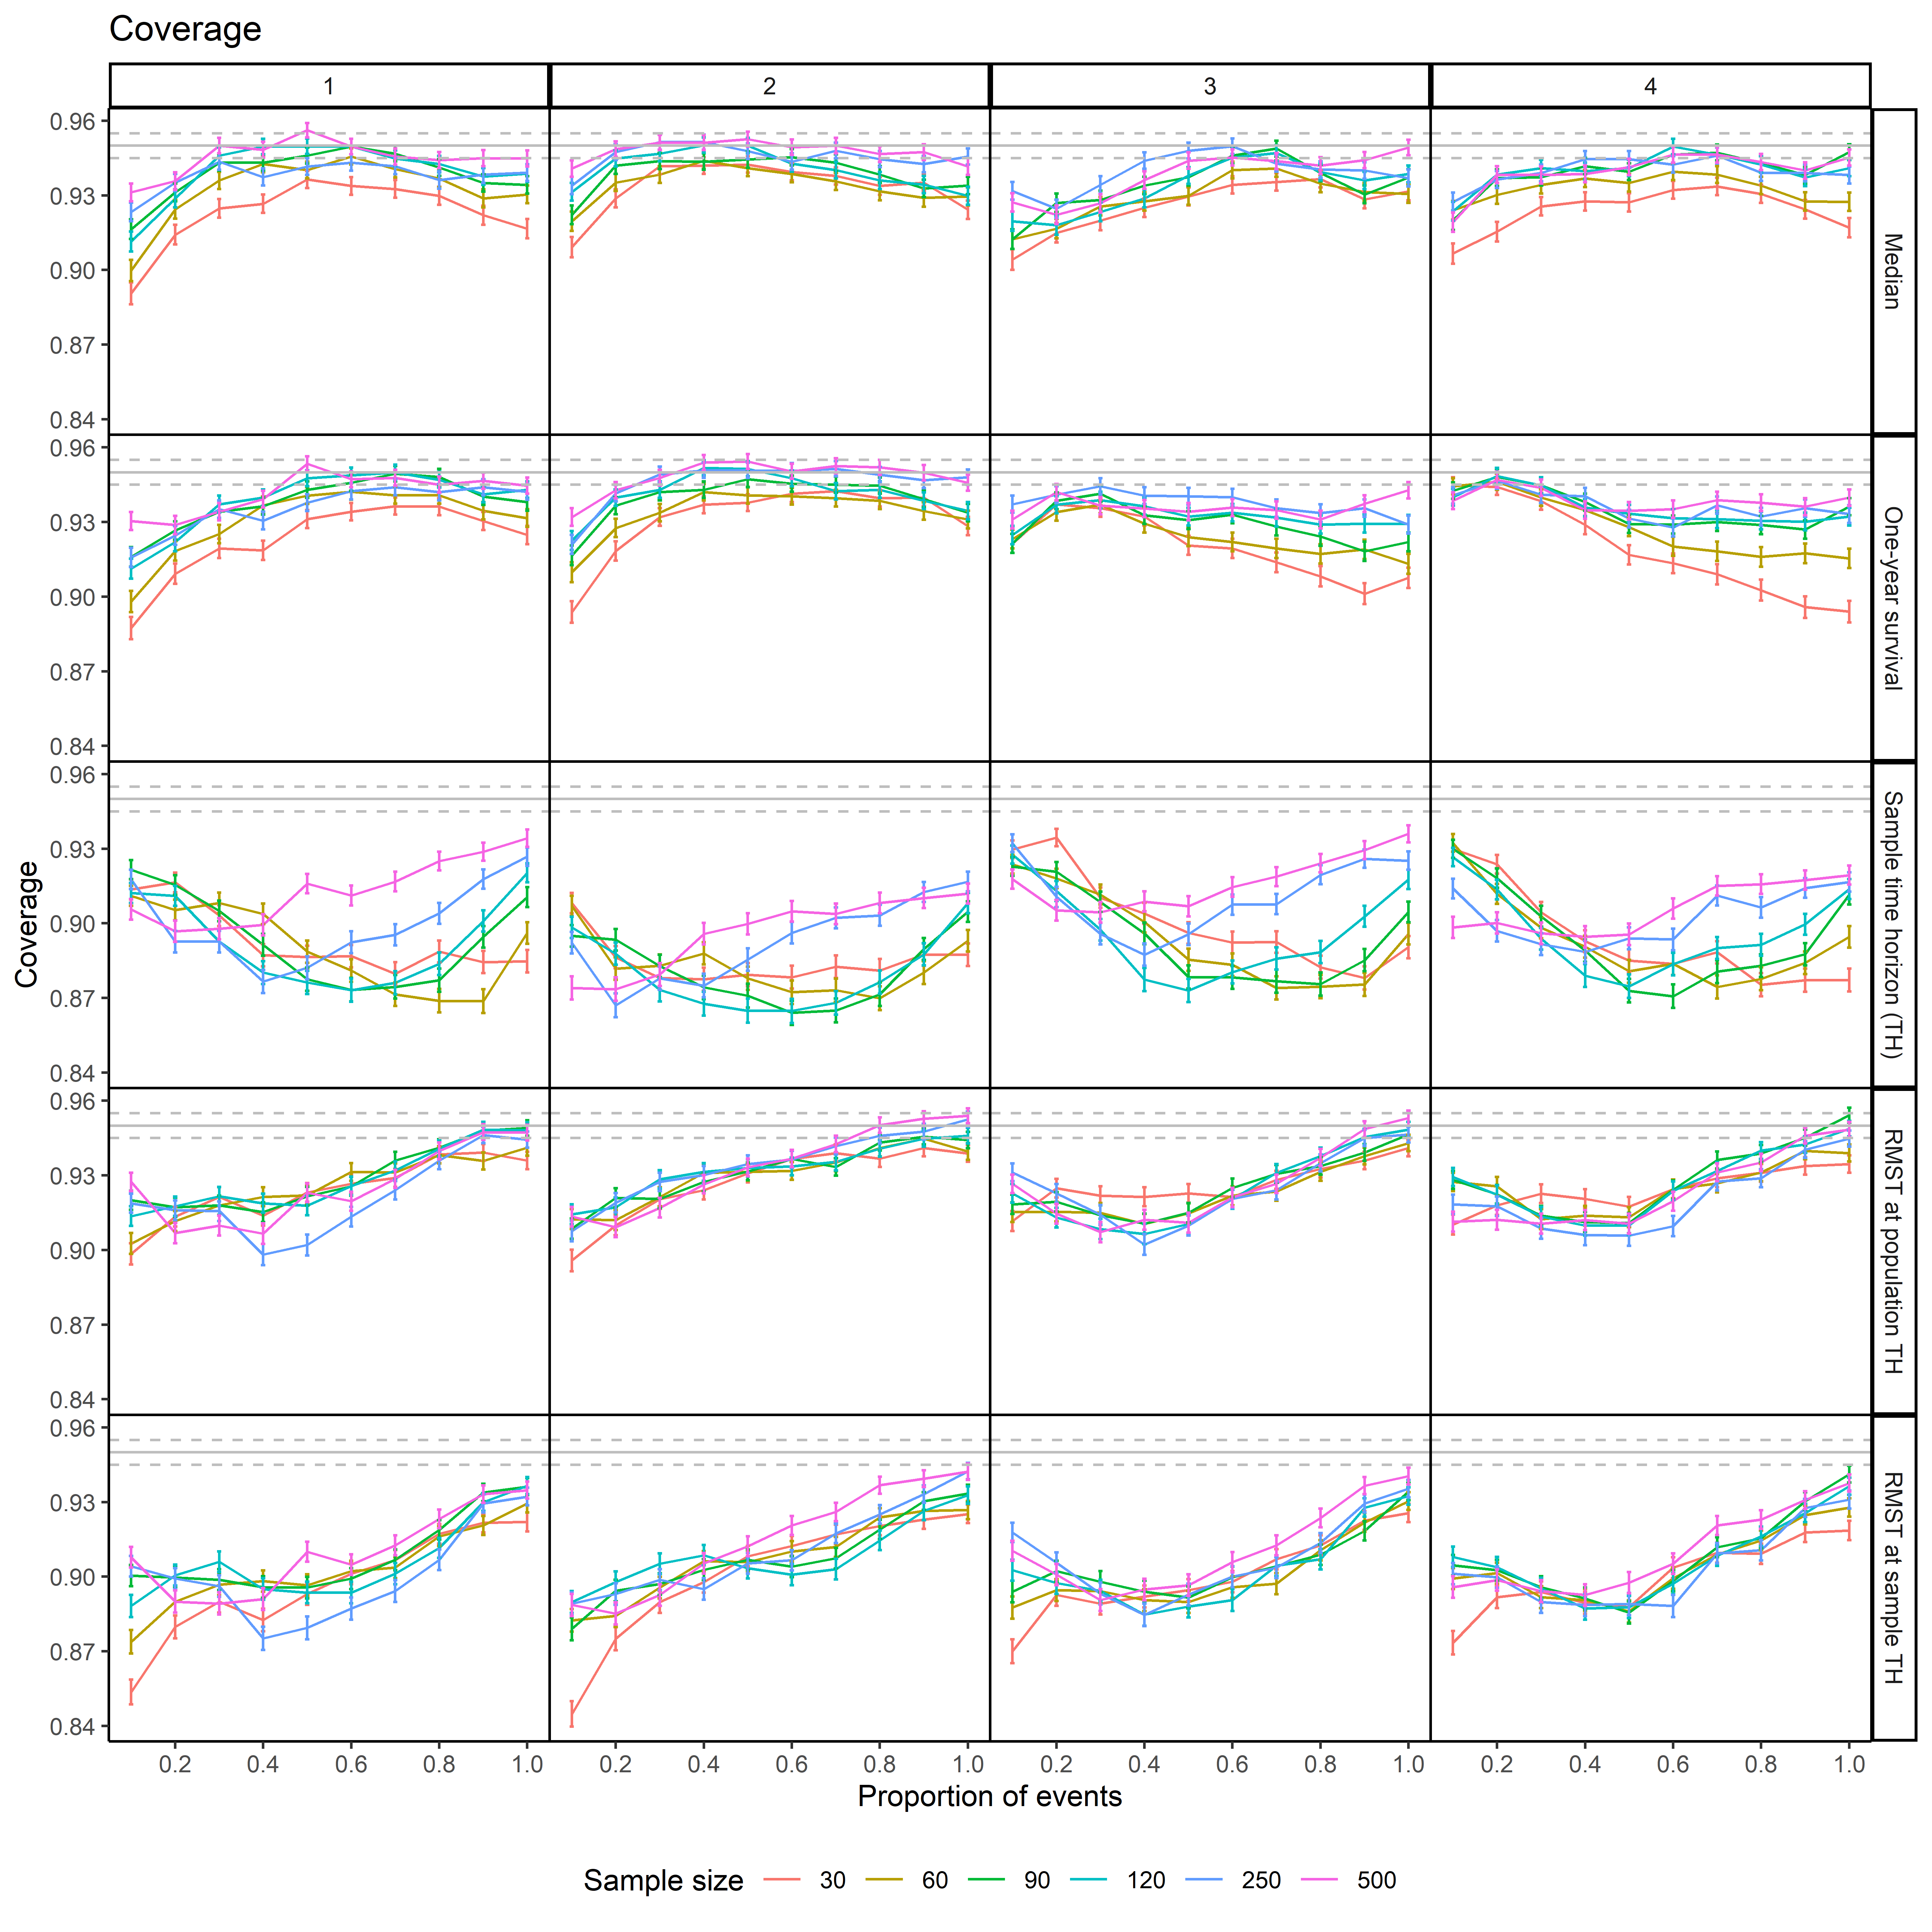
Figure S4-3 Coverage at each sample size and level of proportion of events for each scenario when distribution was chosen by BIC
Scenarios: 1- high event rate, short accrual
2- high event rate, long accrual
3- low event rate, short accrual
4- low event rate, long accrual

Mean absolute percentage error (MAPE)
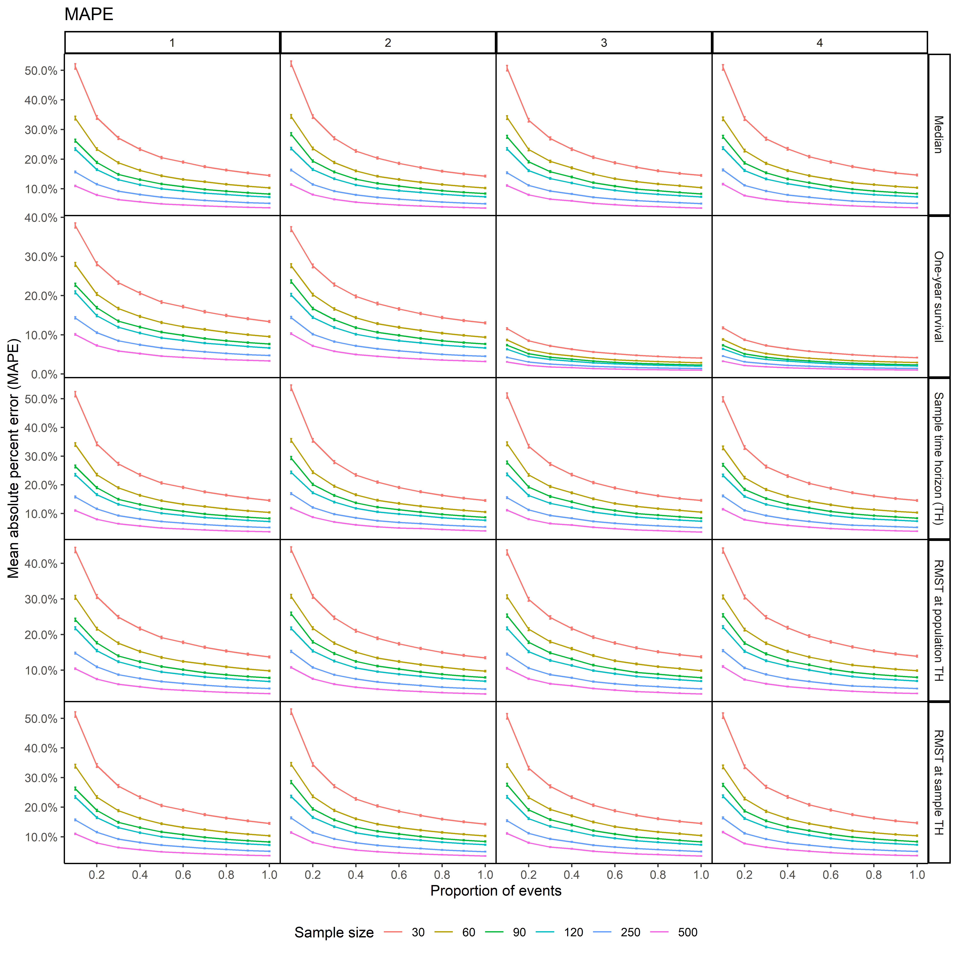 Figure S4-4 Mean absolute percentage error (MAPE) at each sample size and level of proportion of events for each scenario when distribution correctly specified as exponential
Scenarios: 1- high event rate, short accrual
2- high event rate, long accrual
3- low event rate, short accrual
4- low event rate, long accrual
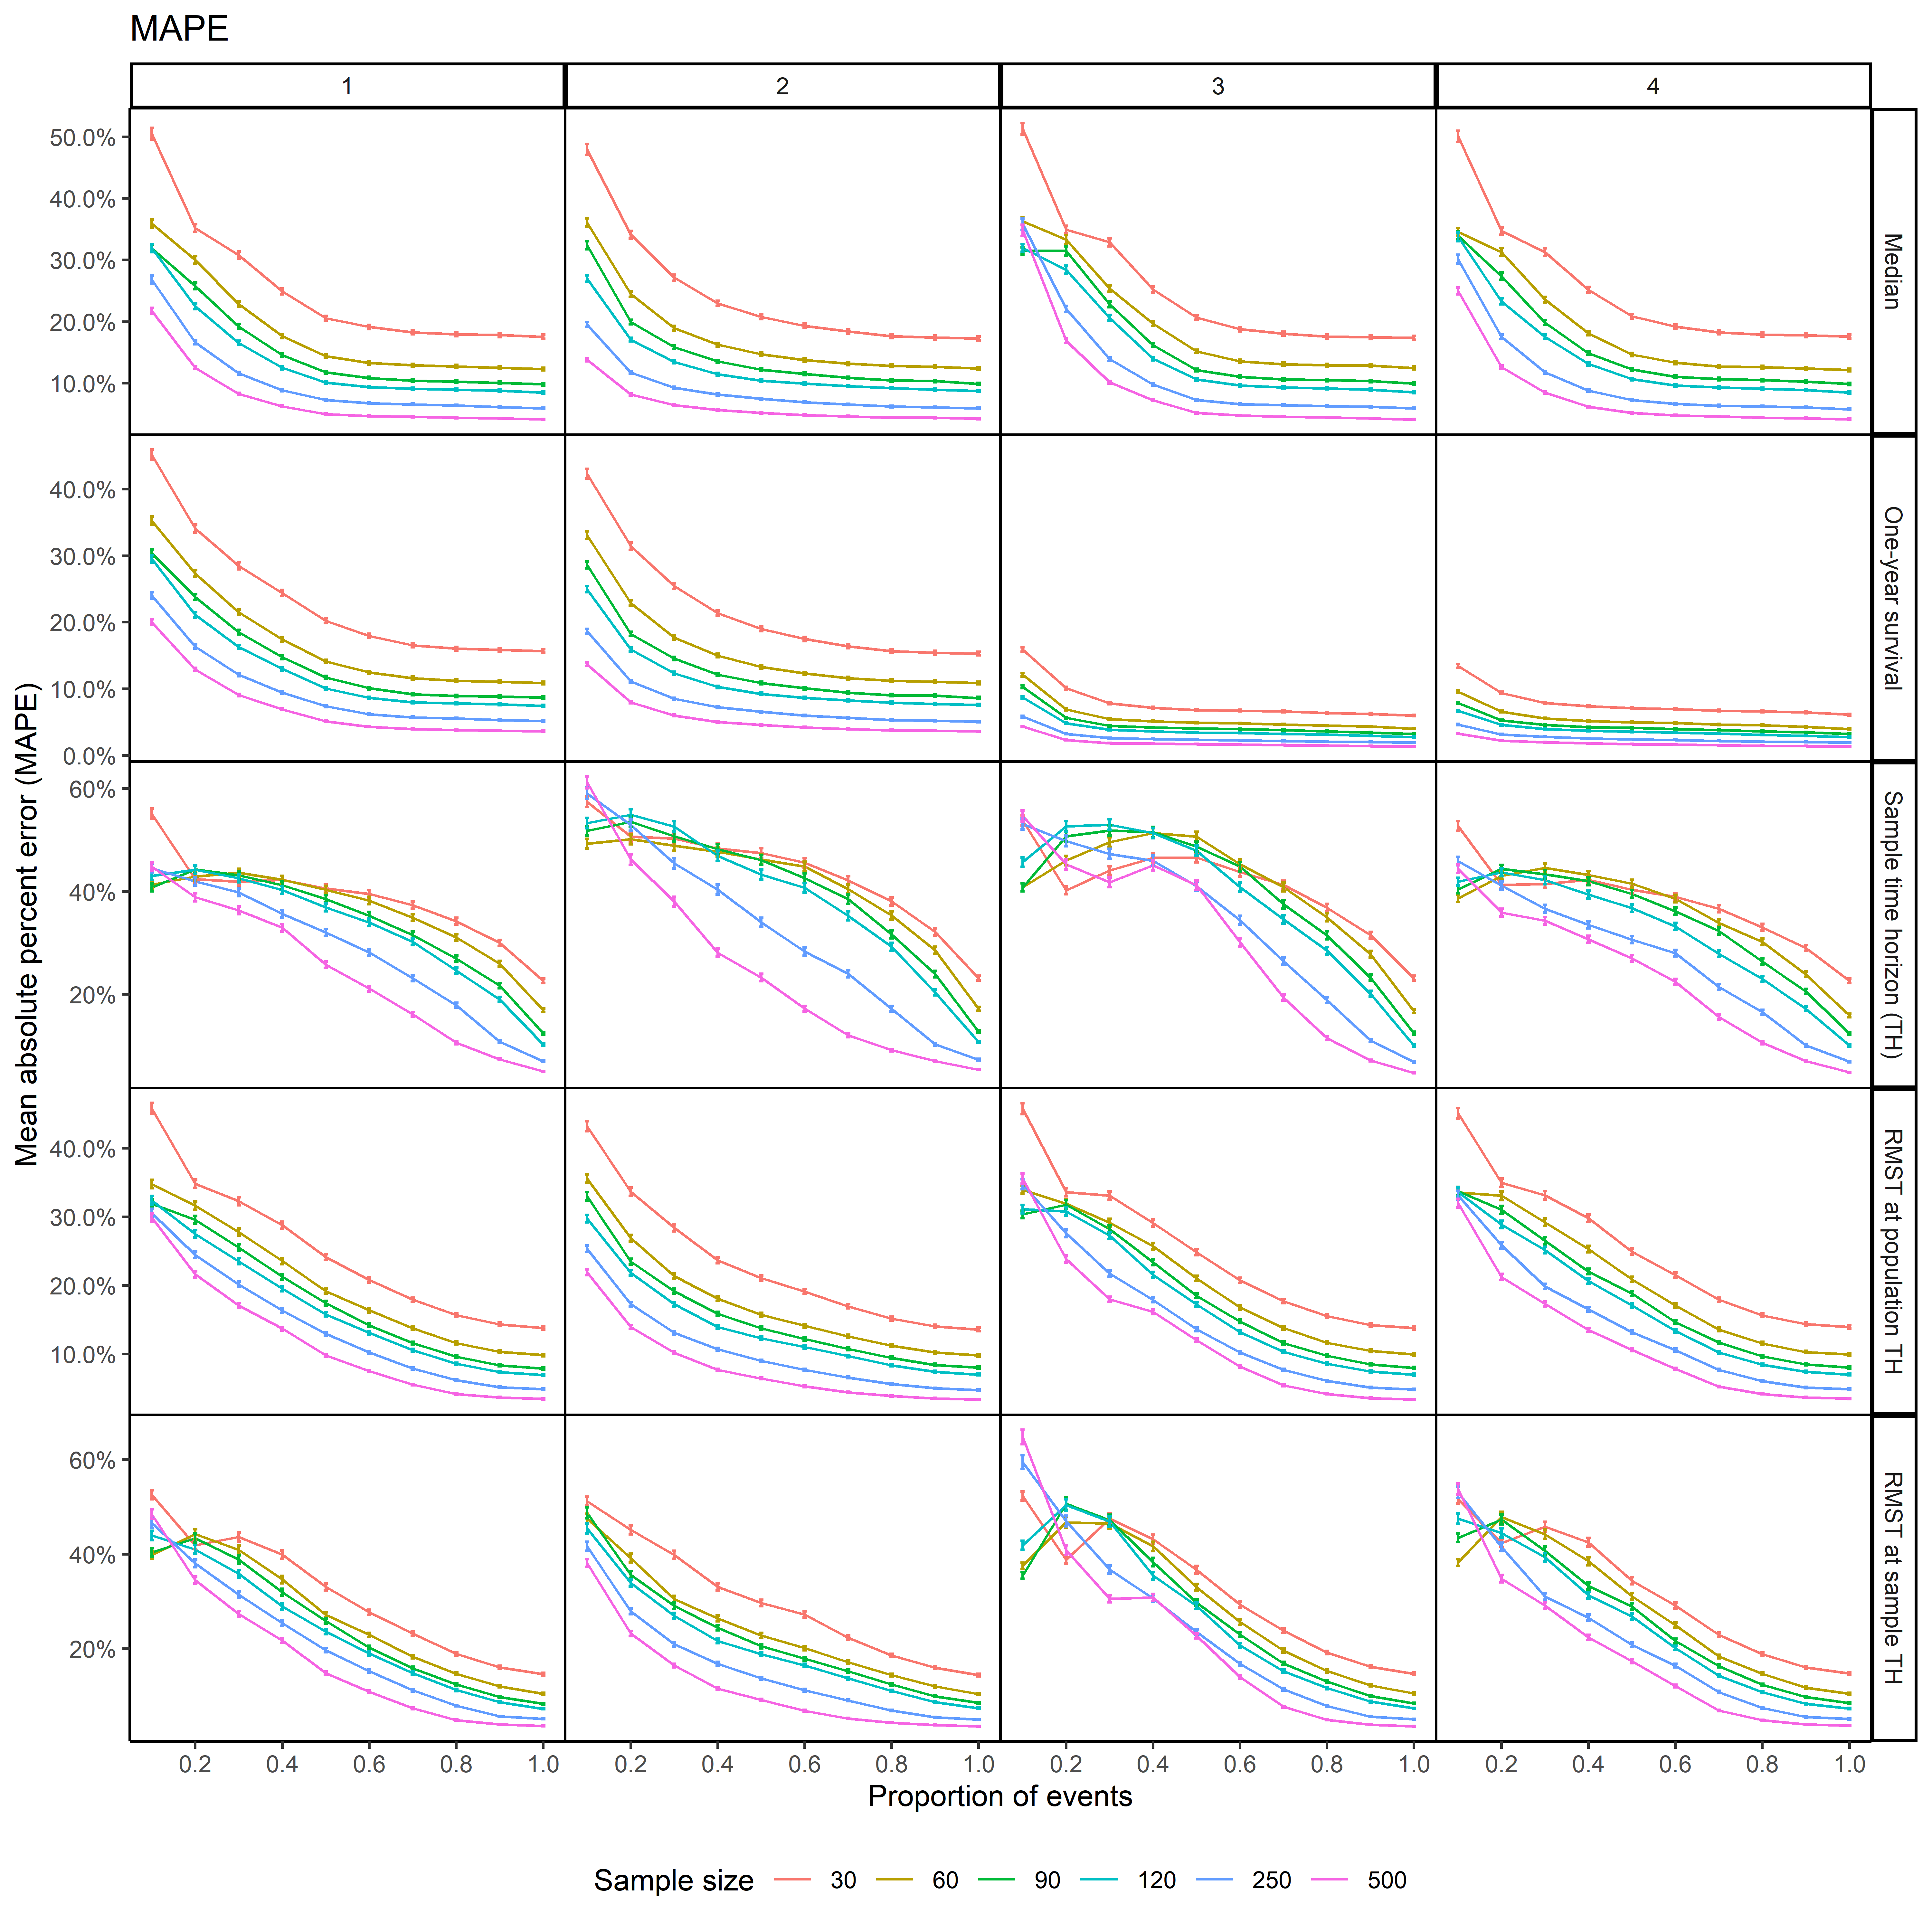
Figure S4-5 Mean absolute percentage error (MAPE) at each sample size and level of proportion of events for each scenario when distribution is chosen by AIC
Scenarios: 1- high event rate, short accrual
2- high event rate, long accrual
3- low event rate, short accrual
4- low event rate, long accrual
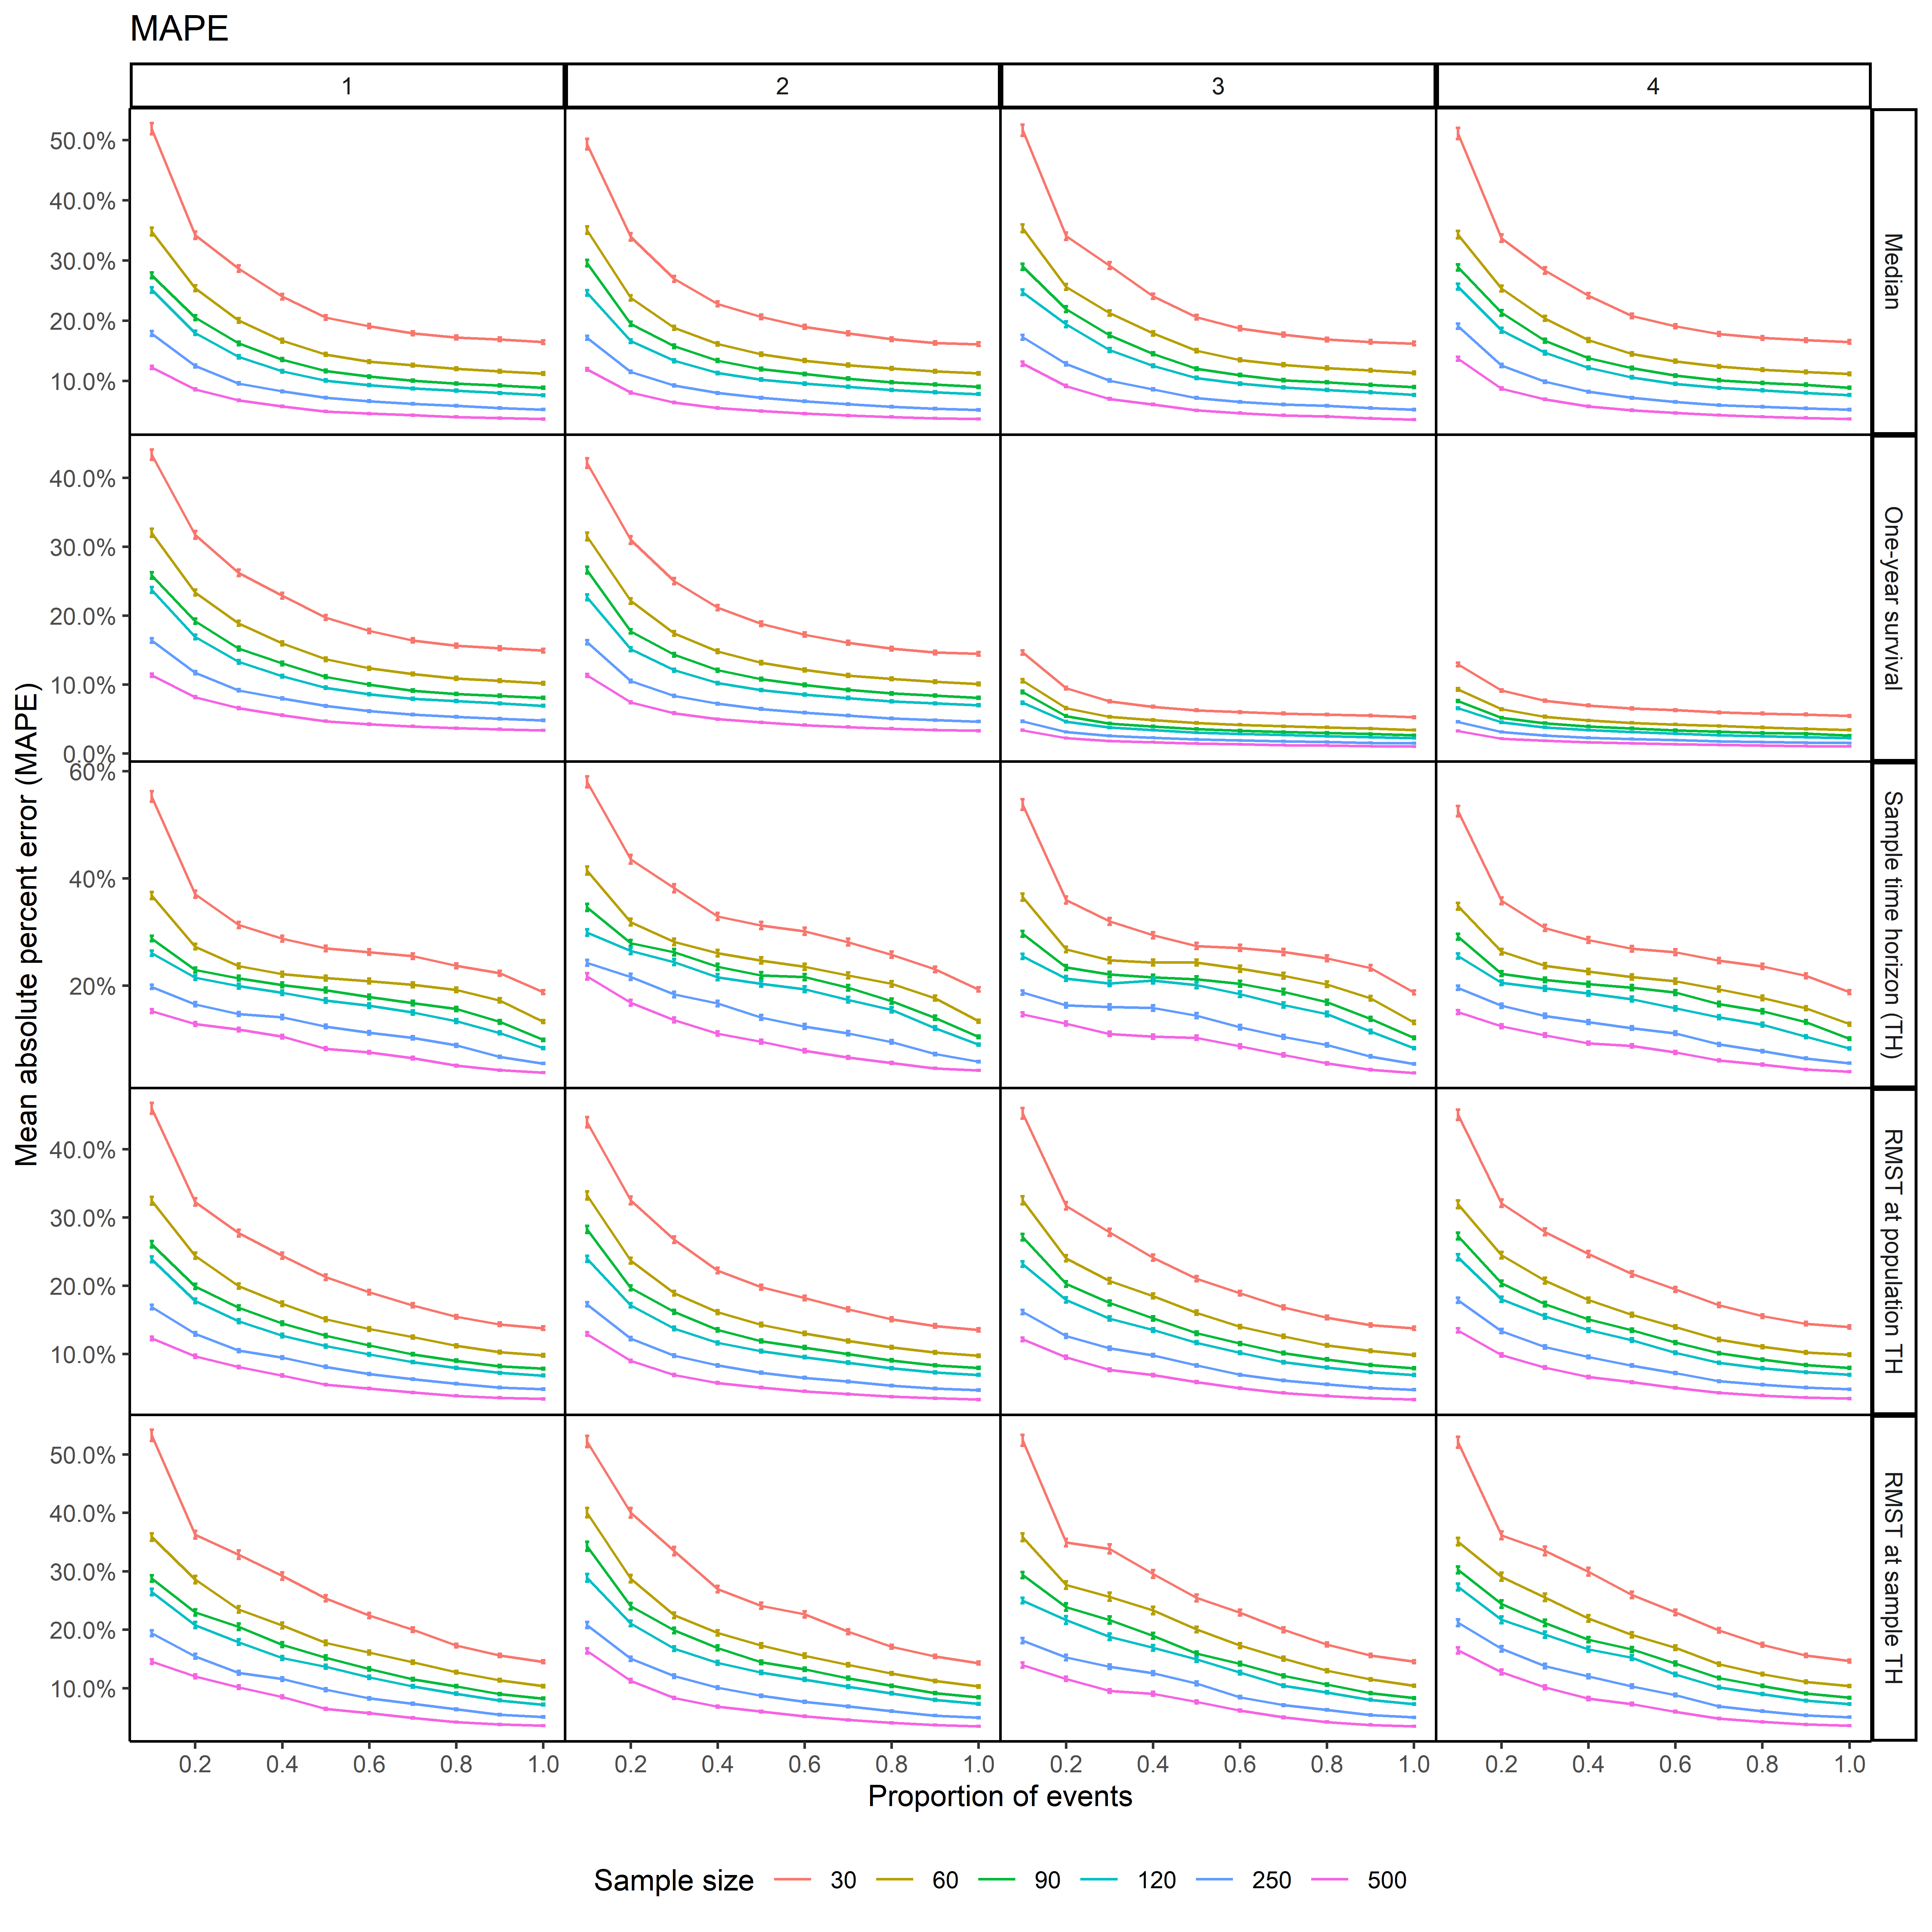
Figure S4-6 Mean absolute error (MAPE) at each sample size and level of proportion of events for each scenario when distribution is chosen by BIC
Scenarios: 1- high event rate, short accrual
2- high event rate, long accrual
3- low event rate, short accrual
4- low event rate, long accrual

Probability of >20% difference
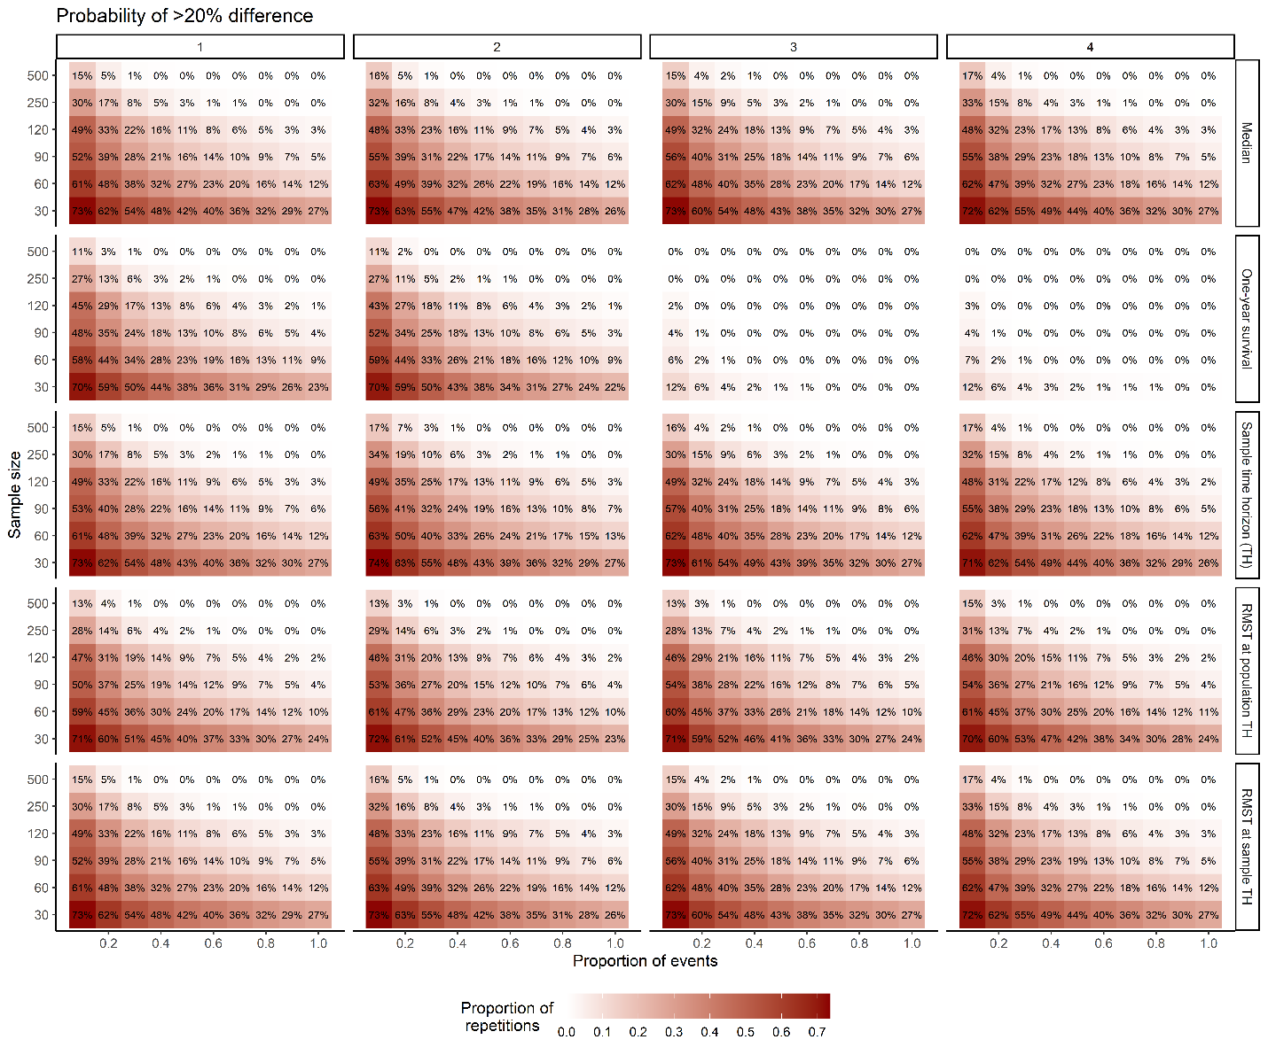
Figure S4-7 Proportion of repetitions with estimates > 20% different from population fitted value across scenarios with distribution correctly specified as exponential
Scenarios: 1- high event rate, short accrual
2- high event rate, long accrual
3- low event rate, short accrual
4- low event rate, long accrual

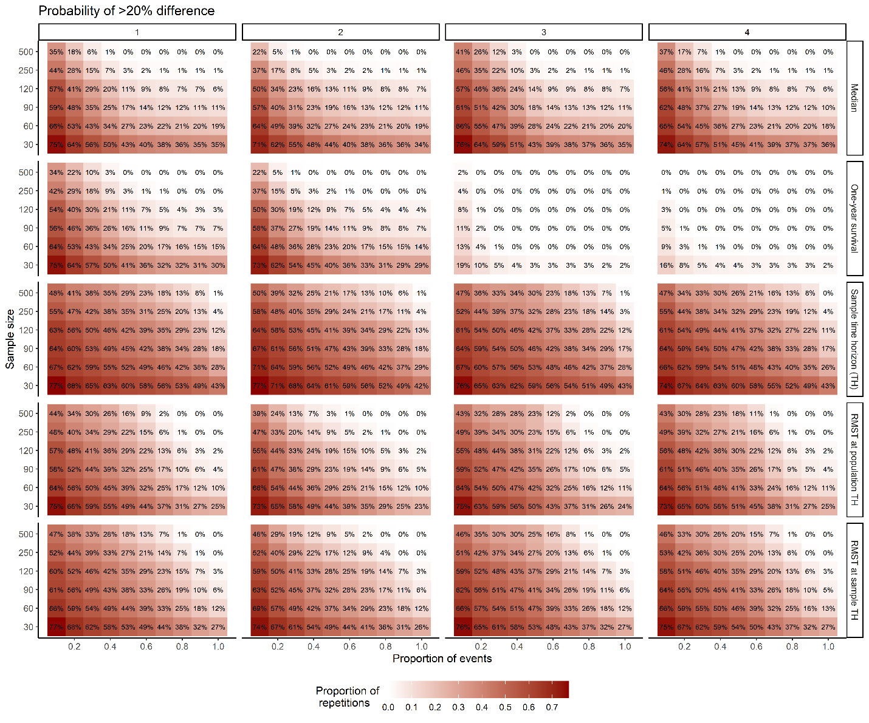
Figure S4-8 Proportion of repetitions with estimates > 20% different from population fitted value across scenarios with distribution specified by AIC
Scenarios: 1- high event rate, short accrual
2- high event rate, long accrual
3- low event rate, short accrual
4- low event rate, long accrual

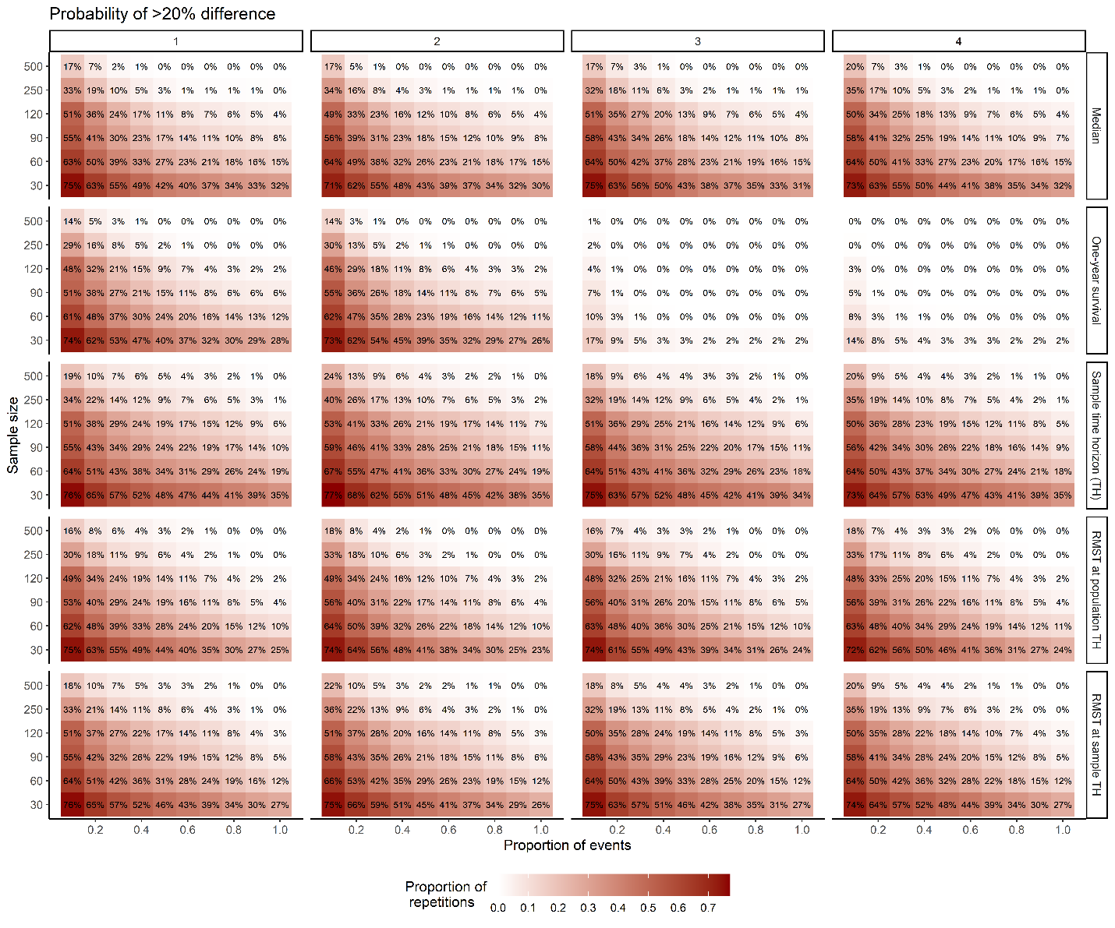
Figure S4-9 Proportion of repetitions with estimates > 20% different from population fitted value across scenarios with distribution specified by BIC
Scenarios: 1- high event rate, short accrual
2- high event rate, long accrual
3- low event rate, short accrual
4- low event rate, long accrual

