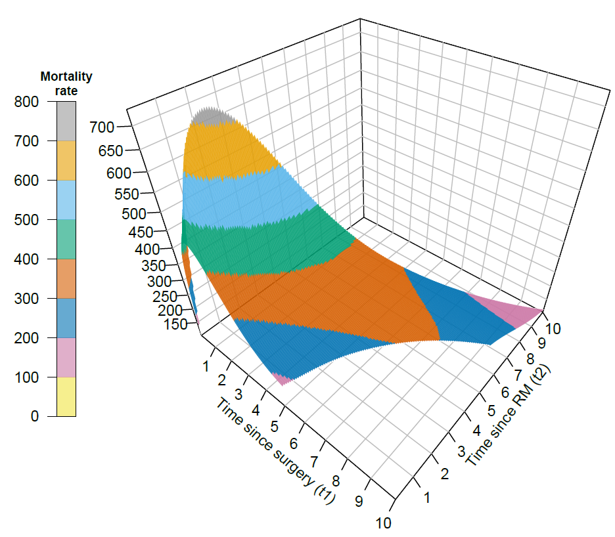
Supplementary Figure 1: Estimated mortality rates surface per 1000 person-years over two time-scales for breast cancer patients in the Rotterdam Breast Cancer data, who were aged 50 at primary surgery, received hormonal therapy and experienced relapse or metastasis (RM).

