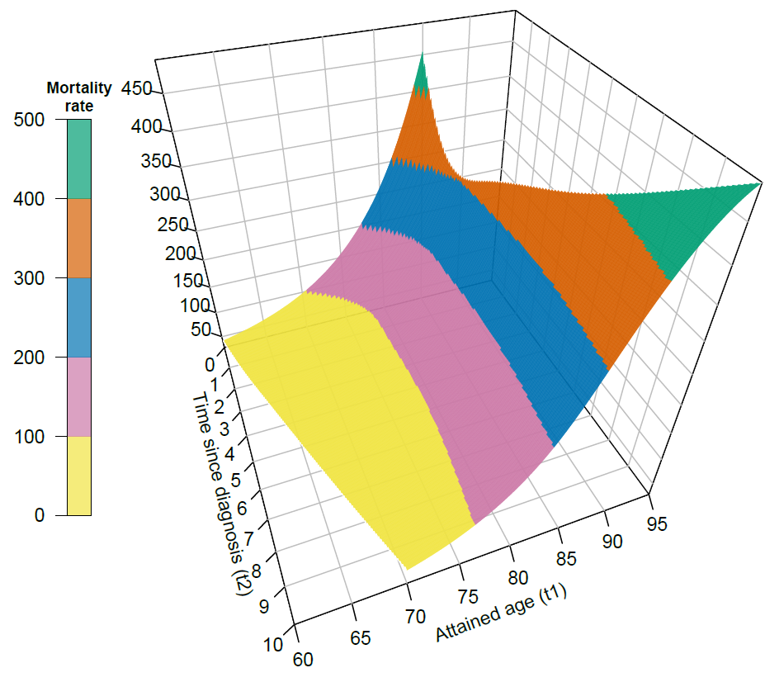 Supplementary Figure 2: Estimated mortality rates surface per 1000 person-years over two time-scales for male MPN patients in Sweden.

