Supplemental Online Content

Power and sample sizes estimation in clinical trials with treatment switching in intention-to-treat analysis: a simulation study
Lejun Deng^{1#}, Chih-Yuan Hsu^{2,3#}, Yu Shyr^{2,3*}

¹Montgomery Bell Academy, Nashville, TN, 37205, USA
²Department of Biostatistics, Vanderbilt University Medical Center, Nashville, TN 37232, USA
³Center for Quantitative Sciences, Vanderbilt University Medical Center, Nashville, TN 37232, USA
*corresponding authors: Yu Shyr (yu.shyr@vanderbilt.edu)
# These authors contributed equally.

- Details for censoring distribution

- Parameters determination in beta, gamma, uniform, and independent exponential distributions via pt and rho

- Figure s1: Weibull survival functions with different shapes and $m_{1}$ = 1 and $m_{2}$ = 1.5.

- Table s1: Simulation results for powers and sample sizes under $s = 0.5$ and administrative censoring only (censor.rate = “AC.only”).

- Table s2: Simulation results for powers and sample sizes under $s = 1$ and administrative censoring only (censor.rate = “AC.only”).

Details for censoring distribution
The censoring consists of both dropout censoring and administrative censoring. The distribution of the censoring can be expressed as follows:
$$f\left(c | v\right)=d\left(c\right)I\left(0<c<T_{e}-v\right)+ \overline{D}\left(T_{e}-v\right)I\left(c=T_{e}-v\right),$$
where $v$ is the entry time which follows a uniform distribution $U(0, T_{a})$, and $d\left(c\right)$ and $\overline{D}\left(c\right)$ are the density function and survival function of dropout censoring, respectively. $I(∙)$ is the indicator function. For simplicity, we assume a uniform distribution for the dropout censoring, i.e., $d(c) = h^{-1} I(0 < c < h)$. $h$ is determined by the formula of $P\left(C_{1}<T_{1}\right)$ with a given censoring rate of the control group assuming no treatment switching, where $P\left(C_{1}<T_{1}\right)$ is a function of $h$ and can be explicitly expressed as follows:
$$P\left(C_{1}<T_{1}\right)=\int_{0}^{T_{a}}{P\left(C_{1}<T_{1}\right|v)}f\left(v\right)dv,$$
Where$$P\left(C_{1}<T_{1}\right|v)=\int_{0}^{T_{e}-v}{\int_{c}^{∞}{f\left(c | v\right)f_{T_{1}}\left(t\right)}dt dc}+ \int_{T_{e}-v}^{∞}{\int_{c}^{∞}{f\left(c | v\right)f_{T_{1}}\left(t\right)}dt dc} \\ =\int_{0}^{T_{e}-v}{\int_{c}^{∞}{d\left(c\right)f_{T_{1}}\left(t\right)}dt dc}+\overline{D}\left(T_{e}-v\right)\int_{T_{e}-v}^{∞}{f_{T_{1}}\left(t\right)}dt \\ =\int_{0}^{{min⁡(T}_{e}-v, h)}{h^{-1}\int_{c}^{∞}{f_{T_{1}}\left(t\right)}dt dc}+I\left(h>T_{e}-v\right)\left(1-h^{-1}\left(T_{e}-v\right)\right)\int_{T_{e}-v}^{∞}{f_{T_{1}}\left(t\right)}dt \\ ={\left(hλ_{1}\right)}^{-1}\left(1-e^{-λ_{1} min\left(T_{e}-v, h\right)}\right)+I\left(h>T_{e}-v\right)\left(1-h^{-1}\left(T_{e}-v\right)\right)e^{-λ_{1}\left(T_{e}-v\right)}. \\ \left(if T_{1} follows an exponential distribution with the median of m_{1}. λ_{1}=\log\left(2\right)/m_{1}\right)$$For $T_{e}-T_{a}<h<T_{e}$,
$P\left(C_{1}<T_{1}\right)=\int_{0}^{T_{e}-h}{{\left(hλ_{1}\right)}^{-1}\left(1-e^{-λ_{1} h}\right)}f_{V}\left(v\right)dv+\int_{T_{e}-h}^{T_{a}}{{\left(hλ_{1}\right)}^{-1}\left(1-e^{-λ_{1} {(T}_{e}-v)}\right)}f_{V}\left(v\right)dv$
$$+\int_{T_{e}-h}^{T_{a}}{\left(1-h^{-1}\left(T_{e}-v\right)\right)e^{-λ_{1}\left(T_{e}-v\right)}}f_{V}\left(v\right)dv$$
$$={\left(hλ_{1}T_{a}\right)}^{-1}\left(1-e^{-λ_{1} h}\right)\left(T_{e}-h\right)+{\left(hλ_{1}T_{a}\right)}^{-1}\left(T_{a}-\left(T_{e}-h\right)\right)-{\left(hλ_{1}T_{a}\right)}^{-1}\int_{T_{e}-h}^{T_{a}}{e^{-λ_{1} {(T}_{e}-v)}}dv \\ + T_{a}^{-1}\int_{T_{e}-h}^{T_{a}}{e^{-λ_{1} {(T}_{e}-v)}}dv-{\left(hT_{a}\right)}^{-1}\int_{T_{e}-h}^{T_{a}}{\left(T_{e}-v\right)e^{-λ_{1} {(T}_{e}-v)}}dv \\ ={\left(hλ_{1}T_{a}\right)}^{-1}\left\{\left(1-e^{-λ_{1} h}\right)\left(T_{e}-h\right)+\left(T_{a}-\left(T_{e}-h\right)\right)-{λ_{1}^{-1}b}_{2}\left(h\right)+hb_{2}\left(h\right)-(b_{1}\left(h\right)+{λ_{1}^{-1}b}_{2}\left(h\right))\right\},$$
where $b_{1}\left(x\right)=\left(T_{e}-T_{a}\right)e^{-λ_{1} {(T}_{e}-T_{a})}-x e^{-λ_{1}x}$ and $b_{2}\left(x\right)=e^{-λ_{1} {(T}_{e}-T_{a})}-e^{-λ_{1}x}$.
For $h≤T_{e}-T_{a}$,
$P\left(C_{1}<T_{1}\right)=\int_{0}^{T_{a}}{{\left(hλ_{1}\right)}^{-1}\left(1-e^{-λ_{1} h}\right)}f_{V}\left(v\right)dv={\left(hλ_{1}\right)}^{-1}\left(1-e^{-λ_{1} h}\right)$.
For $T_{e}≤h$,
$$P\left(C_{1}<T_{1}\right)=\int_{0}^{T_{a}}{{\left(hλ_{1}\right)}^{-1}\left(1-e^{-λ_{1} \left(T_{e}-v\right)}\right)}f_{V}\left(v\right)dv+\int_{0}^{T_{a}}{\left(1-h^{-1}\left(T_{e}-v\right)\right)e^{-λ_{1}\left(T_{e}-v\right)}}f_{V}\left(v\right)dv \\ ={\left(hλ_{1}T_{a}\right)}^{-1}\left(T_{a}-λ_{1}^{-1}b_{2}\left(T_{e}\right)+hb_{2}\left(T_{e}\right)-(b_{1}\left(T_{e}\right)+{λ_{1}^{-1}b}_{2}\left(T_{e}\right))\right). \\ \left(={\left(hλ_{1}\right)}^{-1}\left(1-e^{-λ_{1}T_{e}}+hλ_{1}e^{-λ_{1}T_{e}}-λ_{1}T_{e}e^{-λ_{1}T_{e}}\right) if T_{a}=0\right)$$

Parameters determination in beta, gamma, uniform, and independent exponential distributions via pt and rho
We consider using $pt$ and rho to determine the parameters in the assumed distributions for the switching time, where $pt=E(s)/E\left(T_{1}\right)$ denotes the ratio of the average switching time to the average survival time of the control group, and rho denotes the correlation between $s=XT_{1}$ and $T_{1}$. When $pt$ and $rho$ are given, the parameters in the assumed distributions can be obtained through solving the two equations: $pt=E(s)/E\left(T_{1}\right)=E(X)$ and
$$rho=cor\left(s, T_{1}\right)=\frac{E\left(XT_{1}^{2}\right)-E\left(XT_{1}\right)E\left(T_{1}\right)}{\sqrt{Var\left(s\right)}\sqrt{Var\left(T_{1}\right)}}=\frac{E\left(X\right)\sqrt{Var\left(T_{1}\right)}}{\sqrt{E\left(X^{2}\right)Var\left(T_{1}\right)+Var\left(X\right){\left(E\left(T_{1}\right)\right)}^{2}}} \\ =\frac{E(X)}{\sqrt{E\left(X^{2}\right)+Var(X)}} \left(if T_{1} follows an exponential distribution\right),$$
where
$$Var\left(s\right)=E\left(X^{2}\right)E\left(T_{1}^{2}\right)-{\left(E\left(X\right)\right)}^{2}{\left(E\left(T_{1}\right)\right)}^{2} \\ =E\left(X^{2}\right)E\left(T_{1}^{2}\right)-E\left(X^{2}\right){\left(E\left(T_{1}\right)\right)}^{2}+{E\left(X^{2}\right){\left(E\left(T_{1}\right)\right)}^{2}-\left(E\left(X\right)\right)}^{2}{\left(E\left(T_{1}\right)\right)}^{2} \\ =E\left(X^{2}\right)Var\left(T_{1}\right)+Var\left(X\right){\left(E\left(T_{1}\right)\right)}^{2}.$$
When $s=XT_{1}$ and $X\sim beta(a,b)$, $pt=a/(a+b)$ and $rho=\left\{\frac{a}{a+b}\right\}/ {\left\{{\left(\frac{a}{a+b}\right)}^{2}+\frac{2ab}{{\left(a+b\right)}^{2}\left(a+b+1\right)}\right\}}^{1/2}$. When $s=XT_{1}$ and $X\sim gamma(a,b)$, $pt=a/b$ and $rho=\left\{\frac{a}{b}\right\}/ {\left\{{\left(\frac{a}{b}\right)}^{2}+\frac{2a}{b^{2}}\right\}}^{1/2}$. When $s$ follows an exponential distribution and is independent of $T_{1}$, the mean parameter can be determined by $E\left(s\right)=pt E\left(T_{1}\right)=pt {×m}_{1}/log⁡(2).$ When $s=XT_{1}$ and $X$ follows a uniform distribution $U(0, 1)$, i.e., $s$ follows a uniform distribution $U\left(0, T_{1}\right)$, then $pt$ equals 0.5 and $rho$ is a constant (= 0.775 if $T_{1}$ follows an exponential distribution).

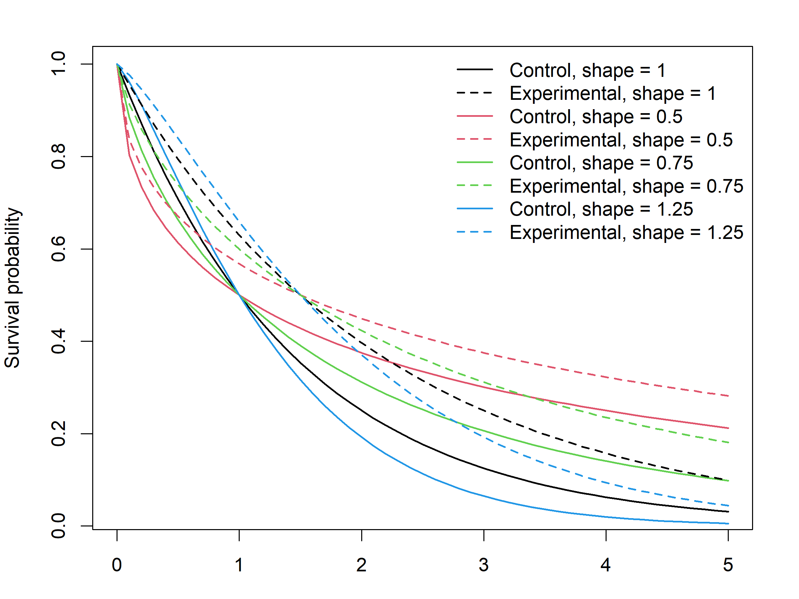
Figure s1. Weibull survival functions with different shapes and $m_{1}$ = 1 and $m_{2}$ = 1.5.
Table s1. Simulation results for powers and sample sizes under $s = 0.5$ and administrative censoring only (censor.rate = “AC.only”). power = 0.8, alpha = 0.05, $m_{1}$ = 1, $T_{a}$ = 3, $T_{e}$ = 5.
$$r$$ | $$p$$ | $$m_{2}/m_{1}$$ | $$n_{no-s}$$  (no switch) | $$n_{S}$$  (switch) | Ratio of  $$n_{s}/n_{no-s}$$ | Power based on $n_{no-s}$
1 | 0.2 | 1.25 | 369 | 501 | 1.358 | 0.668
 |  | 1.50 | 115 | 160 | 1.391 | 0.665
 |  | 1.75 | 63 | 87 | 1.396 | 0.652
 |  | 2.00 | 42 | 59 | 1.404 | 0.647
1 | 0.4 | 1.25 | 369 | 715 | 1.938 | 0.525
 |  | 1.50 | 115 | 234 | 2.035 | 0.516
 |  | 1.75 | 63 | 129 | 2.048 | 0.505
 |  | 2.00 | 42 | 87 | 2.071 | 0.504
1 | 0.6 | 1.25 | 369 | 1064 | 2.883 | 0.365
 |  | 1.50 | 115 | 364 | 3.165 | 0.355
 |  | 1.75 | 63 | 199 | 3.159 | 0.353
 |  | 2.00 | 42 | 139 | 3.310 | 0.350
1 | 0.8 | 1.25 | 369 | 1849 | 5.011 | 0.246
 |  | 1.50 | 115 | 616 | 5.617 | 0.223
 |  | 1.75 | 63 | 343 | 5.444 | 0.227
 |  | 2.00 | 42 | 233 | 5.548 | 0.235
1 | 1.0 | 1.25 | 369 | 3728 | 10.103 | 0.142
 |  | 1.50 | 115 | 1230 | 10.696 | 0.141
 |  | 1.75 | 63 | 691 | 10.968 | 0.138
 |  | 2.00 | 42 | 487 | 11.595 | 0.134
2 | 0.2 | 1.25 | 271 | 371 | 1.369 | 0.675
 |  | 1.50 | 82 | 117 | 1.427 | 0.652
 |  | 1.75 | 45 | 66 | 1.467 | 0.663
 |  | 2.00 | 31 | 46 | 1.484 | 0.665
2 | 0.4 | 1.25 | 271 | 535 | 1.974 | 0.526
 |  | 1.50 | 82 | 170 | 2.073 | 0.507
 |  | 1.75 | 45 | 94 | 2.089 | 0.515
 |  | 2.00 | 31 | 63 | 2.032 | 0.501
2 | 0.6 | 1.25 | 271 | 810 | 2.980 | 0.375
 |  | 1.50 | 82 | 262 | 3.195 | 0.362
 |  | 1.75 | 45 | 148 | 3.289 | 0.361
 |  | 2.00 | 31 | 102 | 3.290 | 0.366
2 | 0.8 | 1.25 | 271 | 1395 | 5.148 | 0.239
 |  | 1.50 | 82 | 457 | 5.573 | 0.233
 |  | 1.75 | 45 | 252 | 5.600 | 0.232
 |  | 2.00 | 31 | 178 | 5.742 | 0.238
2 | 1.0 | 1.25 | 271 | 2796 | 10.314 | 0.147
 |  | 1.50 | 82 | 937 | 11.427 | 0.139
 |  | 1.75 | 45 | 513 | 11.400 | 0.148
 |  | 2.00 | 31 | 361 | 11.645 | 0.161
$n_{s}$ and $n_{no-s}$ denote the required sample size with and without treatment switching, respectively.

Table s2. Simulation results for powers and sample sizes under $s = 1$ and administrative censoring only (censor.rate = “AC.only”). power = 0.8, alpha = 0.05, $m_{1}$ = 1, $T_{a}$ = 3, $T_{e}$ = 5.
$$r$$ | $$p$$ | $$m_{2}/m_{1}$$ | $$n_{no-s}$$  (no switch) | $$n_{S}$$  (switch) | Ratio of  $$n_{s}/n_{no-s}$$ | Power based on $n_{no-s}$
1 | 0.2 | 1.25 | 369 | 446 | 1.209 | 0.716
 |  | 1.50 | 115 | 143 | 1.243 | 0.700
 |  | 1.75 | 63 | 81 | 1.286 | 0.693
 |  | 2.00 | 42 | 56 | 1.310 | 0.689
1 | 0.4 | 1.25 | 369 | 560 | 1.518 | 0.610
 |  | 1.50 | 115 | 179 | 1.557 | 0.620
 |  | 1.75 | 63 | 98 | 1.556 | 0.595
 |  | 2.00 | 42 | 68 | 1.619 | 0.600
1 | 0.6 | 1.25 | 369 | 706 | 1.913 | 0.507
 |  | 1.50 | 115 | 231 | 2.009 | 0.504
 |  | 1.75 | 63 | 128 | 2.032 | 0.513
 |  | 2.00 | 42 | 86 | 2.048 | 0.514
1 | 0.8 | 1.25 | 369 | 916 | 2.482 | 0.423
 |  | 1.50 | 115 | 299 | 2.600 | 0.409
 |  | 1.75 | 63 | 168 | 2.667 | 0.418
 |  | 2.00 | 42 | 119 | 2.833 | 0.407
1 | 1.0 | 1.25 | 369 | 1278 | 3.463 | 0.324
 |  | 1.50 | 115 | 401 | 3.487 | 0.313
 |  | 1.75 | 63 | 225 | 3.514 | 0.313
 |  | 2.00 | 42 | 156 | 3.714 | 0.300
2 | 0.2 | 1.25 | 271 | 329 | 1.214 | 0.723
 |  | 1.50 | 82 | 103 | 1.256 | 0.716
 |  | 1.75 | 45 | 57 | 1.267 | 0.711
 |  | 2.00 | 31 | 41 | 1.323 | 0.708
2 | 0.4 | 1.25 | 271 | 409 | 1.509 | 0.634
 |  | 1.50 | 82 | 131 | 1.598 | 0.628
 |  | 1.75 | 45 | 72 | 1.600 | 0.621
 |  | 2.00 | 31 | 48 | 1.548 | 0.613
2 | 0.6 | 1.25 | 271 | 516 | 1.904 | 0.528
 |  | 1.50 | 82 | 168 | 2.049 | 0.521
 |  | 1.75 | 45 | 92 | 2.044 | 0.495
 |  | 2.00 | 31 | 64 | 2.065 | 0.503
2 | 0.8 | 1.25 | 271 | 684 | 2.524 | 0.434
 |  | 1.50 | 82 | 223 | 2.720 | 0.418
 |  | 1.75 | 45 | 124 | 2.756 | 0.421
 |  | 2.00 | 31 | 83 | 2.677 | 0.429
2 | 1.0 | 1.25 | 271 | 918 | 3.387 | 0.329
 |  | 1.50 | 82 | 306 | 3.732 | 0.312
 |  | 1.75 | 45 | 168 | 3.733 | 0.340
 |  | 2.00 | 31 | 116 | 3.742 | 0.329
$n_{s}$ and $n_{no-s}$ denote the required sample size with and without treatment switching, respectively.

