Supplementary Material for
The Preventiometer - Reliability of a cardiovascular multi-device measurement platform and its measurement agreement with a cohort study

In Study 2 one data pair for the weight in kg for stationary Preventiometer was excluded, while for the mobile Preventiometer 2 data pairs for weight in kg and 2 data pairs for height in cm were excluded. The corresponding Blend-Altman plots are compared to provide a visualization of differences between data with and without this correction (see Figure a).

 | with correction (as in paper) | without correction
weight in kg for stationary Preventiometer | 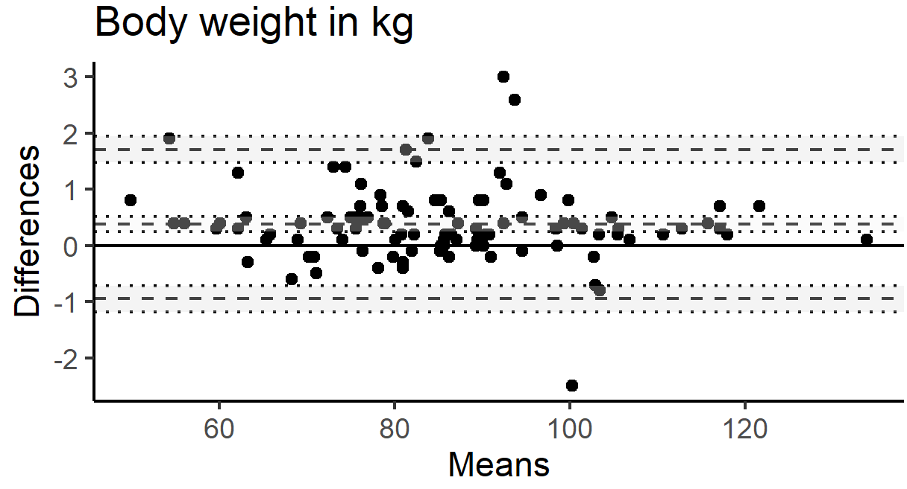 | 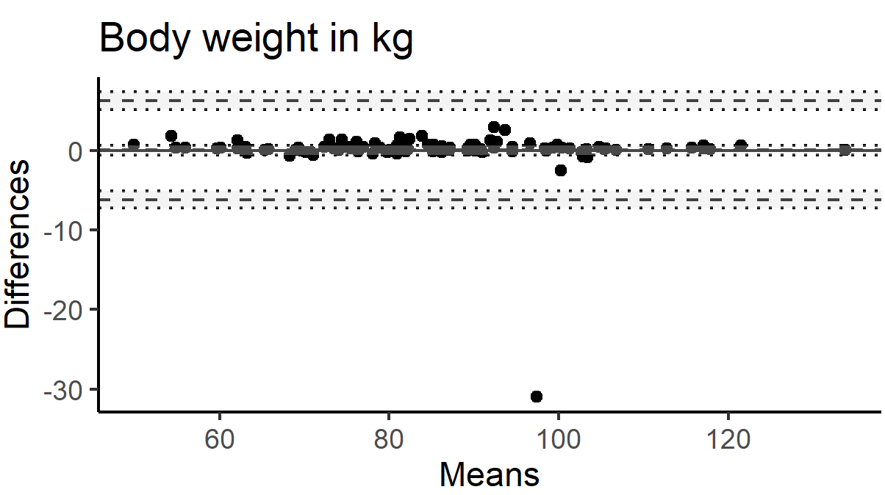
weight in kg for mobile Preventiometer | 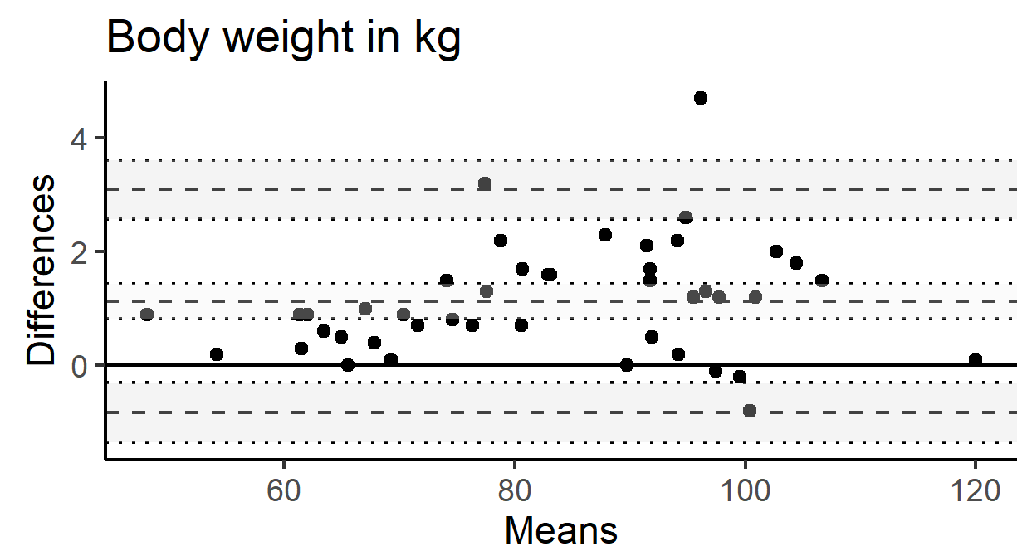 | 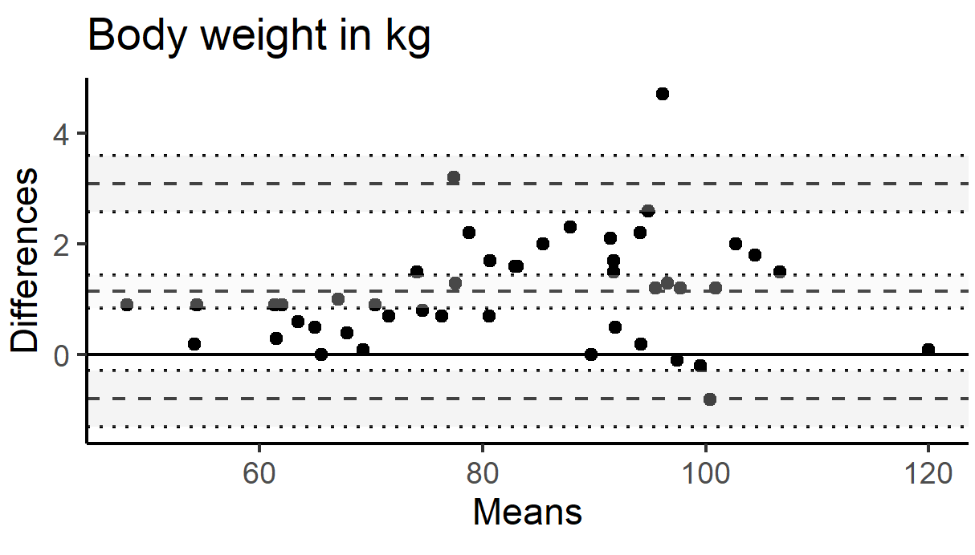
height in cm for stationary Preventiometer | 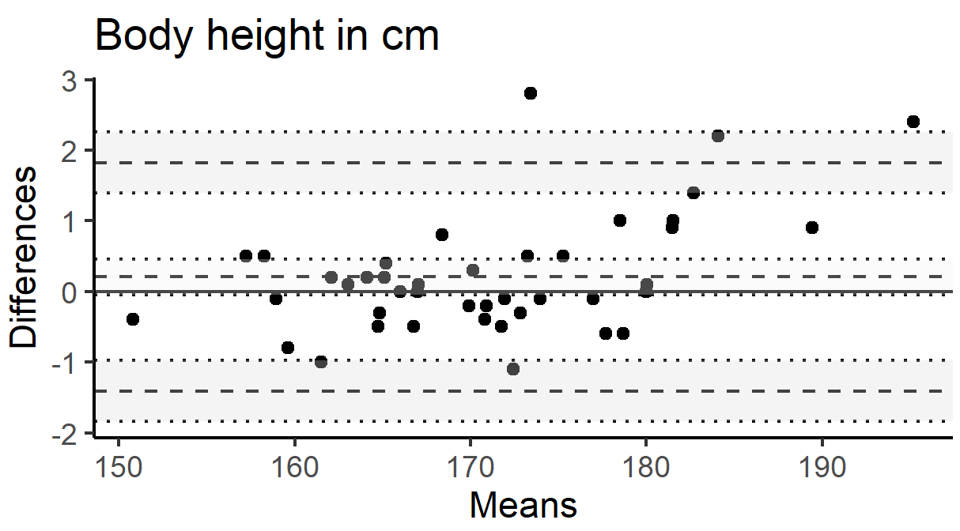 | 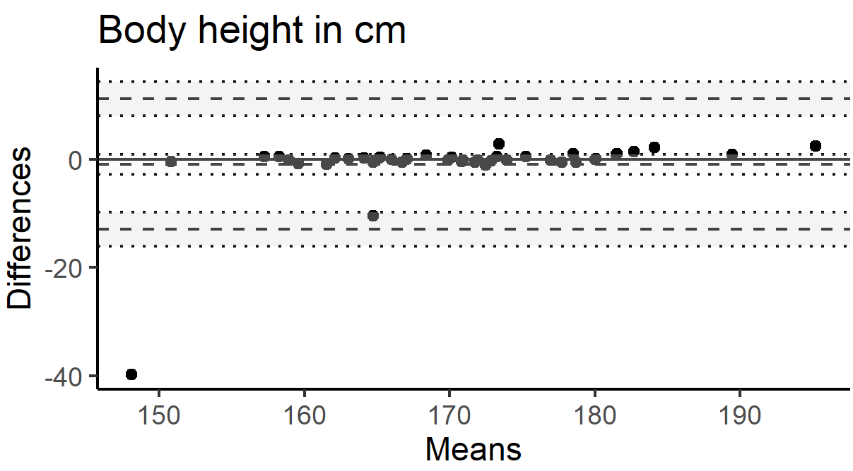
Figure A. Blend-Altman plots for the comparison of the effects of data exclusion.

