Supplementary figure 3 . The receiver operating characteristic curves for the 2 components (C1+C2) of the SpA cases versus to the aggregated control groups(n=350)

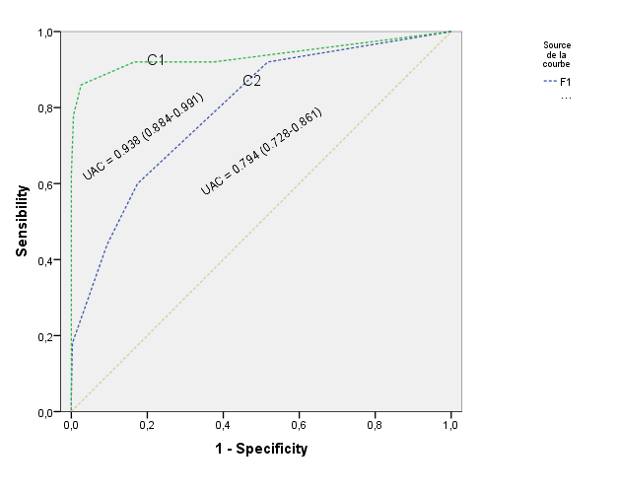

C1: first component  Do you have stiffness in back lasting for >30 minutes ?  Do you have back pain awakening you the 2nd half of the night ?  Does physical exercise improve your back pain ?  Does NSAID improve your back pain ?  Do you have buttock pain ?  Do you have back pain ?  Do you have heel pain ?  Do you have urethritis ? | C2 : second component  Do you have joint swelling ?  Do you have joint pain ?  Do you have joint swelling in more than 3 joints ?

