Additional file 1: Figure S1 Legend

Additional file 1: Figure S1. Overall survival of four subgroups divided by first-line medication and subsequent treatment
Kaplan Meier survival curves of patients with and without subsequent treatment after administration of lenvatinib or sorafenib.

Additional file 1: Figure S1. Overall survival of four subgroups divided by first-line medication and subsequent treatment

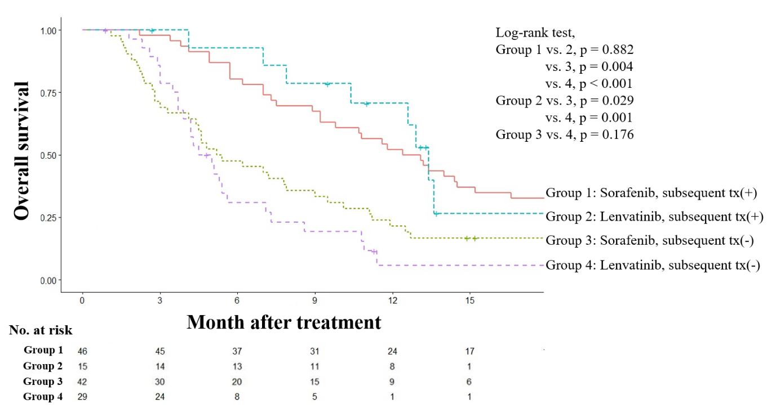
Kaplan Meier survival curves of patients with and without subsequent treatment after administration of lenvatinib or sorafenib.

