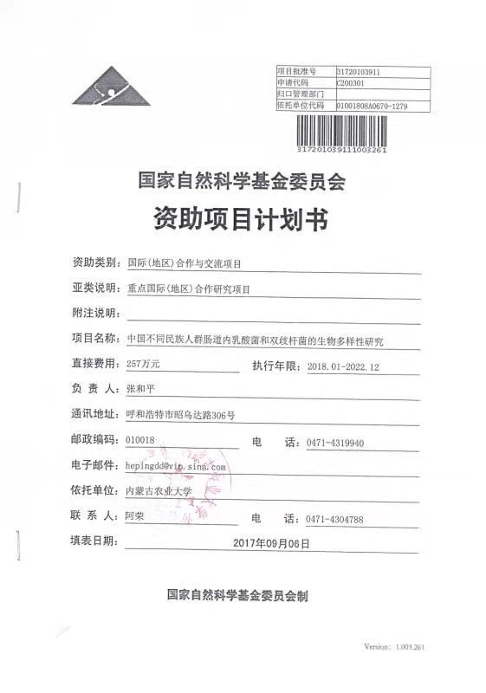
Appendix 7 Copy of National Natural Science Foundation of China with English translation
Project approval number: 31720103911
Application code: C200301
Central Management Department:
Relying unit code: 01001808A0670-1279

National Natural Science Foundation of China
Funding project plan
Funding category: International (regional) cooperation and exchange projects
Subcategory description: Key international (regional) cooperative research projects
Note description:
Project name: Study on Biodiversity of Lactobacillus and Bifidobacterium in the Intestines of Different Ethnic Groups in China
Direct cost: ¥2.57 million Execution period: January 2018 to December 2022
Person in charge: Heping Zhang
Mailing address: No. 306, Zhaowuda Road, Hohhot
Postal Code: 010018 Phone: 0471-439940
Email: hepingdd@vip.sina.com
Supporting unit: Inner Mongolia Agricultural University
Contact: A Rong Phone: 0471-4304788
Date of completion: September 06, 2017

National Natural Science Foundation of China
Signature:

