- Exploratory Factor Analysis (EFA) for Experiences of ageism (EA)

KMO and Bartlett's Test
Kaiser-Meyer-Olkin Measure of Sampling Adequacy. |  | .823
Bartlett's Test of Sphericity | Approx. Chi-Square | 3996.414
 | df | 55
 | Sig. | .000

Total Variance Explained
Factor | Initial Eigenvalues |  |  | Extraction Sums of Squared Loadings |  |  | Rotation Sums of Squared Loadings
 | Total | % of Variance | Cumulative % | Total | % of Variance | Cumulative % | Total | % of Variance | Cumulative %
1 | 4.802 | 43.658 | 43.658 | 4.307 | 39.157 | 39.157 | 2.453 | 22.299 | 22.299
2 | 2.115 | 19.230 | 62.888 | 1.963 | 17.842 | 57.000 | 2.422 | 22.022 | 44.321
3 | 1.182 | 10.747 | 73.635 | .821 | 7.468 | 64.468 | 2.216 | 20.147 | 64.468
4 | .722 | 6.568 | 80.203
5 | .454 | 4.127 | 84.330
6 | .418 | 3.798 | 88.128
7 | .363 | 3.304 | 91.432
8 | .309 | 2.811 | 94.243
9 | .263 | 2.393 | 96.636
10 | .194 | 1.761 | 98.397
11 | .176 | 1.603 | 100.000
Extraction Method: Maximum Likelihood.

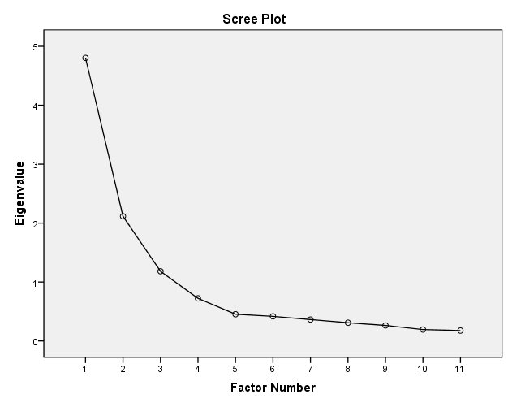

Rotated Factor Matrixª
 | Factor
 | 1 | 2 | 3
witnessed1 | .748 | .246 | .086
witnessed2 | .773 | .374 | .059
witnessed3 | .759 | .253 | .120
witnessed4 | .627 | .182 | .034
encountered1 | .329 | .730 | .129
encountered2 | .318 | .818 | .069
encountered3 | .253 | .740 | .173
encountered4 | .183 | .565 | .163
perceived1 | .109 | .126 | .850
perceived2 | .076 | .122 | .915
perceived3 | .044 | .155 | .743
Extraction Method: Maximum Likelihood.
Rotation Method: Varimax with Kaiser Normalization.
a. Rotation converged in 5 iterations.
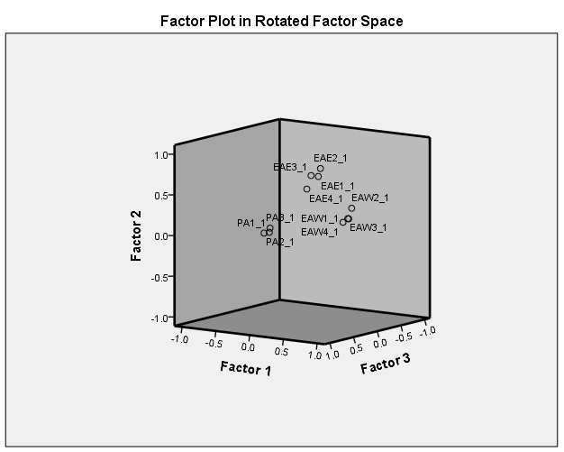

- Exploratory Factor Analysis (EFA) for Age Stereotypes (AS)

KMO and Bartlett's Test
Kaiser-Meyer-Olkin Measure of Sampling Adequacy. |  | .717
Bartlett's Test of Sphericity | Approx. Chi-Square | 1187.635
 | df | 6
 | Sig. | .000

Total Variance Explained
Factor | Initial Eigenvalues |  |  | Extraction Sums of Squared Loadings
 | Total | % of Variance | Cumulative % | Total | % of Variance | Cumulative %
1 | 2.694 | 67.345 | 67.345 | 2.267 | 56.682 | 56.682
2 | .753 | 18.832 | 86.177
3 | .325 | 8.117 | 94.294
4 | .228 | 5.706 | 100.000
Extraction Method: Maximum Likelihood.

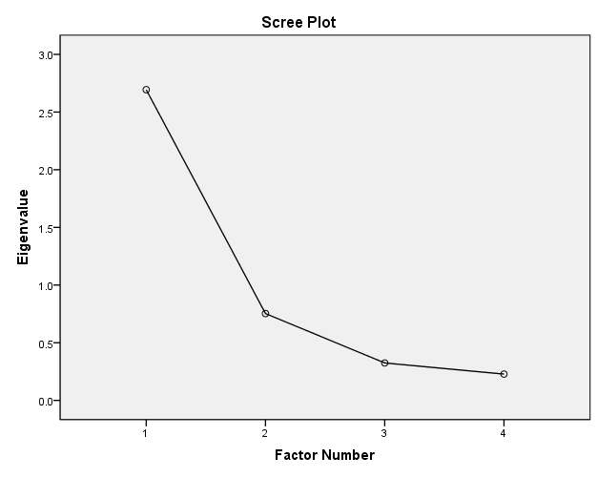

Factor Matrixª
 | Factor
 | 1
AS1 | .849
AS2 | .881
AS3 | .699
AS4 | .530
Extraction Method: Maximum Likelihood.
a. 1 factors extracted. 5 iterations required.

