SUPPLEMENTARY FIGURE 1. Hospitalization annual trends in people > 85 years old in Spain per 100 global discharges by age group, from 2000 to 2015

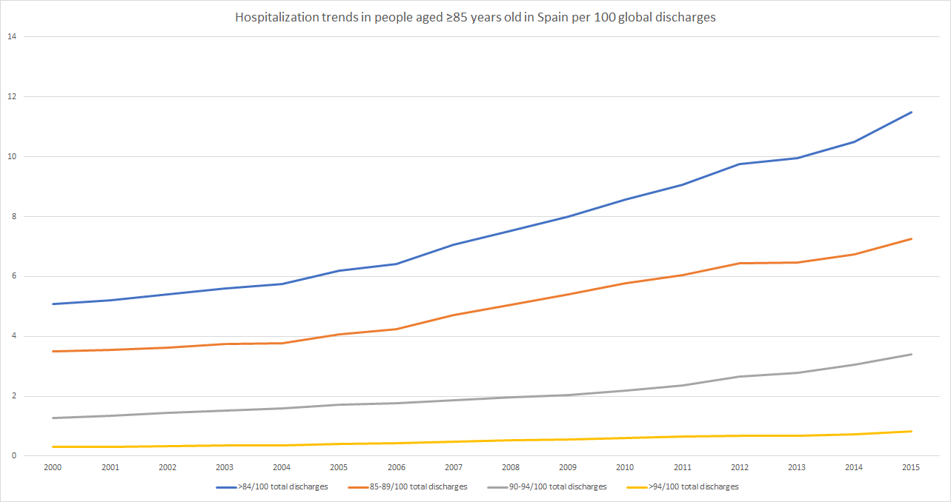

SUPPLEMENTARY FIGURE 2. Annual trends in people > 85 years of the proportion of deaths per age group, from 2000 to 2015
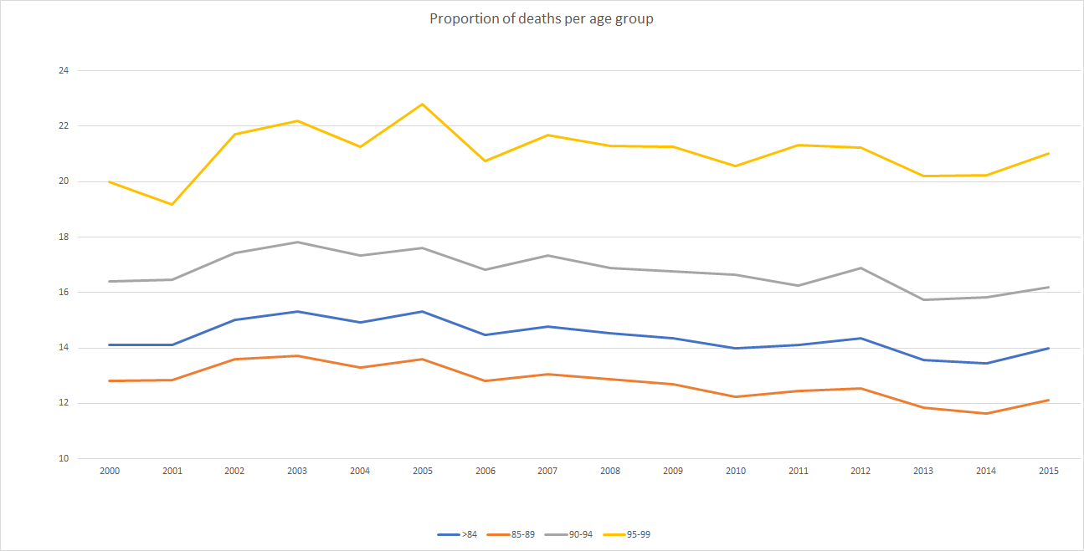

SUPPLEMENTARY FIGURE 3. Annual trends in people > 85 years of mean length of stay per age group, from 2000 to 2015

