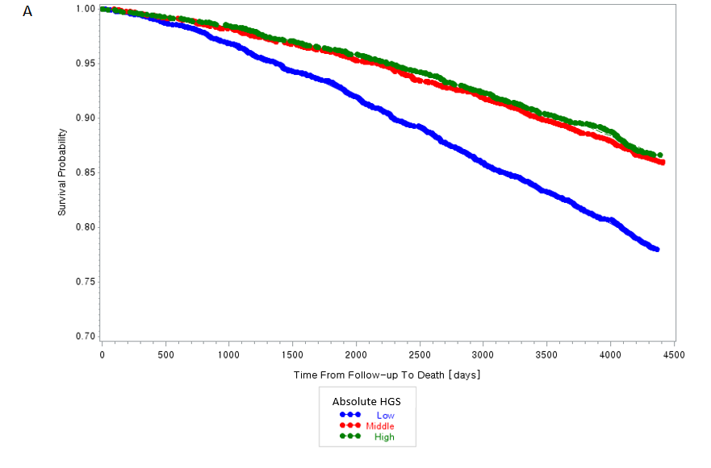
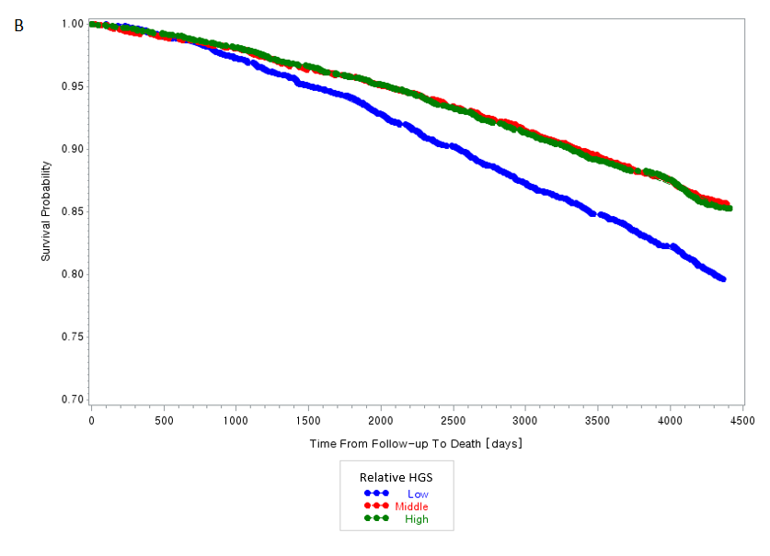
Supplementary 1. Kaplan-Meier curves of all-cause mortality according to handgrip strength. A shows the results of absolute handgrip strength, while B shows the results of relative handgrip strength.

