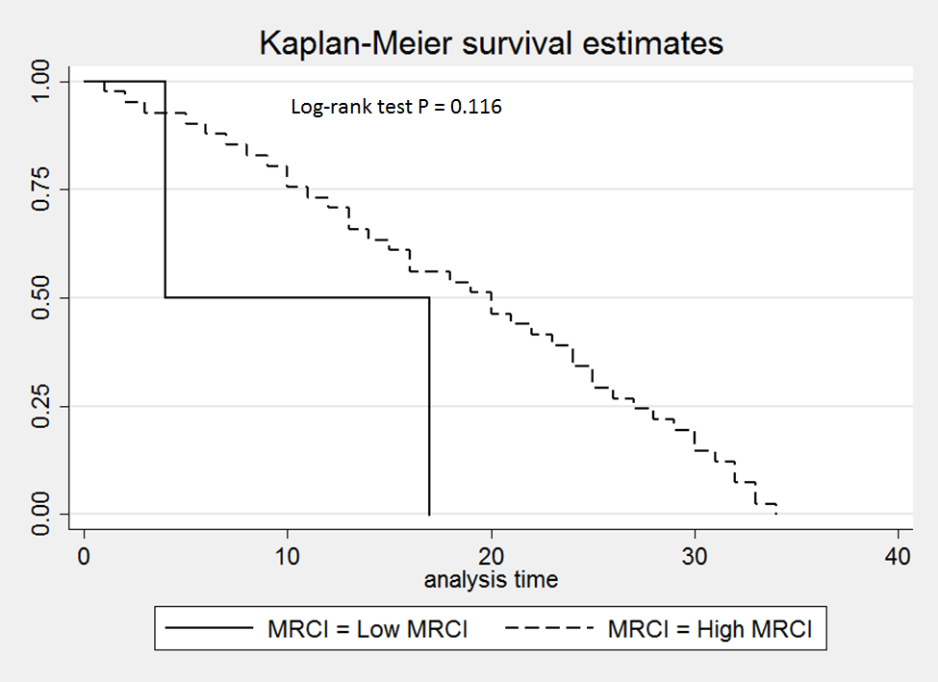
Supplementary Figure 1: Kaplan-Meier survival curve

