Missed opportunities for HIV testing in patients newly diagnosed with HIV in Morocco

Supporting Information
Figure S2. Characteristics of patients who sought care for a clinical indicator in the three years prior to HIV diagnosis according to whether or not (missed opportunity) the care provider offered them an HIV test (n=252).

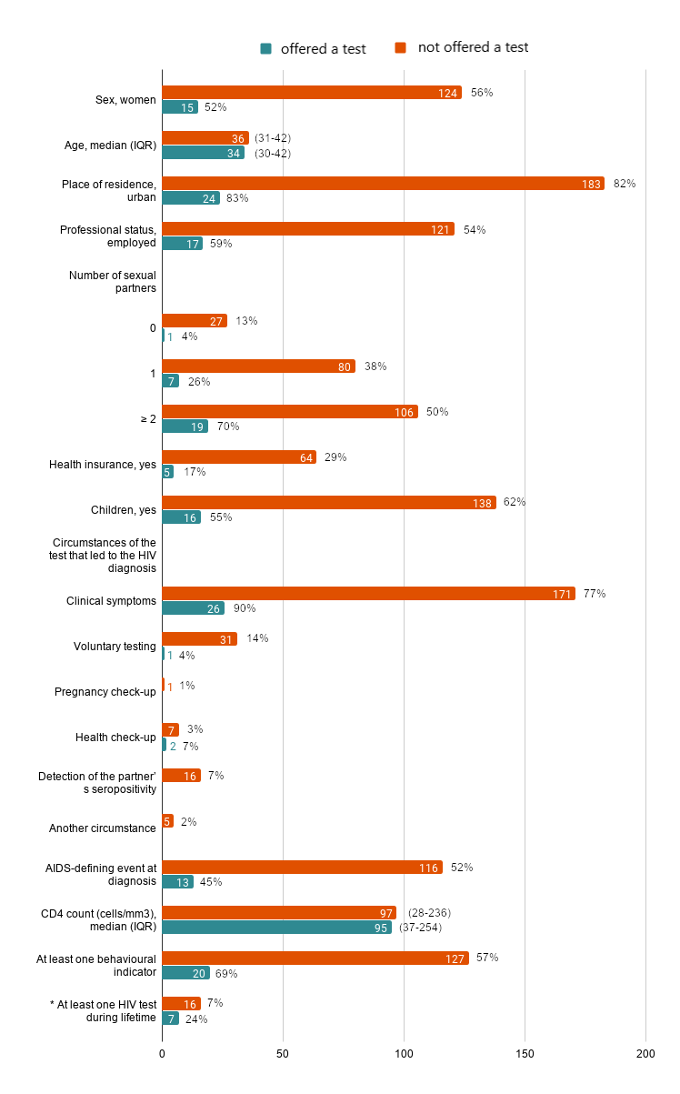
IQR: interquartile range.

* Characteristics of the two groups of patients were compared using Chi2 tests. Only one comparison was significant. At least one HIV test during lifetime: 7% among those who were not offered a test versus 24% among those who were, p=0.009.

