Supplementary material: Algorithm
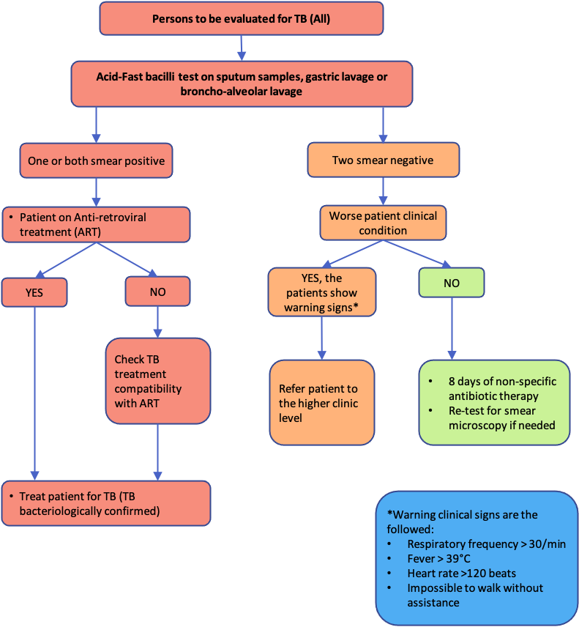

Figure S1: National TB Programme’s algorithm available in 2016

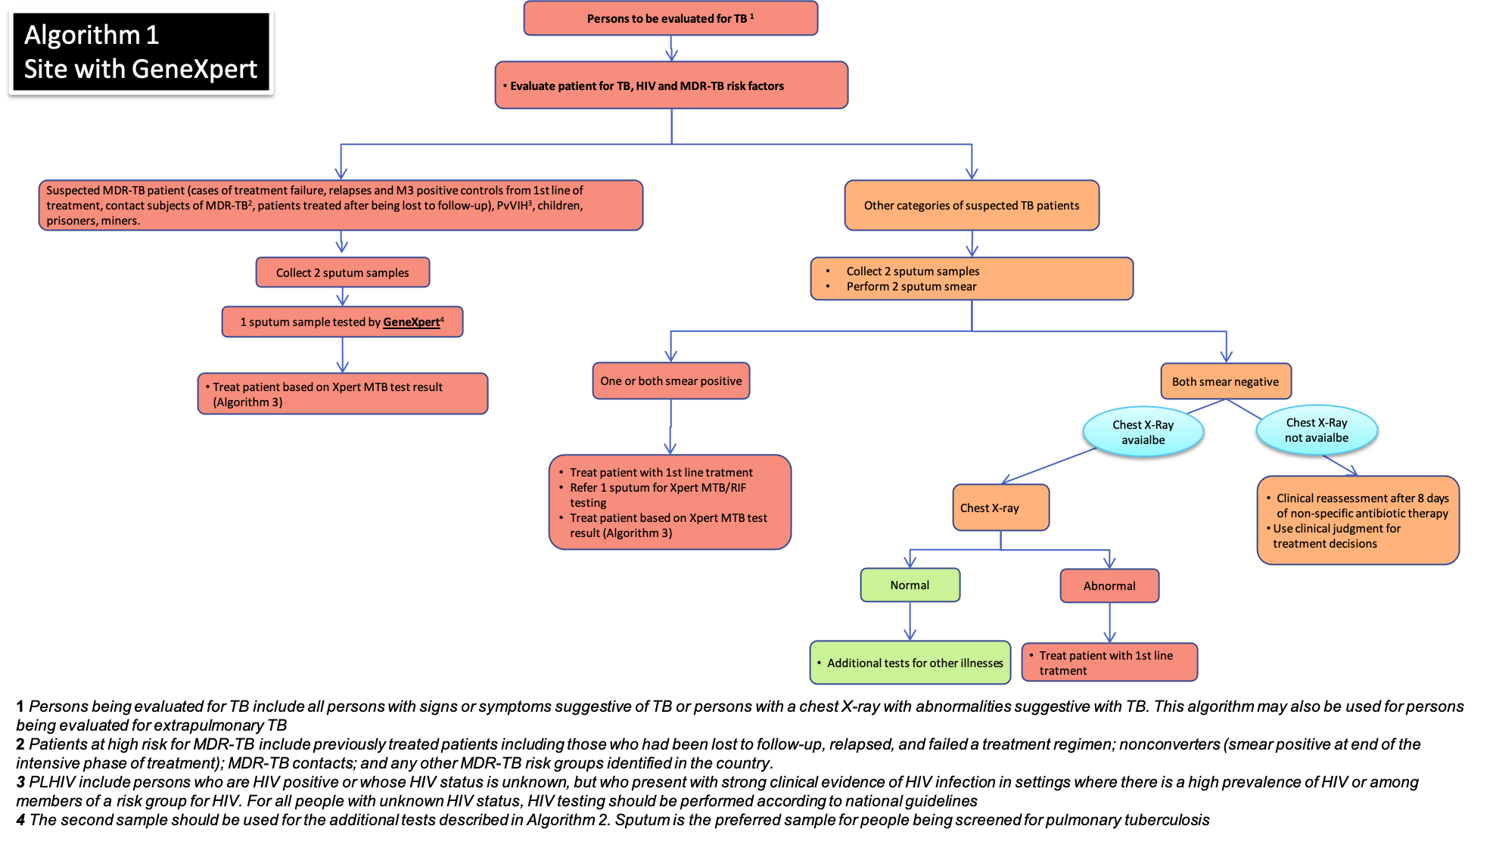
Figure S2.1: National TB Programme’s algorithms developed and implemented in 2017 – GeneXpert site algorithm

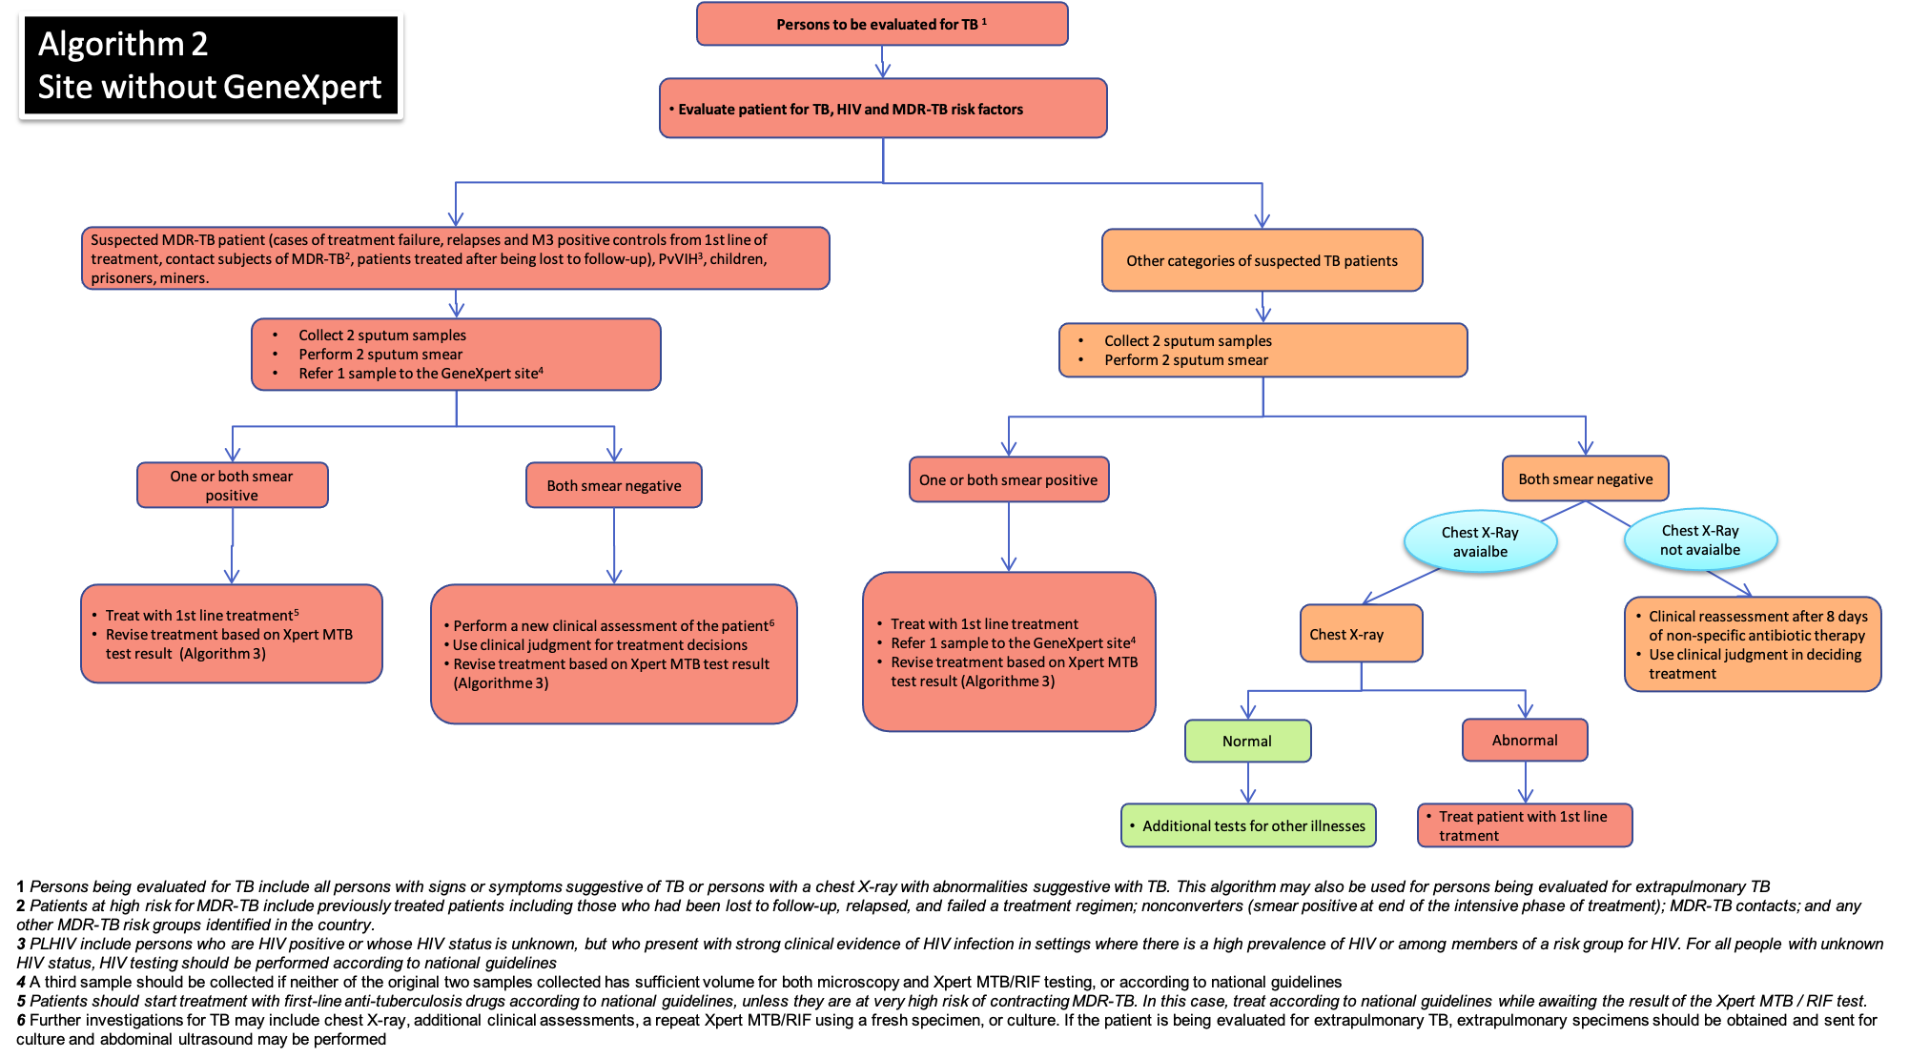

Figure S2.2: National TB Programme’s algorithms developed and implemented in 2017 – Non GeneXpert site algorithm

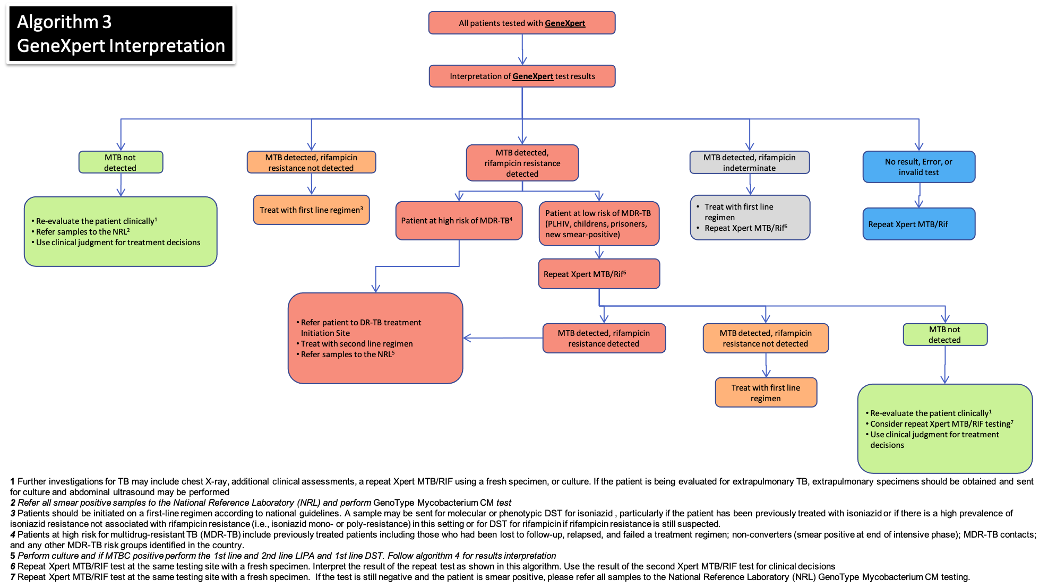

Figure S2.3: National TB Programme’s algorithms developed and implemented in 2017 – GeneXpert interpretation algorithm

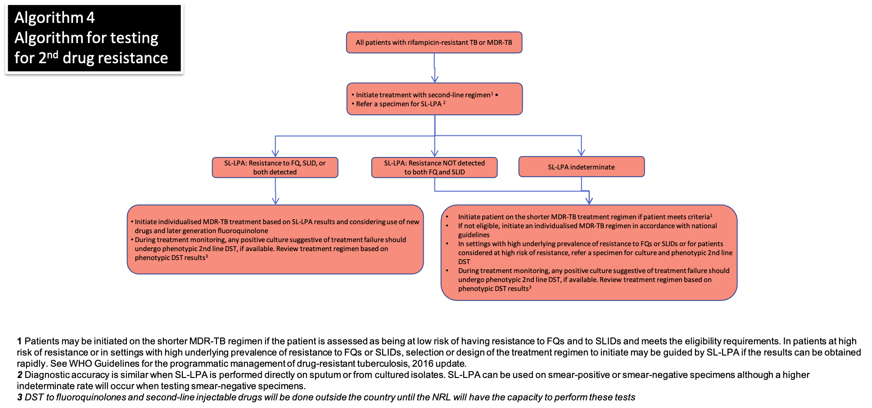

Figure S2.4: National TB Programme’s algorithms developed and implemented in 2017 – TB-MR, pre-XDR-TB and XDR-TB diagnostic algorithm

