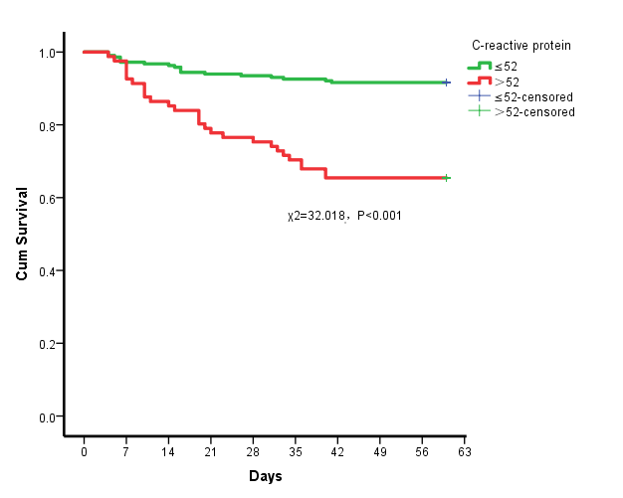
Supplementary figure6: Survival curves of 60-day mortality in all patients with CRP＞52 vs CRP≤52

