Figure S1: Map of seropositivity (made with Rstudio, own source)

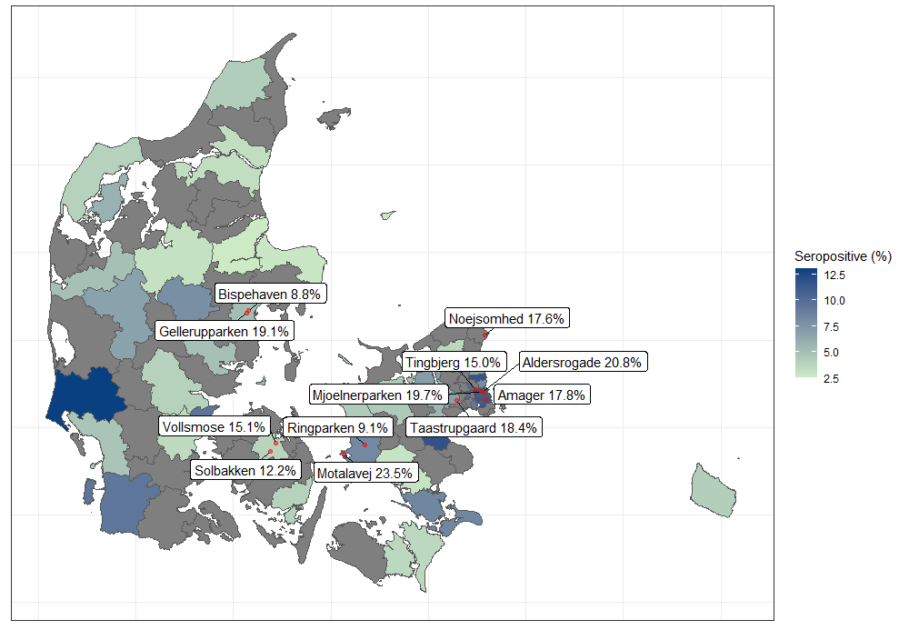
Colors indicating the general population (blood donors)
Text boxes indicating the study cohort.
Gellerupparken: Including SH area Gellerupparken and Bazar Vest
Noejsomhed: Including SH area Noejsomhed and SH area Vapnagaard

Figure S2: Frequency of symptoms among 3,236 individuals in SH areas stratified by seropositivity.
Red: Seropositive, Blue: Seronegative

Figure S3: Forest plot of risk ratios (RR) for each symptom reported by questionnaire cohort.

Figure S4: General recommendations from the Danish Health authorities

1 | Keep a distance of 2 meters whenever possible and always at least 1 meter
2 | Avoid handshakes, hugs and kisses on the cheek
3 | Self-isolate and take a PCR test if you have symptoms of COVID-19
4 | Open windows and doors and ventilate your home regularly
5 | Avoid being too many people together indoors
6 | Cough or sneeze into your sleeve
7 | Wash your hands often or use hand sanitizer
8 | Clean thoroughly and regularly, especially surfaces that are touched by many people
9 | Persons aged 12 or more must wear face masks or shields in following locations: public transportation, wholesale and retail shops, at premises for cultural, sports and club activities, religious communities, day-care facilities, schools, education institutions, public and private hospitals and clinics and premises where clients are offered services involving physical contacts

Figure S5: Change of behavior among 3,236 individuals in Danish SH areas during the pandemic by seropositivity
Red: seropositive, Blue: seronegative

Figure S6: Change of behavior among 2,871 individuals in SH areas by sex and age in quartiles
(Green – age >56 years, red – age 45-56 years, blue – age 31-45 years, yellow - <31 years)
Appendix

List of test sites:
Copenhagen | Mjoelnerparken
 | Tingbjerg
 | Aldersrogade
 | Amager
 | Taastrupgård
Helsingoer | Noejsomhed
 | Vapnagaard
Slagelse | Ringparken
Korsoer | Motalavej
Aarhus | Bispehaven
 | Gellerupparken and Bazar Vest
Odense | Solbakken
 | Vollsmose

The questionnaire:

Introductory questions
Do you want to state your civil registration (CPR) number? | Yes  No
What is your civil registration number (without hyphen)? | _________________________
Confirm your civil registration number (without hyphen) | _________________________
THE CIVIL REGISTRATION NUMBERS DO NOT MATCH. PLEASE CHECK ABOVE AND ENTER AGAIN (This field disappears when the civil registration numbers entered in the above fields are identical) | _________________________
What is your gender? | Male  Female  Other  Don’t wish to answer
What is your date of birth? | _________________________
What is your postcode? | _________________________
How much do you weigh in kilograms (kg)? | _________________________
How tall are you in centimetres (cm)? | _________________________
Do you wish to do a finger prick test for COVID-19? | Yes  No  Don’t know
May we compare the results of this survey with public registers? | Yes  No

Questions about your antibody tests
This part of the questionnaire concerns the antibody tests you have done in connection with We are testing Denmark
What is the result of your finger prick test? |  |  | Negative  Positive for IgM  Positive for IgG  Positive for both IgM and IgG  Inconclusive  I have not done the test/the test failed
Questions about COVID-19 infection
This part of the questionnaire concerns whether you have been infected with COVID-19.
If you were to give your best assessment, do you think/know that you have ever been infected with COVID-19? |  |  | Yes, I know/think that I have had COVID-19  No, I know that I haven’t had/I don’t think that I have had COVID-19
Have you previously been tested for COVID-19? |  |  | Yes  No
What type of COVID-19 test have you taken?  Select one or both answer options |  |  | Swab (sample from throat, nose or pharynx)  Antibody test (finger prick test or blood test)  Don’t know/don’t wish to answer
Was one or more of your tests positive? |  |  | Yes  No
Symptoms
The next questions concern your general health and whether you have had symptoms of COVID-19.
Have you had one or more of the following symptoms since 1 February?
(Select an answer for each option)
 | No | Yes, slight |  | Yes, some | Yes, pronounced | Don’t know
Fever
Chills
Impaired sense of smell
Impaired sense of taste
Sore throat
Cough
Difficulty breathing/shortness of breath

What do you think is/was the cause of your symptoms?  Select one or more of the following answer options: |  |  | COVID-19  Influenza or an influenza-like disease  Common cold  Allergy/hay fever  Asthma  Gastrointestinal infection  Other  Don’t know
Which of the following conditions best describes how you felt when you were feeling the worst, while you had/suspected you had COVID-19? |  |  | I had no symptoms  I was at home with symptoms, but felt well  I was bed-ridden at home with symptoms  I was admitted to hospital  I was admitted and on a ventilator.
Risk of COVID-19
The following questions concern how great the risk is that you have been exposed to coronavirus.
 | Yes | No |  | Don’t know | Not relevant
Have you stayed for minimum 15 minutes in the same room as an infected person?
Have you had body contact with a person infected with COVID-19?
Have you worked/studied with someone who was infected with COVID-19?
Has someone in your household been infected with COVID-19?
Has someone in your family or a friend outside your household been infected with COVID-19?

This part concerns behaviour
Have you taken any of the following measures due to the risk of COVID-19 infection?  Select all relevant answers: |  |  | I wash hands more often  I cough or sneeze into my sleeve  I use disposable tissues  I wear disposable face masks  I avoid shaking hands  I avoid greeting persons by hugging and/or kissing them on both cheeks  I limit my use of public transport  I avoid places where many people are gathered  I stay at home  I work more from home  I avoid travelling outside my own country and/or region  None of the above
Do you smoke? |  |  | No  Yes – occasionally  Yes – daily, less than 10 times a day  Yes – daily, 10 or more times a day  Previously  Don’t wish to answer

Have you consumed alcohol in the past 12 months? | Yes  No  Don’t know/don’t wish to answer
On how many days a week do you drink alcohol? | 0-1 days  2 days  3 days  4 days  5 days  6 days  7 days
How many units do you typically drink per week?  1 unit = 1 regular beer or 1 glass of red/white wine or 1 alcoholic soft drink or 1 alcoholic cider or 1 glass of fortified wine or 1 drink/cocktail or 1 acquavit/shot | _________________________
Do you use euphoriant drugs? | No  Yes – occasionally  Yes – often  Previously  Don’t wish to answer
Did you get an influenza vaccine last autumn/winter 2019?  Select one of the following answer options: | Yes  No  I don’t know/don’t remember
Did you get an influenza vaccine this autumn/winter 2020?  Select one of the following answer options: | Yes  No  I don’t know/don’t remember
Work and education
The following questions are about your education and your work
What is your highest level of completed education?  Select one of the following answer options: | I have no formal education  Primary education  Secondary education (youth education)  Vocational training or short-term/medium-term higher education  Long-term higher education  Don’t know
What is your main occupation?  Select one of the following answer options: | Full-time work  Part-time work  Self-employed  Student  Homemaker  Unemployed  On long-term sick leave or parental leave  Pensioner  Other

Which area(s) or type(s) of work best describe(s) your work?  Select one or more answers |  |  |  |  | Healthcare sector  Nursing home  Home care  Shop work  Office work  School/other educational establishment  Tradesman  Transport (Bus, taxi, train or other means)  Other  Don’t wish to answer
The following questions concern your household
Information about your household is important to enable us to assess your risk of being infected with coronavirus and getting COVID-19.

How many people in the following age groups, including yourself, live in your household?
Please select one answer for each element.
 | None | 1 | 2 | 3 |  | 4 | 5 | >5 | Not relevant
0-4-year-olds
5-18-year-olds
19-44-year-olds
45-64-year-olds
65+-year-olds
May we contact you later if we have elaborating further questions? |  |  |  |  | Yes  No
What is your email address? |  |  |  |  | _________________________
Confirm your email address |  |  |  |  | _________________________
THE EMAIL ADDRESSES DO NOT MATCH. PLEASE CHECK ABOVE AND ENTER AGAIN (This field disappears when the email addresses entered in the above fields are identical) |  |  |  |  | _________________________

