Additional file 3
Univariate analysis of procalcitonin on a severe COVID-19 infection. Odds ratio with 95% confidence interval of the natural logarithm of procalcitonin: 2.79 (2.20 – 3.63).
The Hosmer-Lemeshow test showed a high goodness-of-fit: p=0.91
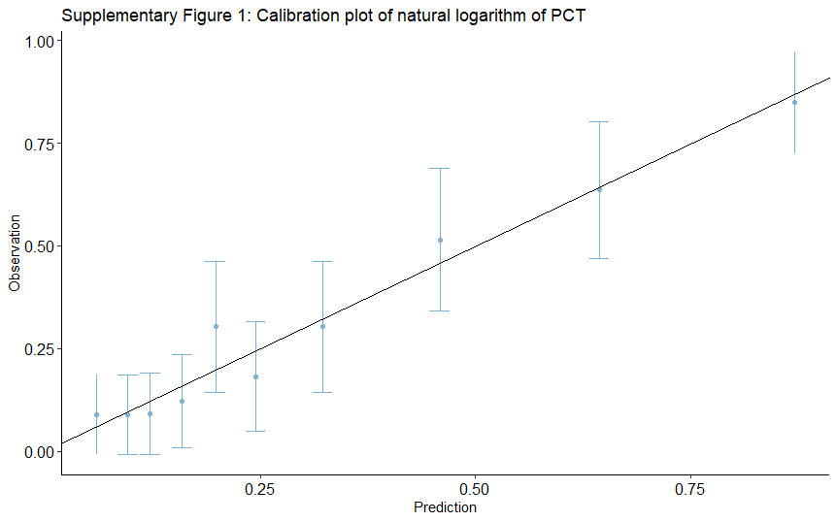
Figure S1: Calibration plot of the natural logarithm of procalcitonin. Slope: 1.00 (0.77 – 1.26), intercept: 0.00 (-0.32 – 0.34).
PCT: Procalcitonin

