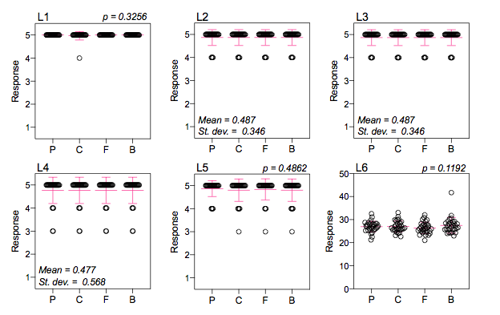

Additional file 3: Figure S3 Responses to laboratory survey. P-values are shown for questions that could be assessed using one-way ANOVA. Mean and standard deviation (st. dev.) are shown for questions where responses were identical across devices.

