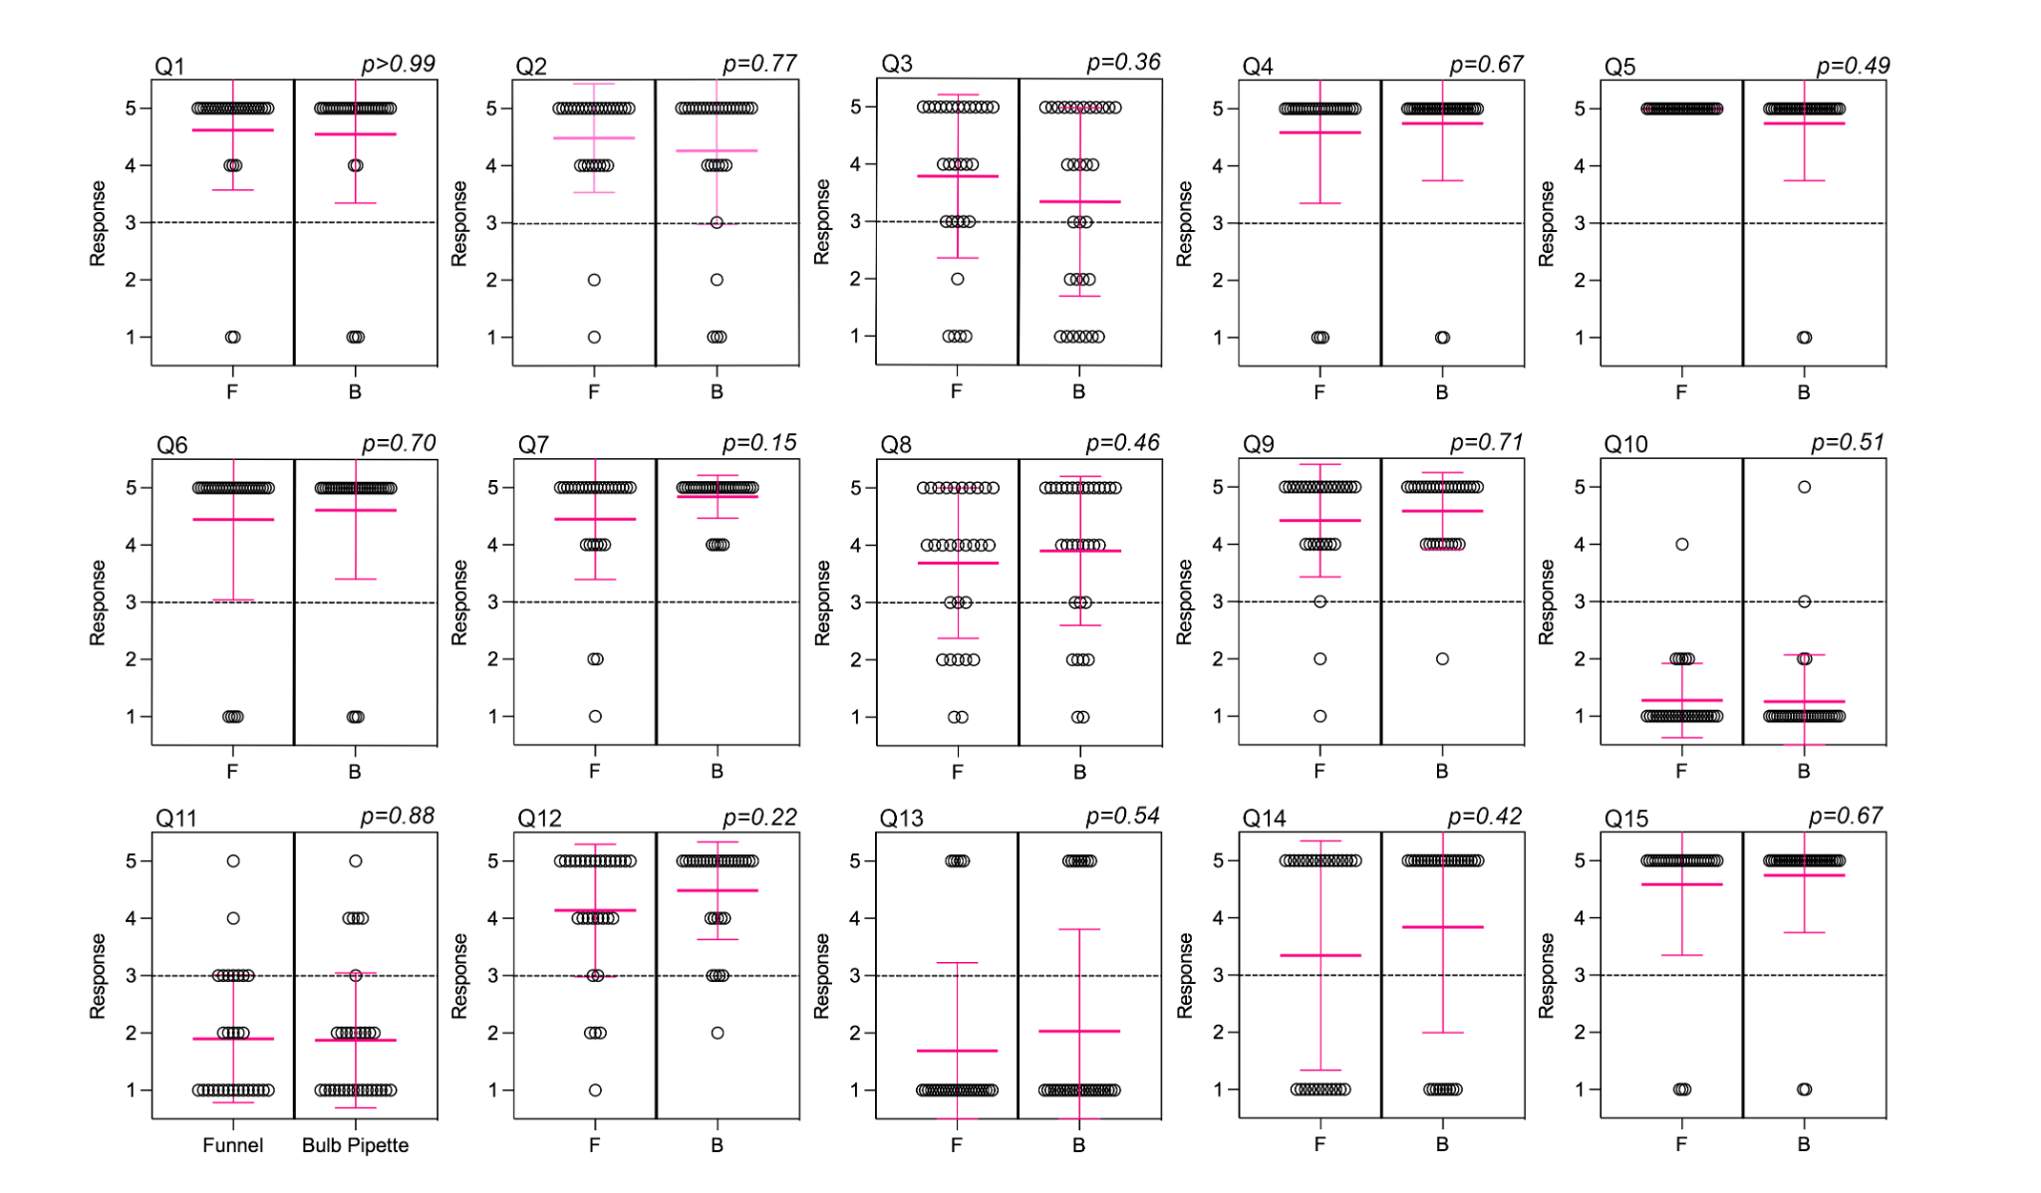

Additional file 4: Figure S4 Responses to participant surveys for at home collection kit. Mean and standard deviation are marked in pink. Survey data were analyzed using Mann-Whitney. P < 0.05 is significantly different. Abbreviations: F = funnel, B = bulb pipette

