Table S2: M. tuberculosis genes associated with resistance or compensatory mutation.

Drug | Genes | Publication no.
Rifampicin | rpoB, rpoC, rpoA, rpoD, Rv2752c | 1,3,6,7
Isoniazid | fabG1-inhA, inhA, katG,ndh, furA, oxyR, aphC, fadE24, srmR, kasA, mshA, Rv1258c, Rv2752c | 1,3,7,8
Ethambutol | embB, embC, embA, ubiA, embR, iniA, iniC, manB, ubiA | 1,6,7,8
Pyrazinamide | pncA, rpsA, panD, clpC1, rpsA, clpC1, Rv1258c, PPE35 | 1,6,7,8
Streptomycin | rpsL, gidB, rrs, whiB7, Rv1258c | 1,6,7,8
Ethionamide | fabG1-inhA, ethA, ethR | 1,6,7,8
Fluoroquinolones | gyrA, gyrB | 1,6,7,8
Amikacin | rrs, whib7, gidB | 1,4,8,11
Kanamycin | Rv2417c-eis, whiB7, rrs, gidB | 1,4,8,10,11
Capreomycin | tlyA, whiB7, rrs, gidB | 1,4,8,11
Para-amnosalicylic acid | ribD, thyA, dfrA, folC | 5,9
Cycloserine | alr, ddl, cycA | 6
Bedaquiline | atpE, Rv0678, mmpL5, mmpS5, pepQ, Rv1979c | 2,6,12
Linezolid | rrl, rplC | 6
Delamanid | fgd1, ddn, fbiA, fbiB, fbiC, Rv2983 | 2,6,12
Clofazimine | Rv0678, mmpL5, mmpS5, pepQ, Rv1979c | 2,6,13

Publications used to identify these genes include
- Ramaswamy, S. V., et al (2004). Genotypic analysis of multidrug-resistant Mycobacterium tuberculosis isolates from Monterrey, Mexico. J Med Microbiol, 53(Pt 2), 107-113. doi: 10.1099/jmm.0.05343-0
- Bloemberg, G. V., et al. (2015). Acquired Resistance to Bedaquiline and Delamanid in Therapy for Tuberculosis. N Engl J Med, 373(20), 1986-1988. doi: 10.1056/NEJMc1505196
- Comas, I., et al. (2012). Whole-genome sequencing of rifampicin-resistant Mycobacterium tuberculosis strains identifies compensatory mutations in RNA polymerase genes. Nat Genet, 44(1), 106-110. doi: 10.1038/ng.1038
- Jnawali, H. N.,et al. (2013). Molecular genetics of Mycobacterium tuberculosis resistant to aminoglycosides and cyclic peptide capreomycin antibiotics in Korea. World J Microbiol Biotechnol, 29(6), 975-982. doi: 10.1007/s11274-013-1256-x
- Mathys, V., et al. (2009). Molecular genetics of para-aminosalicylic acid resistance in clinical isolates and spontaneous mutants of Mycobacterium tuberculosis. Antimicrob Agents Chemother, 53(5), 2100-2109. doi: 10.1128/AAC.01197-08
- Koser, C. U., et al (2013). Whole-genome sequencing for rapid susceptibility testing of M. tuberculosis. N Engl J Med, 369(3), 290-292. doi: 10.1056/NEJMc1215305
- Manson, A. L.,et al (2017). Genomic analysis of globally diverse Mycobacterium tuberculosis strains provides insights into the emergence and spread of multidrug resistance. Nat Genet, 49(3), 395-402. doi: 10.1038/ng.3767
- Sandgren, A., et al. (2009). Tuberculosis drug resistance mutation database. PLoS Med, 6(2), e2. doi: 10.1371/journal.pmed.1000002
- Zheng, J., et al. (2013). para-Aminosalicylic acid is a prodrug targeting dihydrofolate reductase in Mycobacterium tuberculosis. J Biol Chem, 288(32), 23447-23456. doi: 10.1074/jbc.M113.475798
- Zaunbrecher, M. A., et al. (2009). Overexpression of the chromosomally encoded aminoglycoside acetyltransferase eis confers kanamycin resistance in Mycobacterium tuberculosis. Proc Natl Acad Sci U S A, 106(47), 20004-20009. doi: 10.1073/pnas.0907925106
- Dheda, K., et al. (2017). The epidemiology, pathogenesis, transmission, diagnosis, and management of multidrug-resistant, extensively drug-resistant, and incurable tuberculosis. Lancet Respir Med. doi: 10.1016/S2213-2600(17)30079-6
- Bloemberg, G.V., et al. (2015). Acquired Resistance to Bedaquiline and Delamanid in therapy for tuberculosis. N Engl J Med (373):1986-8
- Zhang, S., et al. (2015). Identification of novel mutations associated with clofazimine resistance in Mycobacterium tuberculosis. J Antimicrob Chemother, 70(9), 2507-2510

Table S3: Phylogenetic markers in known drug resistance genes as per Merker et al 2020

genome pos | gene | polymorphism | genotype association
7362 | Rv0006 | E21Q (gag/Cag) | non H37Rv_lab_strain
7585 | Rv0006 | S95T (agc/aCc) | non H37Rv-like
7892 | Rv0006 | L197L (ctg/ctA) | NEW-1
8040 | Rv0006 | G247S (ggc/Agc) | LAM (associated)
9304 | Rv0006 | G668D (ggc/gAc) | non H37Rv-like
575679 | Rv0486 | N111S (aac/aGc) | Haarlem
575907 | Rv0486 | A187V (gca/gTa) | Beijing modern
760115 | Rv0667 | D103D (gac/gaT) | Haarlem
762434 | Rv0667 | G876G (ggt/ggG) | Delhi/CAS
763031 | Rv0667 | A1075A (gct/gcC) | non Euro-American
764995 | Rv0668 | A542A (gcc/gcG) | LAM
765150 | Rv0668 | G594E (ggg/gAg) | Ghana, Haarlem, X-type
766645 | Rv0668 | E1092D (gaa/gaC) | Beijing Central Asia
1834177 | Rv1630 | R212R (cga/cgC) | Beijing, Beijing like
1917972 | Rv1694 | L11L (cta/ctG) | non H37Rv_lab_strain
2102990 | Rv1854c | V18A (gtg/gCg) | S-type (associated)
2154724 | Rv1908c | R463L (cgg/cTg) | non Euro-American
3073868 | Rv2764c | T202A (acc/Gcc) | LAM
3840764 | Rv3423c | L219L (ctg/ctC) | H37Rv-like (associated)
4238675 | Rv3792 | G248G (ggc/ggT) | Beijing Central Asia
4238963 | Rv3792 | H344H (cac/caT) | S-type
4239298 | Rv3792 | A456V (gcc/gTc) | Haarlem
4242075 | Rv3793 | R738Q (cgg/cAg) | Delhi/CAS
4242241 | Rv3793 | D793D (gac/gaT) | Beijing (associated)
4242643 | Rv3793 | R927R (cgc/cgT) | non H37Rv_lab_strain
4242803 | Rv3793 | V981L (gtg/Ctg) | Ghana, Haarlem, X-type
4243346 | Rv3794 | Q38Q (caa/caG) | Beijing W148
4243460 | Rv3794 | C76C (tgc/tgT) | Beijing
4249408 | Rv3795 | P965P (ccg/ccA) | X-type
4407588 | Rv3919c | A205A (gca/gcG) | non Euro-American
4407927 | Rv3919c | E92D (gaa/gaC) | Beijing
4408156 | Rv3919c | L16R (ctt/cGt) | LAM

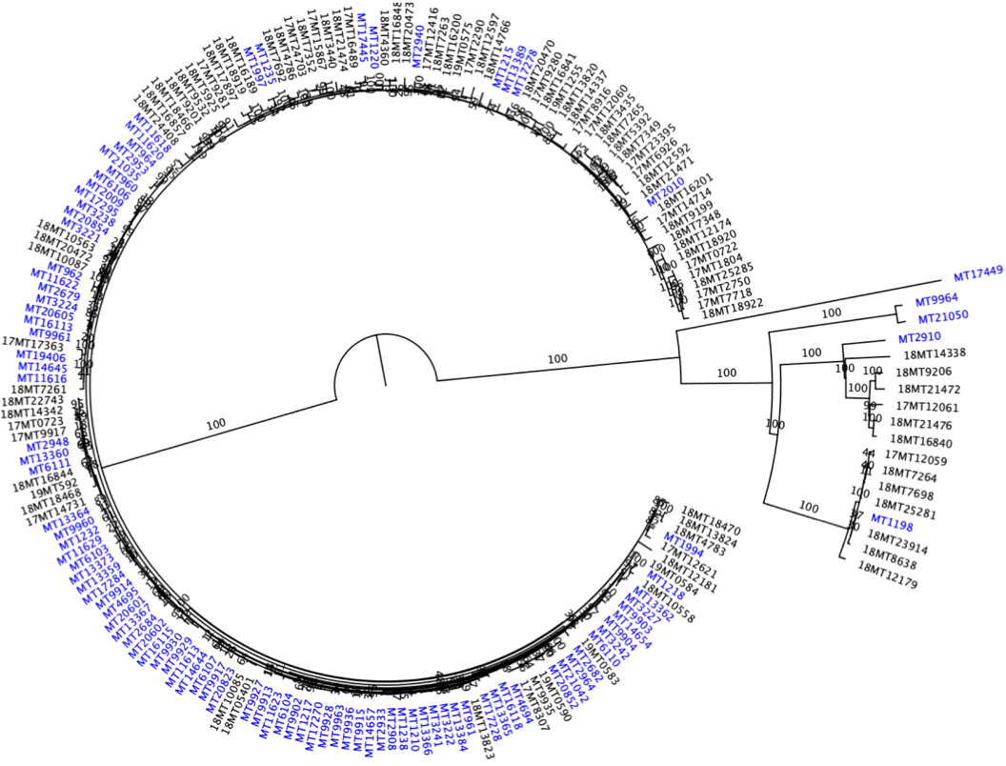
Figure S1: Phylogeny of 194 isolates collected from Daru (blue tip labels) and CPHL, Papua New Guinea. Maximum likelihood tree constructed using IQ-TREE, at 1000 bootstraps – GTR+I+G nucleotide substitution model based on 1809 SNPs. Two distinct lineages were observed, with majority Lineage 2 (sensi strico modern Beijing L2.2.1.1-dominant, circular branch) and Lineage 4 (Euro-American 4.8, outward branch)

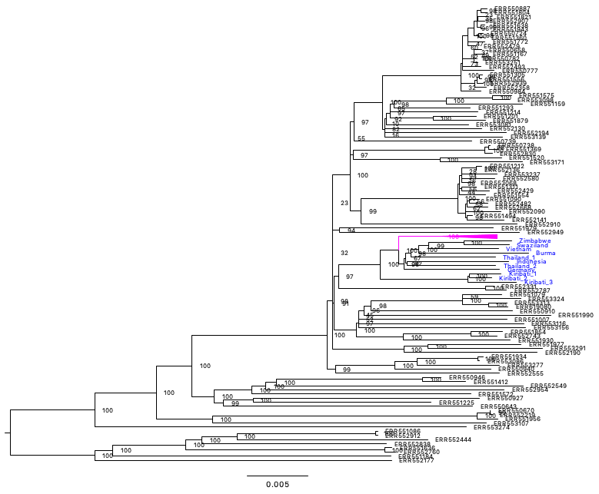
RD150

Figure S2: Phylogeny of 176 lineage 2 PNG isolates (purple - monophyletic clade) with a global collection of 110 Beijing genomes. Maximum likelihood constructed using IQ-TREE, at 1000 bootstraps – GTR+I+G nucleotide substitution model based on 6920 SNPs. Nearest neighbouring branch labels (blue) – show genomes identified from different countries.

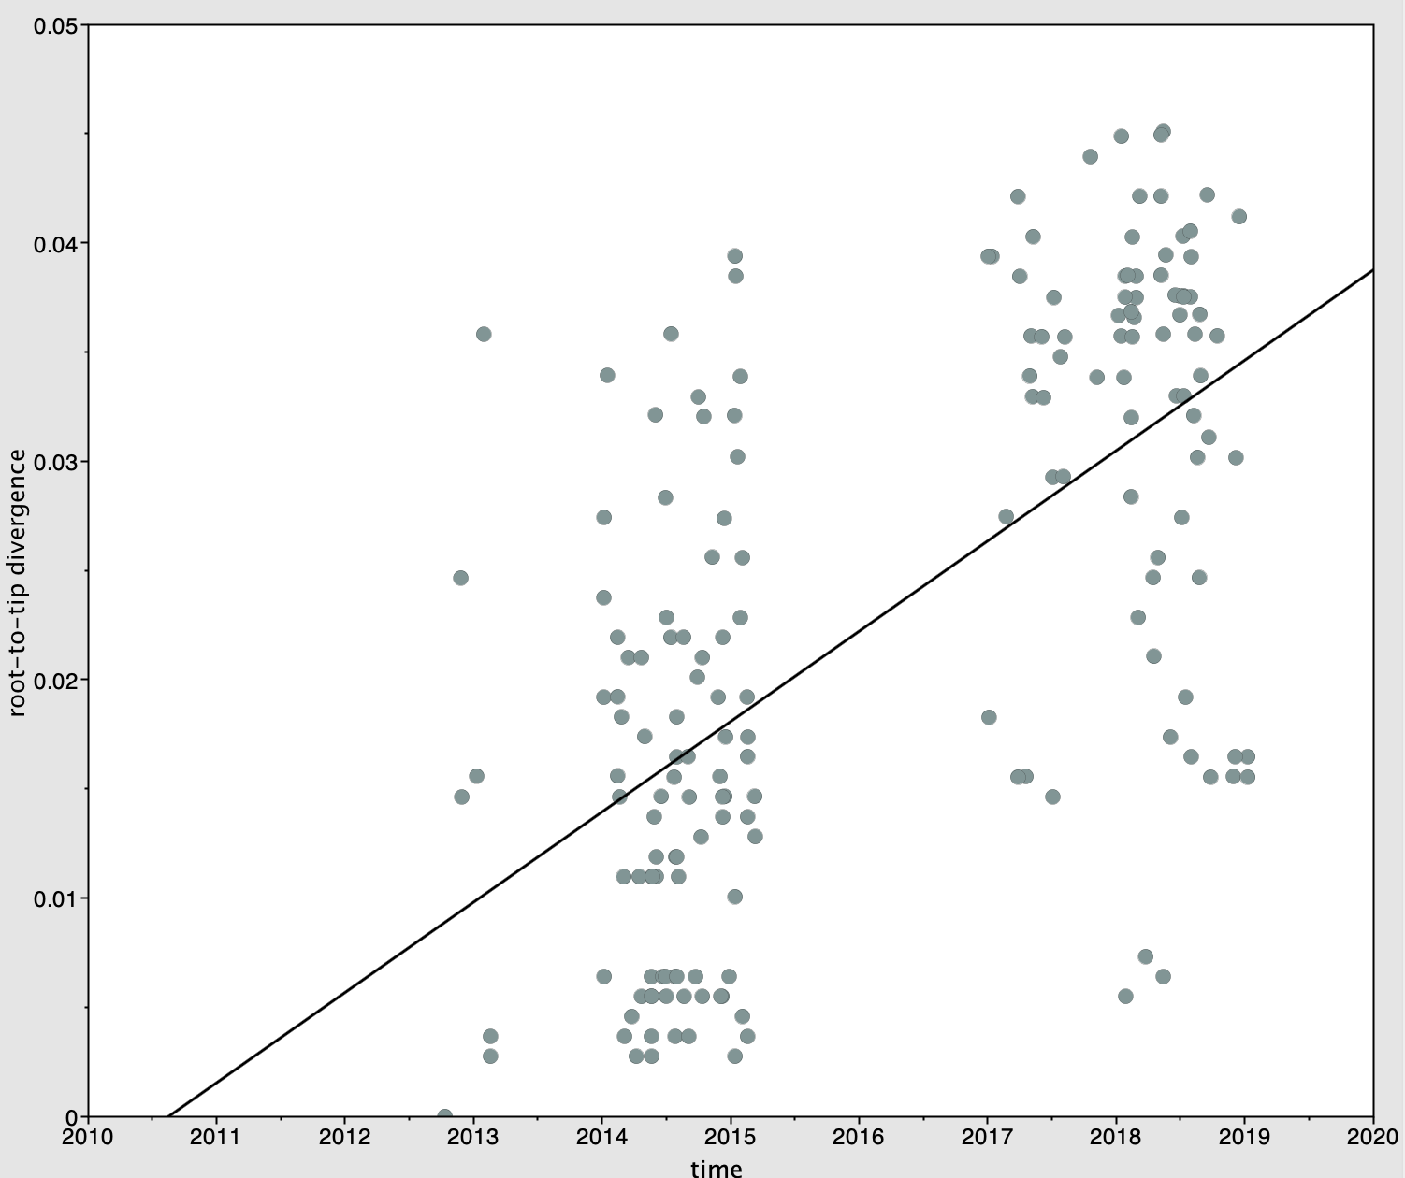

Figure S3: Linear regression analysis showing correlation between root-to-tip distance and sampling years (R² =0.384) of an extended collection of 176 PNG Beijing datasets covering the period 2012 to 2019.

 | Path Sampling |  | Stepping Stone
 | strict | relaxed | strict | relaxed
No sampling date | -5527459.062 | -5527597.353 | -5527448.022 | -5527592.941
With sampling date | -5527795.574 | -5527803.198 | -5527789.371 | -5527801.814
log Bayes factor | 336.512 | 205.845 | 341.349 | 208.873

Table S4: Bayesian evaluation of temporal signal (BETS) results for strict and relaxed molecular clock analysis of Beijing isolates.

Substitution Model | Clock Model | Tree Prior | Path sampling | Stepping stone | Mean ESS
HKY | Relaxed Lg Normal | Constant | -5527803.198 | -5527801.814 | 622
HKY | Relaxed Lg Normal | Expansion | -5527785.4 | -5527770.324 | 967
HKY | Relaxed Lg Normal | Exponential | -5527882.1 | -5527879.23 | 1203
GTR | Relaxed Lg Normal | Skyline | -5527812.015 | -5527813.014 | 3422
GTR | Relaxed Lg Normal | Constant | -5527814.816 | -5527813.062 | 1320
GTR | strict | Constant | -5527814.862 | -5527814.088 | 1425

Table S5: Path and stepping stone sampling results of relaxed clock model selection based on marginal likelihood considering 100 steps and 10 million chain length.

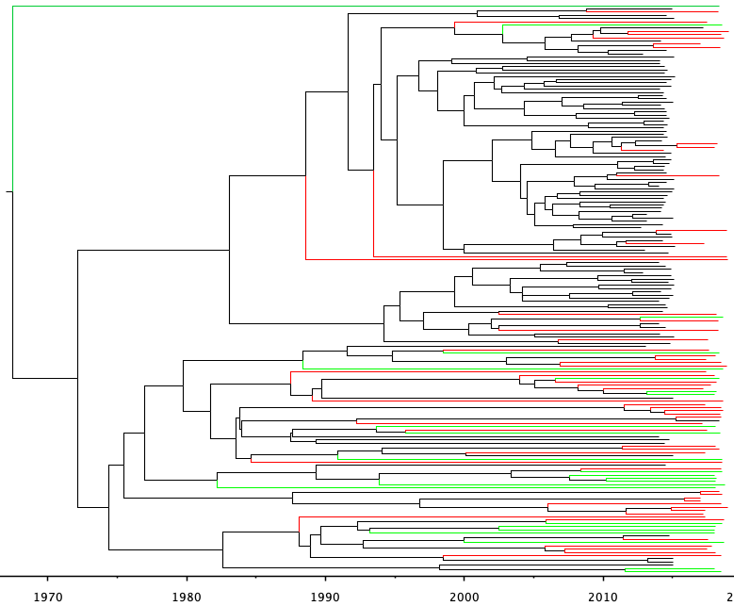
fabG1-inhA (C-15T)
inhA (p.Ile21Val)
ndh (p.Glu102fs )
rpoB (p.Ser450Leu)
rpoB (p.Asp435Tyr)
gyrA (p.Asp94Gly)
katG (p.Ser315Thr)
inhA (p.Leu203Leu)
fabG1-inhA (G-17T)
fabG1-inhA (T-8C)
rpoB (p.Asp435Val)
katG (p.Ser315Asn)
katG (p.Ile364Thr)
rpsL (p. Lys43Arg)
rrs (A514C)
rrs (C517T)
A
B

Figure S4: Evolutionary history of drug resistance among the Beijing strains of PNG forming two clades; A – Daru dominant clade, B – NCD dominant clade. Black tip branches – Daru isolates, red – NCD and green – isolates from other provinces. On the tree nodes are steps of fixation of different resistance conferring mutations among isolates that share the respective mutation; colors represent mutations for the different drugs, red – Rifampicin, blue – Isoniazid, Orange – Streptomycin and green – Fluoroquinolone.

Figure S5: Concordance of phenotypic and genotypic drug resistance among Beijing strains from CPHL (Green – bars) and Daru (Red – bars). Some of the isolates were phenotypically susceptible but had genotypic markers for resistance, dashed green bar – CPHL, dashed red – Daru. X axis are drugs and their associated mutations, RIF – Rifampicin, INH – Isoniazid, EMB – Ethambutol, PZA – Pyrazinamide, STR – Streptomycin, FLQ – Fluoroquinolone, SLI – Second line injectables.

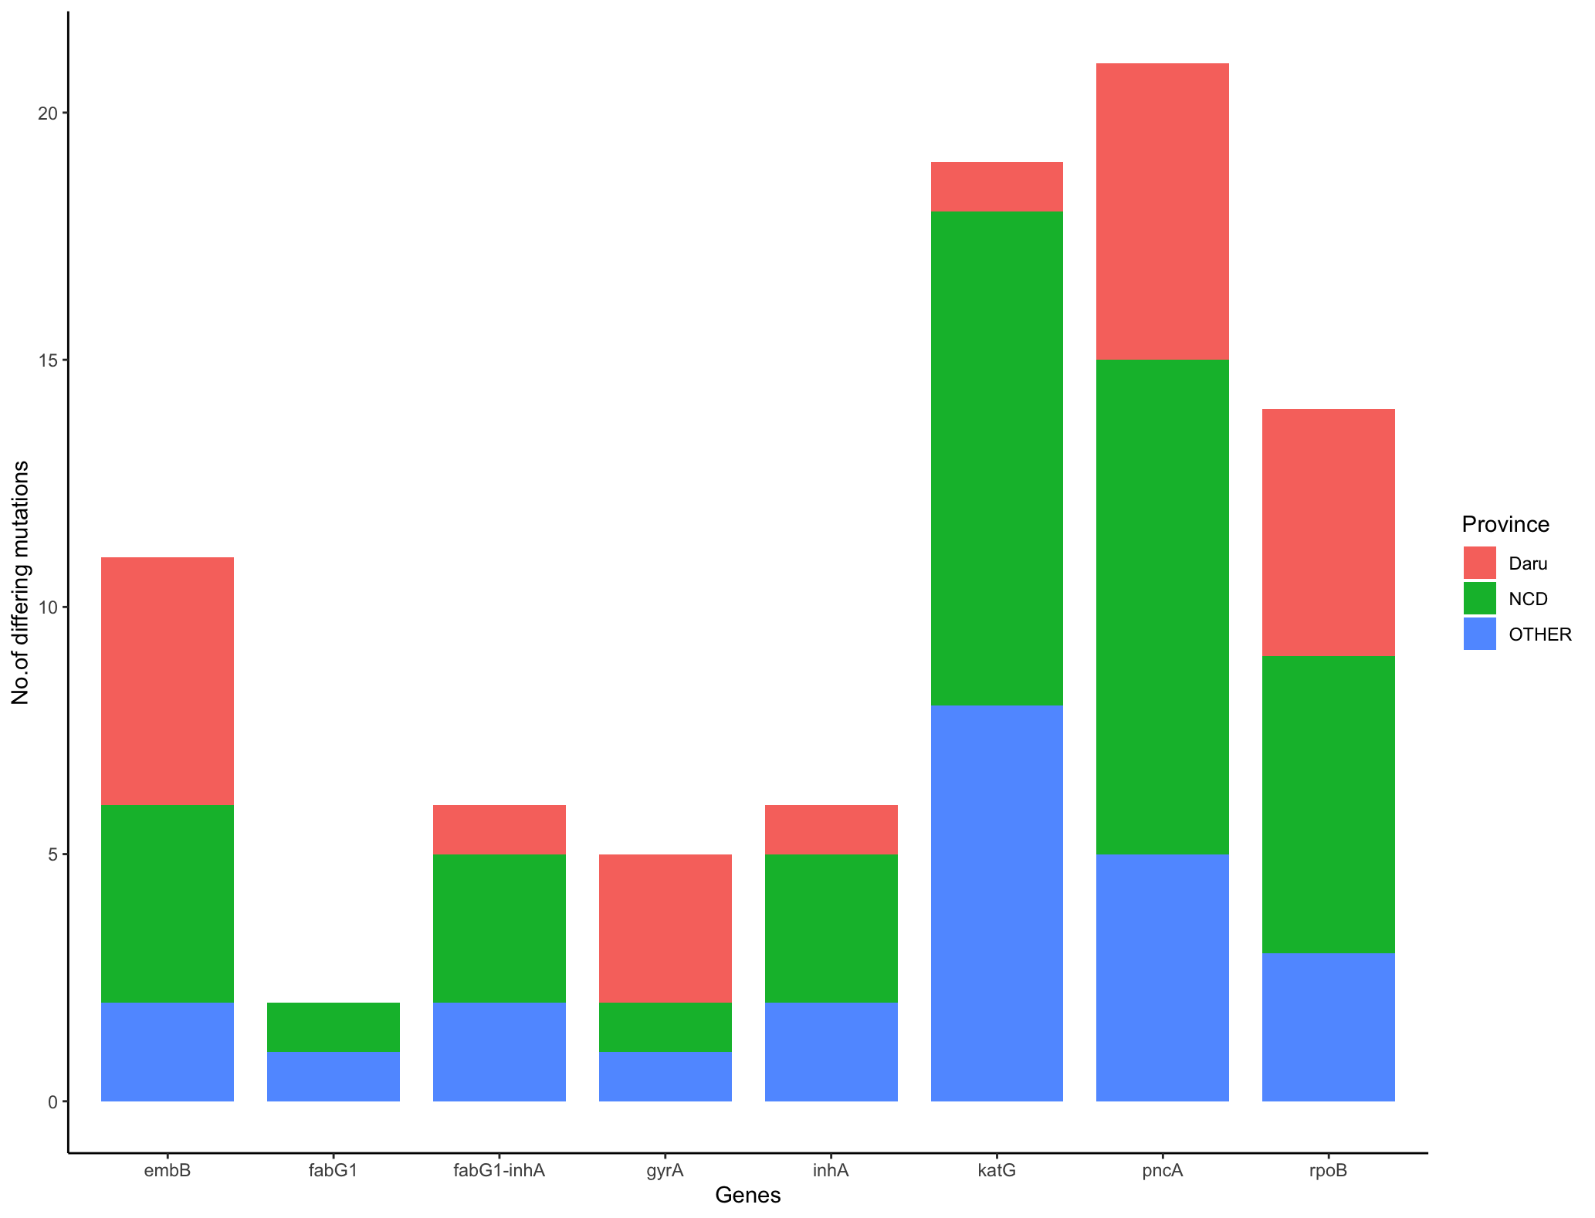

Figure S6: Number of unique mutations within some of the common genes known to confer resistance to First-line drugs (embB – Ethambutol; fabG1, fabG1-inhA, inhA, katG – Isoniazid; pncA – Pyrazinamide; rpoB- Rifampicin) and Fluoroquinolone (gyrA).

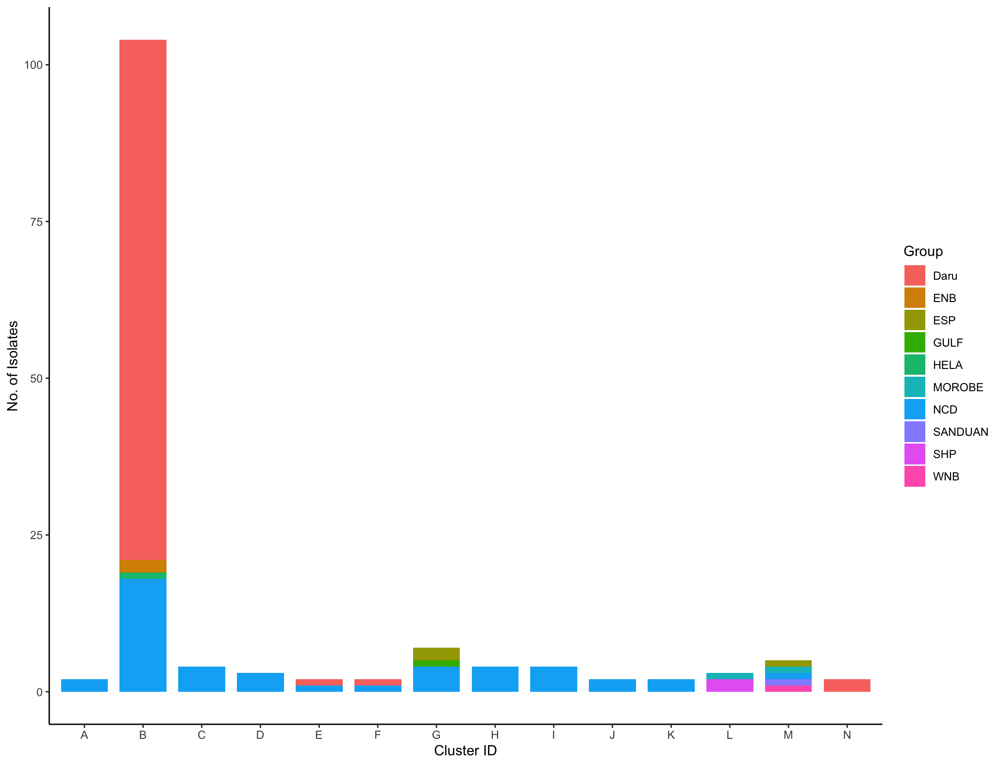

Figure S7: Genomic clusters created by Transcluster software (transmission threshold - 21 and transmission rate – 2) among Beijing strains, stratified by identified PNG provinces

 |  | Clustered
 |  | Daru |  |  | NCD
 |  | Yes (n=87) | No (n=8) | p value | Yes (n=46) | No (n=11) | p value
rpoB compensatory mutation | Yes | 63 | 0 | 0.0001 | 23 | 0 | 0.001
 | No | 24 | 8 |  | 23 | 11
inhA promoter mutation | Yes | 85 | 0 | 0.0001 | 31 | 3 | 0.02
 | No | 2 | 8 |  | 15 | 8

Table S6: Association of genomic clustering among Beijing strains and two genomic features thought to be risk factors of transmission.

