Supplementary table 1. Comparison of hazards rations for all-cause mortality, and ESKD between all situations of DM and hyperuricemia
All-cause mortality
 | HyperUA-, DM- | HyperUA+, DM- | HyerUA-, DM+ | HyperUA+, DM+
HyperUA-, DM- | Reference | 1.481 (1.001-2.192),  p=0.0493 | 1.519 (1.02-2.456), p=0.0088 | 2.123 (1.414-3.186), p=0.0003
HyperUA+, DM- |  | Reference | 1.025 (0.689-1.526), p=0.9016 | 1.433 (1.065-1.928), p=0.0175
HyerUA-, DM+ |  |  | Reference | 1.397 (0.934-2.09), p=0.1033
HyperUA+, DM+ |  |  |  | Reference
ESKD
 | HyperUA-, DM- | HyperUA+, DM- | HyerUA-, DM+ | HyperUA+, DM+
HyperUA-, DM- | Reference | 1.337 (1.033-1.732),  p=0.0271 | 1.589 (1.146-2.203), p=0.0055 | 2.456 (1.872-3.222), p<0.0001
HyperUA+, DM- |  | Reference | 1.188 (0.904-1.561), p=0.216 | 1.837 (1.509-2.236), p<0.0001
HyerUA-, DM+ |  |  | Reference | 1.546 (1.176-2.033), p=0.0018
HyperUA+, DM+ |  |  |  | Reference
HyperUA: hyperuricemia; DM: diabetes mellitus

Supplementary table 2. Cox Proportional Multivariate Hazards Models for all-cause mortality divided by DM and hyperuricemia ind different stages of CKD (strage 3, 4, and 5)
 | HR | 95% C.I. | Chi Square
CKD stage 3
Neither DM nor Hyperuricemia | Reference
Hyperuricemia only | 1.214 | 0.726-2.032 | 0.4601
DM only | 1.016 | 0.526-1.961 | 0.9619
Both DM and Hyperuricemia | 1.147 | 0.633-2.080 | 0.6508
CKD stage 4
Neither DM nor Hyperuricemia | Reference
Hyperuricemia only | 2.318 | 1.032-5.21 | 0.0418
DM only | 3.282 | 1.351-7.974 | 0.0087
Both DM and Hyperuricemia | 3.985 | 1.766-8.991 | 0.0009
CKD stage 5
Neither DM nor Hyperuricemia | Reference
Hyperuricemia only | 1.956 | 0.658-5.812 | 0.2274
DM only | 1.070 | 0.191-5.980 | 0.9388
Both DM and Hyperuricemia | 3.105 | 1.037-9.298 | 0.0429
*p-value <0.05. **adjusted for age, sex, ever smoke, previous CAD, 1 year mean SBP, use of statin, hyperuricemia drug usage, and ACEi/ARB usage.

Supplementary table 3. Cox Proportional Multivariate Hazards Models for ESKD divided by DM and hyperuricemia ind different stages of CKD (strage 3, 4, and 5)
CKD stage 3
Neither DM nor Hyperuricemia | Reference
Hyperuricemia only | 1.42 | 0.628-3.207 | 0.3993
DM only | 3.061 | 1.235-7.586 | 0.0157
Both DM and Hyperuricemia | 3.556 | 1.616-7.824 | 0.0016
CKD stage 4
Neither DM nor Hyperuricemia | Reference
Hyperuricemia only | 1.498 | 0.886-2.532 | 0.1313
DM only | 2.396 | 1.310-4.383 | 0.0046
Both DM and Hyperuricemia | 2.862 | 1.668-4.910 | 0.0001
CKD stage 5
Neither DM nor Hyperuricemia | Reference
Hyperuricemia only | 1.152 | 0.845-1.569 | 0.3708
DM only | 1.038 | 0.625-1.725 | 0.8857
Both DM and Hyperuricemia | 1.815 | 1.296-2.541 | 0.0005

*p-value <0.05. **adjusted for age, sex, ever smoke, previous CAD, 1 year mean SBP, use of statin, hyperuricemia drug usage, and ACEi/ARB usage.

Supplementary figure 1. Kaplan-Meier plot of ESKD and all-cause mortality.
Figure 1A. Kaplan-Meier plot for ESKD
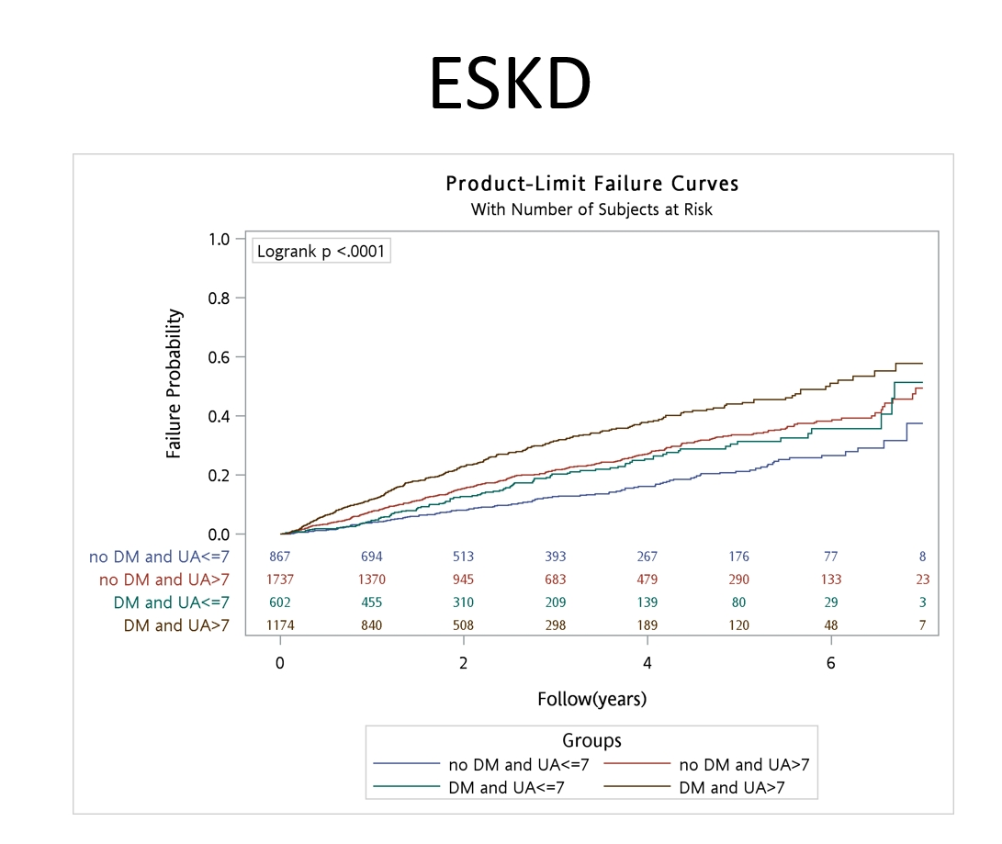

Figure 1B. Kaplan-Meier plot for all-cause mortality
