Focal segmental glomerulosclerosis with hyalinosis (arrow) (PAS staining, ×200)
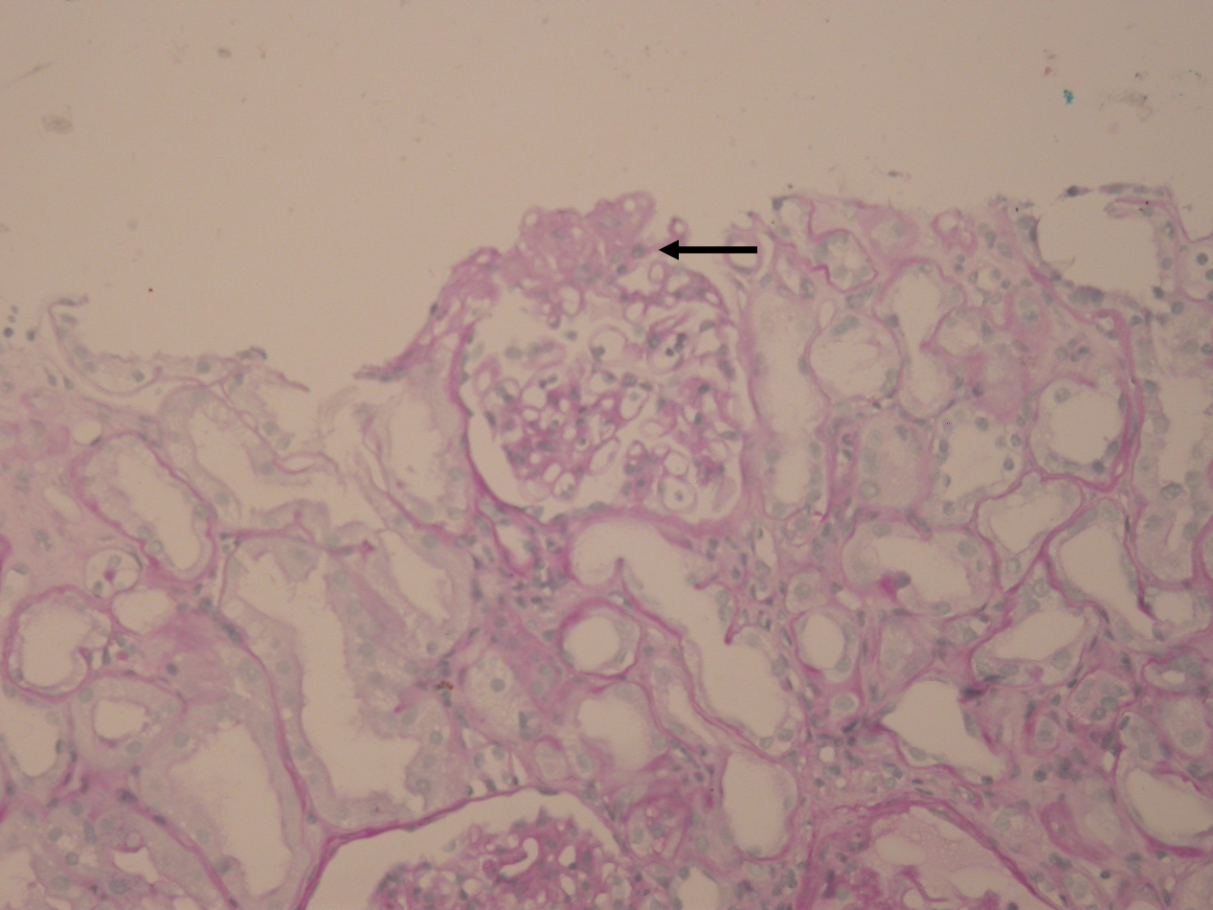

Focal segmental glomerulosclerosis with hyalinosis (arrow) (PAS staining, ×200)
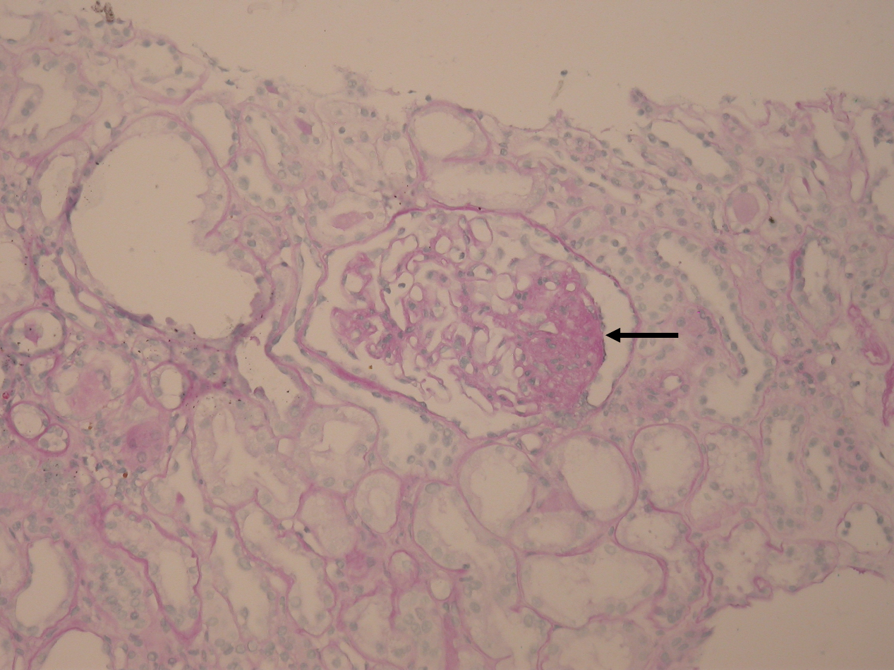

Cortical interstitial inflammation, characterized by lymphocytes and plasma cells, and focal segmental glomerulosclerosis (H&E staining, ×400)
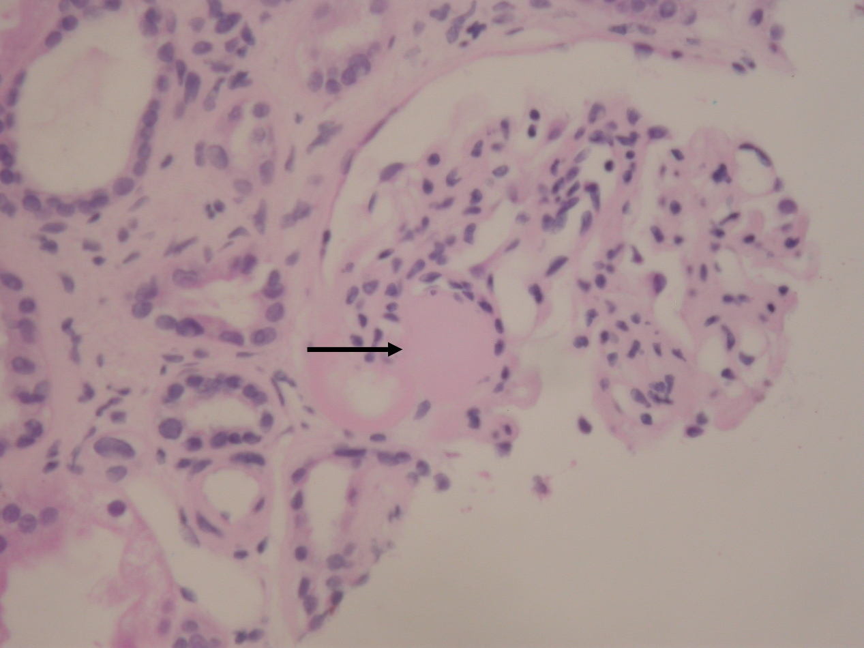

Cortical interstitial inflammation, characterized by lymphocytes and plasma cells, and focal segmental glomerulosclerosis (H&E staining, ×400)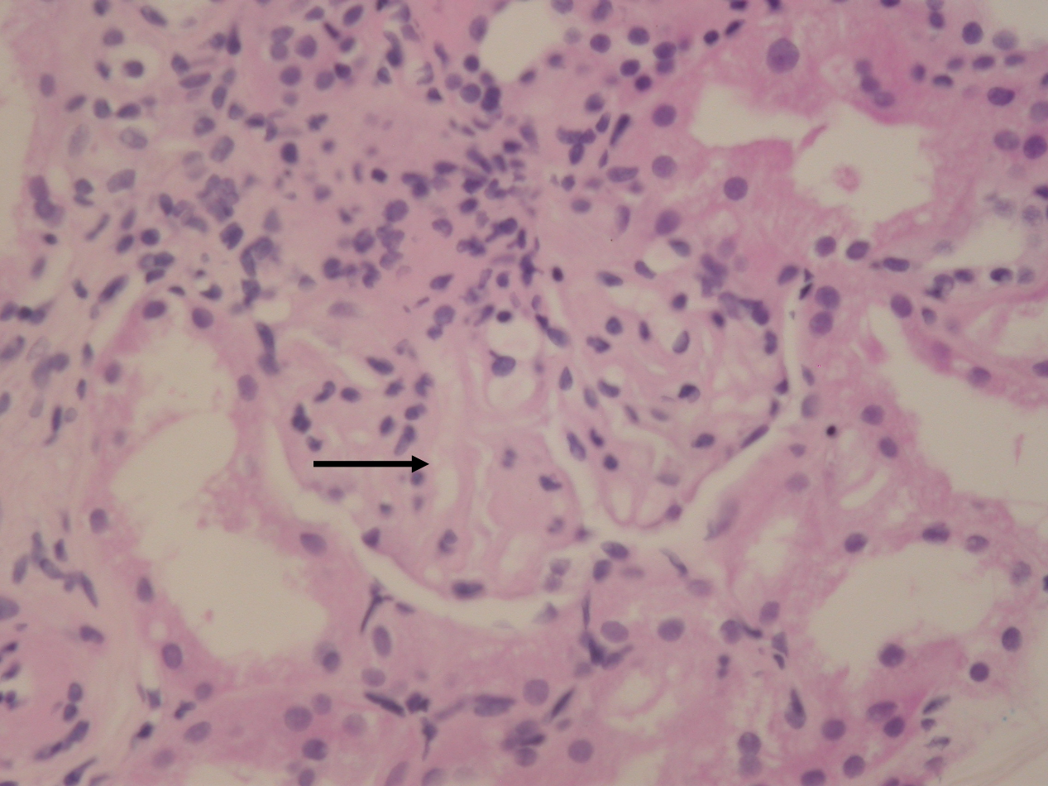

Cortical interstitial inflammation, characterized by lymphocytes and plasma cells, and focal segmental glomerulosclerosis (H&E staining, ×400)
