Figure S1
Mediation Model for Exposure to Vaginal Birth Stories *p<0.05, **p<0.01, ***p<0.001

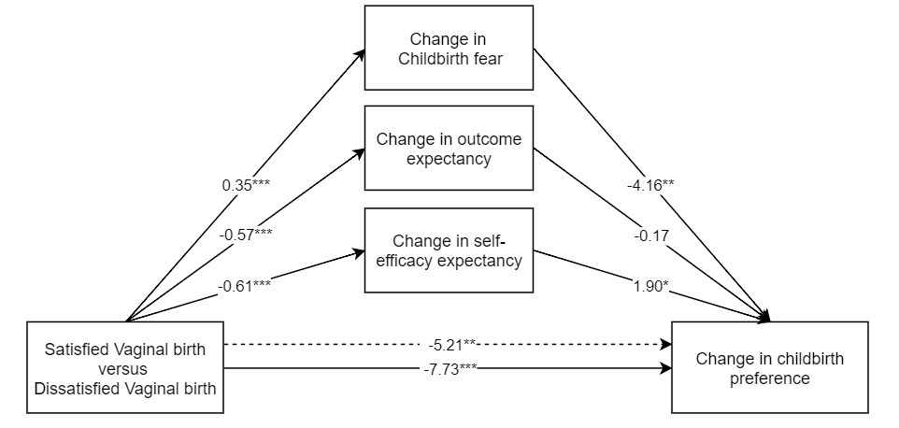
Positive vaginal birth versus
Negative vaginal birth
Change in childbirth preference

