Figure S2
Mediation Model for Exposure to Positive Birth Stories *p<0.05, **p<0.01, ***p<0.001

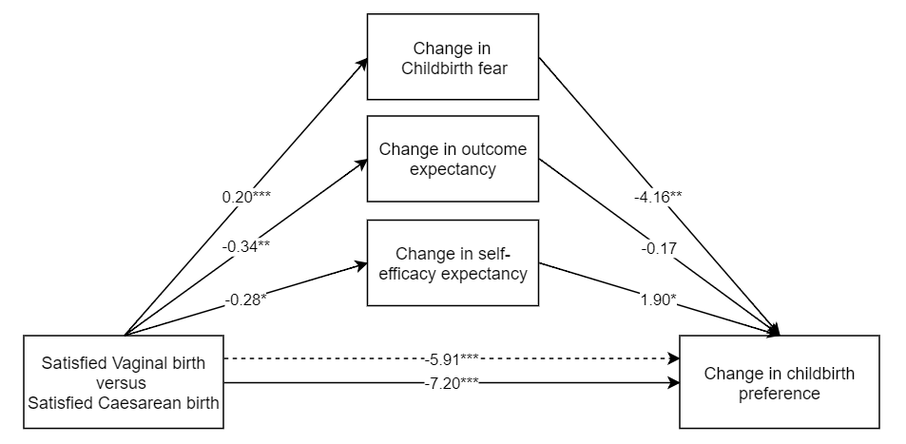
Change in childbirth preference
Positive vaginal birth versus
Positive caesarean birth

