Additional file 1: Figure S1. Propensity score histograms by treatment status (untreated = Shanghai-native, treated = internal migrants)
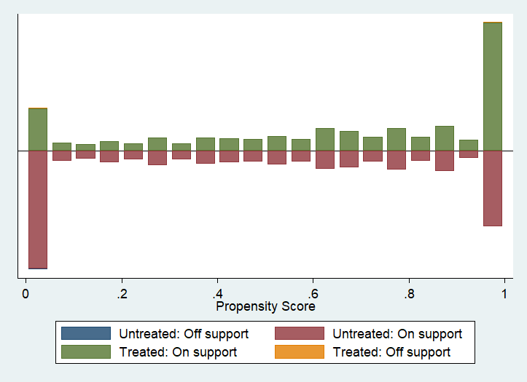
Note: The vertical axis marked in green refers to the treated group, while the untreated group is shown in red. Most of the observations are on support. Hence there is little loss of samples.

