The ARRIVE Guidelines Checklist
Animal Research: Reporting In Vivo Experiments
Carol Kilkenny¹, William J Browne², Innes C Cuthill³, Michael Emerson⁴ and Douglas G Altman⁵
¹The National Centre for the Replacement, Refinement and Reduction of Animals in Research, London, UK, ²School of Veterinary Science, University of Bristol, Bristol, UK, ³School of Biological Sciences, University of Bristol, Bristol, UK, ⁴National Heart and Lung Institute, Imperial College London, UK, ⁵Centre for Statistics in Medicine, University of Oxford, Oxford, UK.

 |  | ITEM | RECOMMENDATION | Section/  Paragraph
 |  |  |  | Title, Paragraph 1
 |  |  |  | Abstract, Paragraphs 1-4
 | INTRODUCTION
 | 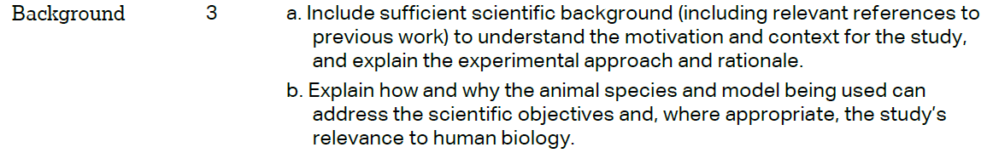 |  |  | Background, Paragraphs 1-3
 |  |  |  | Background, Paragraphs 1-2
 | METHODS
 |  |  |  | Methods, Paragraph 3
 | 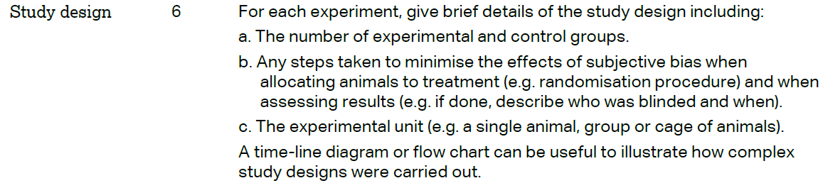 |  |  | Methods, Paragraph 10;  Figures 5 and 6 with the legends.
 | 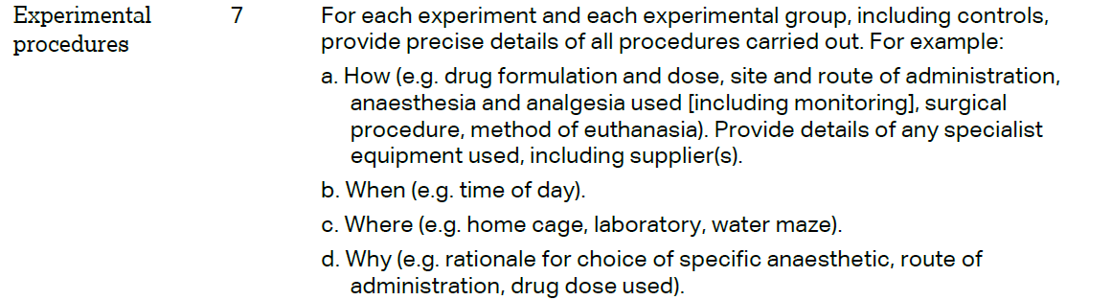 |  |  | Methods, Paragraph 10.
 | 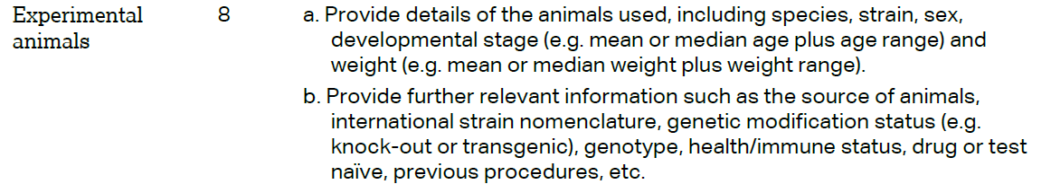 |  |  | Methods, Paragraph 3.
The ARRIVE guidelines. Originally published in PLoS Biology, June 2010¹
 | 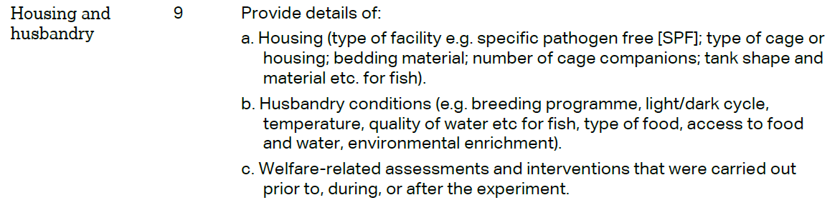 | Methods, Paragraph 3
 | 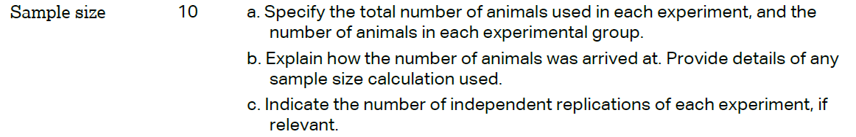 | Methods, Paragraph 10;
 | 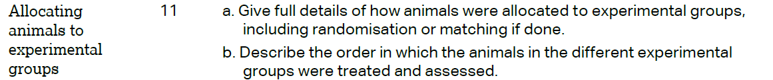 | Methods, Paragraph 10;
 |  | Methods, Paragraph 10;
 | 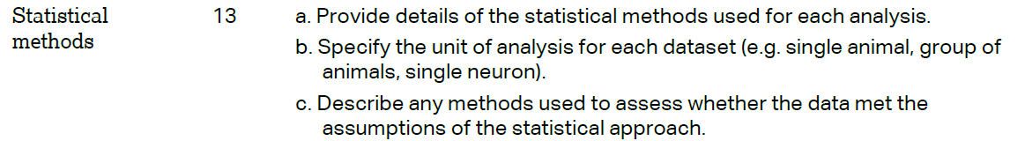 | Methods, Paragraph 11
 | RESULTS
 |  | Methods, Paragraph 10;
 |  | Figures 5 and 6 and the legends
 |  | Results, paragraph 4; Figures 5 and 6 and the legends
 |  | N/A
 | DISCUSSION
 | 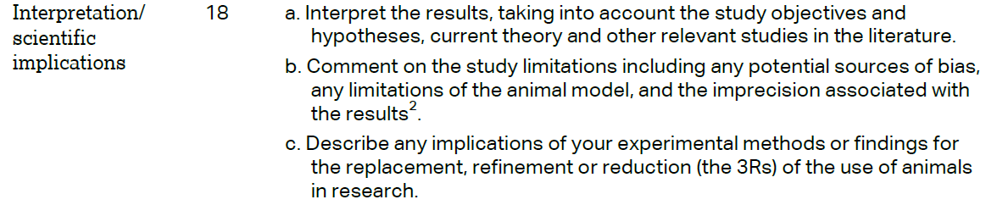 | Discussion, paragraphs 1, 2 and 4
 |  | Discussion, paragraphs 1 and 2.
 |  | Declarations, paragraph 5
