CD9

CD63

GAPDH
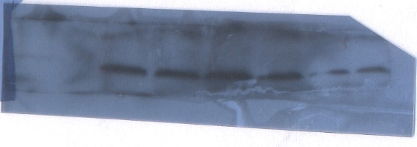

Cytochrome C
