(A)
CDC7
DBF4
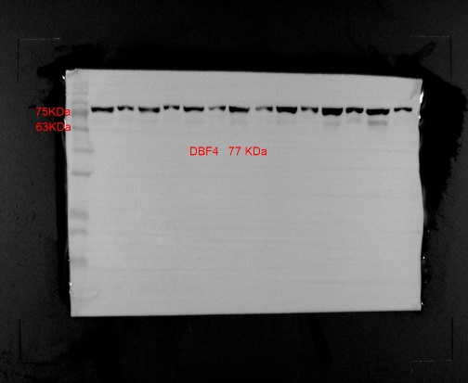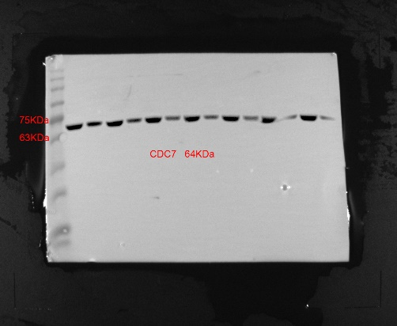
GAPDH

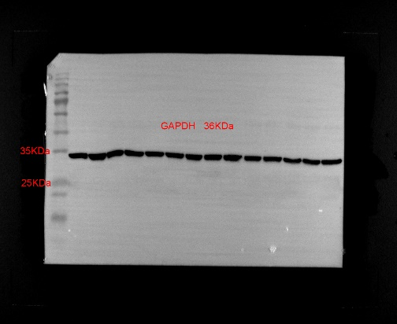

Supplementary Fig. A the original western blot bands of DBF4, CDC7 and GAPDH of samples 1-7.

(B)
DBF4
CDC7

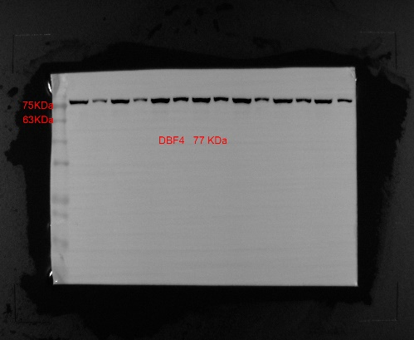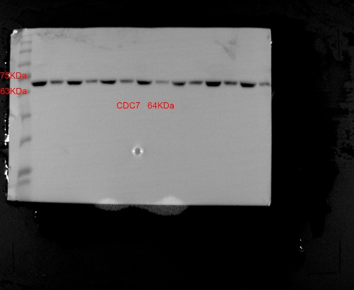
GAPDH

Supplementary Fig. B the original western blot bands of DBF4, CDC7 and GAPDH of samples 8-14.

