Supplemental Figure 1: Patient Selection

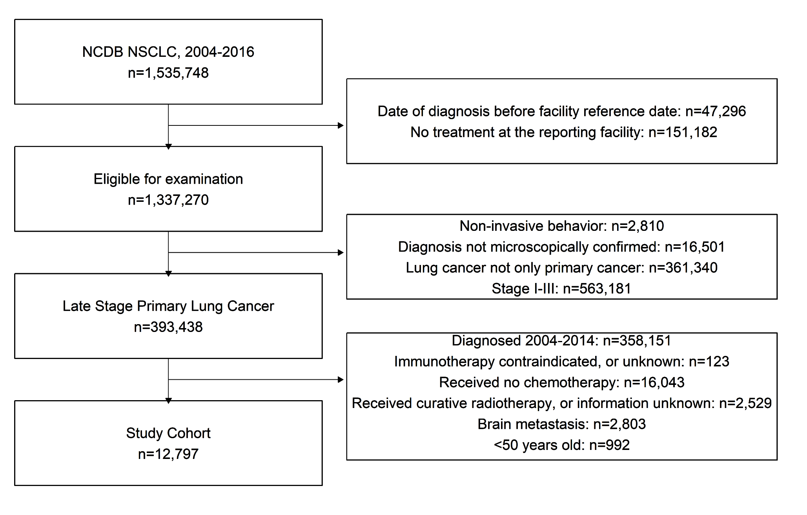

Supplemental Table 1: Drug agents classified as immunotherapy according to the NCDB

Checkpoint Inhibitors | Atezolizumab  Durvalumab  Ipilimumab  Nivolumab  Pembrolizumab
Anti-VEGF/ Angiogenesis inhibitor | Bevacizumab  Cyramza
EGFR Antibody | Cetuximab  Dalotuzumab  Necitumumab  Panitumumab
Vaccines/ Adenoviral p53 Gene Therapy | BLP25  BMS-936558  CEA-Vac  EC-2101  Dendritic cell-P53  Egf Cancer Vaccine  Fowlpox-CEA (6D)  GVAX Lung Cancer Vaccine  INGN 201  IV IL-2 Gene Medicine  Lung Cancer Vaccine  MGV Vaccine  MVA-Muc1-IL2  P53 and RAS vaccine  RAS 5-17 Peptide Vaccine  SB249553  TBC-CEA  Vaccinia-CEA
Other | Thalidomide  Matrix Metalloproteinease Inhibitor  Advexin  Interleukin-12  ProMune  RC-3095  Trastuzumab  TriAb  TriGem  recMAGE-A3+AS15

* these agents are coded as approved for treatment of lung cancer, in clinical trial for lung cancer, or if lung is designated as a primary site of treatment according to the NCDB. Patients should be coded as yes to receiving immunotherapy (variable name RX_SUMM_IMMUNOTHERAPY) if they have been administered any of these agents variable.

