Supplementary materials
Mendelian randomization study of circulating lipids and biliary tract cancer among East Asians

Table of content
Table S1. The genetic instruments used in Mendelian analysis for high-density lipoprotein cholesterol. 2
Table S2. The genetic instruments used in Mendelian analysis for low-density lipoprotein cholesterol. 4
Table S3. The genetic instruments used in Mendelian analysis for total cholesterol. 5
Table S4. The genetic instruments used in Mendelian analysis for triglyceride. 7
Table S5. Association of biliary tract cancer with levels of circulating lipids according to different methods. 8
Figure S1. The forest plot of leave-one-out analysis for high-density lipoprotein cholesterol. 9
Figure S2. The forest plot of leave-one-out analysis for low-density lipoprotein cholesterol. 10
Figure S3. The forest plot of leave-one-out analysis for total cholesterol. 11
Figure S4. The forest plot of leave-one-out analysis for triglyceride. 12
Figure S5. Results of pairwise multivariable Mendelian randomization analysis. 13
Figure S6. Results of multivariable Mendelian randomization analysis. 13

Table S1. The genetic instruments used in Mendelian analysis for high-density lipoprotein cholesterol.
SNP | CHR | position | Nearest genes# | effect_allele | other_allele | beta.exposure | se.exposure | beta.outcome | se.outcome
rs1011685 | 8 | 19830769 | LPL | T | C | 0.1664 | 0.0131 | 0.112749 | 0.115902
rs1109166 | 16 | 67977382 | PSKH1,CTRL,PSMB10,LCAT,SLC12A4 | T | C | -0.0749 | 0.0118 | -0.12981 | 0.107547
rs11216126 | 11 | 116617240 | BUD13 | A | C | -0.117 | 0.0091 | 0.025548 | 0.106533
rs12708980 | 16 | 57012379 | CETP | T | G | 0.1536 | 0.0115 | 0.173321 | 0.150063
rs1532085 | 15 | 58683366 |  | A | G | 0.1152 | 0.0092 | 0.07156 | 0.077981
rs17138358 | 7 | 17920253 | SNX13 | C | G | -0.042 | 0.0077 | -0.01327 | 0.077489
rs17519093 | 11 | 116629905 | BUD13,ZPR1 | A | G | 0.1152 | 0.015 | 0.123932 | 0.18698
rs17821274 | 15 | 58684478 |  | T | C | -0.0547 | 0.0079 | 0.088185 | 0.079001
rs1800588 | 15 | 58723675 | LIPC,LOC101928694 | T | C | 0.137 | 0.0099 | -0.01673 | 0.076804
rs1883023 | 9 | 107564846 | ABCA1 | T | C | -0.061 | 0.008 | -0.07773 | 0.078256
rs1883025 | 9 | 107664301 | ABCA1 | T | C | -0.0983 | 0.0091 | 0.106465 | 0.085198
rs1943973 | 18 | 47179516 |  | A | G | 0.082 | 0.0103 | -0.06237 | 0.107398
rs1973688 | 15 | 58582540 |  | T | C | -0.087 | 0.0098 | -0.14503 | 0.097418
rs2000813 | 18 | 47093864 | LIPG | T | C | 0.0543 | 0.0097 | 0.046731 | 0.088444
rs2144300 | 1 | 230294916 | GALNT2 | T | C | 0.0564 | 0.0104 | -0.06927 | 0.098234
rs2297400 | 9 | 107599481 | ABCA1 | T | C | -0.065 | 0.0088 | 0.036517 | 0.079708
rs3760782 | 19 | 11346550 | DOCK6,C19orf80 | T | C | -0.0676 | 0.0107 | -0.11545 | 0.089654
rs3764261 | 16 | 56993324 | HERPUD1,CETP | A | C | 0.262 | 0.0141 | 0.078876 | 0.094707
rs3786247 | 18 | 47118923 | LIPG | T | G | -0.0957 | 0.0102 | 0.110171 | 0.077015
rs4420638 | 19 | 45422946 | TOMM40,APOE,APOC1,APOC1P1 | A | G | 0.1129 | 0.0132 | 0.10342 | 0.143481
rs445925 | 19 | 45415640 | TOMM40,APOE,APOC1,APOC1P1 | A | G | 0.1197 | 0.0207 | -0.28181 | 0.154736
rs4821116 | 22 | 21973319 | UBE2L3,YDJC,CCDC116 | T | C | -0.0444 | 0.008 | 0.020328 | 0.080262
rs6124760 | 20 | 44581453 | PCIF1,ZNF335 | C | G | 0.1043 | 0.0168 | 0.019221 | 0.161578
rs651821 | 11 | 116662579 | BUD13,ZPR1,APOA5 | T | C | 0.1888 | 0.0102 | 0.200154 | 0.082798
rs7115583 | 11 | 116784376 | SIK3 | T | G | 0.0784 | 0.0115 | 0.105511 | 0.118701
rs8034802 | 15 | 58724792 | LIPC,LOC101928694 | A | T | 0.0824 | 0.0094 | -0.02033 | 0.081995
#: flanking distance (in kB) on each side was 20. NA denotes no gene was available.

Table S2. The genetic instruments used in Mendelian analysis for low-density lipoprotein cholesterol.
SNP | CHR | Position | Nearest genes# | effect_allele | other_allele | beta.exposure | se.exposure | beta.outcome | se.outcome
rs10119 | 19 | 45406673 | PVRL2,TOMM40,APOE,APOC1 | A | G | 0.2063 | 0.019 | -0.23501 | 0.127425
rs10172650 | 2 | 21205457 | APOB | A | G | -0.0945 | 0.012 | 0.004845 | 0.120422
rs12117661 | 1 | 55487346 | BSND,PCSK9 | C | G | 0.0764 | 0.0141 | 0.115547 | 0.133346
rs12610605 | 19 | 45370838 | PVRL2 | A | G | 0.0495 | 0.0088 | 0.010751 | 0.076884
rs12916 | 5 | 74656539 | HMGCR,COL4A3BP | T | C | -0.0793 | 0.0082 | -0.06848 | 0.076846
rs12918956 | 16 | 72224335 | PMFBP1 | T | C | 0.0503 | 0.0087 | -0.01473 | 0.077593
rs174533 | 11 | 61549025 | MYRF,TMEM258,MIR611,FEN1,FADS1 | A | G | -0.0602 | 0.0104 | -0.10152 | 0.0789
rs1799955 | 13 | 32929232 | BRCA2 | A | G | 0.0517 | 0.0087 | 0.017321 | 0.076968
rs1865063 | 19 | 11341029 | DOCK6,C19orf80 | T | C | -0.0549 | 0.0095 | -0.11334 | 0.08946
rs2738452 | 19 | 11229218 | LDLR,MIR6886 | A | G | -0.0734 | 0.0116 | -0.02992 | 0.115503
rs2738464 | 19 | 11242307 | LDLR,MIR6886,SPC24 | C | G | 0.0957 | 0.012 | 0.140272 | 0.082853
rs2980869 | 8 | 126488250 |  | T | C | -0.0503 | 0.0084 | -0.06524 | 0.076824
rs445925 | 19 | 45415640 | TOMM40,APOE,APOC1,APOC1P1 | A | G | -0.5219 | 0.0214 | -0.28181 | 0.154736
rs505151 | 1 | 55529187 | PCSK9,USP24 | A | G | -0.104 | 0.0184 | 0.138774 | 0.182896
rs5744651 | 5 | 74871997 | POLK | A | G | 0.1367 | 0.0228 | 0.230642 | 0.166838
rs579459 | 9 | 136154168 | ABO | T | C | -0.0568 | 0.0096 | 0.144194 | 0.085974
rs588245 | 2 | 21270057 | APOB | A | G | 0.074 | 0.0132 | 0.205052 | 0.137286
rs599839 | 1 | 109822166 | CELSR2,PSRC1,MYBPHL | A | G | 0.1877 | 0.0162 | -0.03768 | 0.144532
rs8051431 | 16 | 72015251 | PKD1L3 | C | G | 0.0753 | 0.0093 | -0.06694 | 0.084031
#: flanking distance (in kB) on each side was 20. NA denotes no gene was available.

Table S3. The genetic instruments used in Mendelian analysis for total cholesterol.
SNP | CHR | Position | Nearest genes# | effect_allele | other_allele | beta.exposure | se.exposure | beta.outcome | se.outcome
rs10119 | 19 | 45406673 | PVRL2,TOMM40,APOE,APOC1 | A | G | 0.1357 | 0.0189 | -0.23501 | 0.127425
rs10172650 | 2 | 21205457 | APOB | A | G | -0.0973 | 0.012 | 0.004845 | 0.120422
rs12916 | 5 | 74656539 | HMGCR,COL4A3BP | T | C | -0.0794 | 0.0081 | -0.06848 | 0.076846
rs12918956 | 16 | 72224335 | PMFBP1 | T | C | 0.0513 | 0.0087 | -0.01473 | 0.077593
rs1532085 | 15 | 58683366 |  | A | G | 0.0588 | 0.0099 | 0.07156 | 0.077981
rs17122278 | 11 | 118449370 | IFT46,ARCN1 | A | G | -0.0469 | 0.0088 | -0.00938 | 0.077496
rs174533 | 11 | 61549025 | MYRF,TMEM258,MIR611,FEN1,FADS1 | A | G | -0.0549 | 0.0103 | -0.10152 | 0.0789
rs1800774 | 16 | 57015545 | CETP | T | C | -0.0688 | 0.0125 | -0.19464 | 0.156448
rs1865063 | 19 | 11341029 | DOCK6,C19orf80 | T | C | -0.0775 | 0.0095 | -0.11334 | 0.08946
rs1883025 | 9 | 107664301 | ABCA1 | T | C | -0.0735 | 0.0096 | 0.106465 | 0.085198
rs2070895 | 15 | 58723939 | LIPC,LOC101928694 | A | G | 0.0757 | 0.0108 | -0.01236 | 0.076917
rs2297400 | 9 | 107599481 | ABCA1 | T | C | -0.0577 | 0.0093 | 0.036517 | 0.079708
rs2738452 | 19 | 11229218 | LDLR,MIR6886 | A | G | -0.0688 | 0.0116 | -0.02992 | 0.115503
rs2738464 | 19 | 11242307 | LDLR,MIR6886,SPC24 | C | G | 0.0827 | 0.0119 | 0.140272 | 0.082853
rs2980869 | 8 | 126488250 |  | T | C | -0.0705 | 0.0084 | -0.06524 | 0.076824
rs3764261 | 16 | 56993324 | HERPUD1,CETP | A | C | 0.0809 | 0.0148 | 0.078876 | 0.094707
rs579459 | 9 | 136154168 | ABO | T | C | -0.0588 | 0.0096 | 0.144194 | 0.085974
rs599839 | 1 | 109822166 | CELSR2,PSRC1,MYBPHL | A | G | 0.1684 | 0.0161 | -0.03768 | 0.144532
rs7192750 | 16 | 72014782 | PKD1L3 | T | C | -0.0683 | 0.0092 | 0.067094 | 0.084043
rs7254892 | 19 | 45389596 | PVRL2,TOMM40,APOE | A | G | -0.3981 | 0.0264 | -0.35756 | 0.201697
rs7776054 | 6 | 135418916 |  | A | G | 0.0598 | 0.0093 | 0.131965 | 0.080583
rs780092 | 2 | 27743154 | GCKR | A | G | 0.0526 | 0.0087 | 0.017496 | 0.084062
rs9958734 | 18 | 47118398 | LIPG | T | C | -0.0919 | 0.0111 | 0.0929 | 0.077236
#: flanking distance (in kB) on each side was 20. NA denotes no gene was available.

Table S4. The genetic instruments used in Mendelian analysis for triglyceride.
SNP | CHR | Position | Nearest genes# | effect_allele | other_allele | beta.exposure | se.exposure | beta.outcome | se.outcome
rs1077834 | 15 | 58723479 | LIPC,LOC101928694 | T | C | -0.0843 | 0.0116 | 0.013713 | 0.077345
rs11216206 | 11 | 1.17E+08 | SIK3 | C | G | 0.0804 | 0.0105 | -0.18362 | 0.086535
rs13233571 | 7 | 72971231 | BCL7B,TBL2 | T | C | -0.1189 | 0.0141 | -0.0957 | 0.12851
rs157582 | 19 | 45396219 | PVRL2,TOMM40,APOE | T | C | 0.1073 | 0.0168 | -0.13534 | 0.089198
rs17482753 | 8 | 19832646 | LPL | T | G | -0.154 | 0.0144 | 0.113639 | 0.115885
rs2001945 | 8 | 1.26E+08 |  | C | G | -0.0647 | 0.0087 | 0.019545 | 0.077868
rs662799 | 11 | 1.17E+08 | BUD13,ZPR1,APOA5 | A | G | -0.2825 | 0.0116 | 0.20139 | 0.082968
rs7164909 | 15 | 58686754 |  | T | C | -0.0638 | 0.0111 | -0.00599 | 0.086438
rs780094 | 2 | 27741237 | GCKR | T | C | 0.1047 | 0.0087 | -0.01964 | 0.077378
rs995000 | 1 | 63107526 | DOCK7 | T | C | -0.0801 | 0.0109 | 0.099126 | 0.110095
#: flanking distance (in kB) on each side was 20. NA denotes no gene was available.

Table S5. Association of biliary tract cancer with levels of circulating lipids according to different methods.
 | HDL | LDL | CHL | TRG
Inverse variance weighted
β (se; P value) | -0.012 (0.007; 0.123) | -0.001 (0.008; 0.915) | -0.0001 (0.008; 0.989) | 0.001 (0.009; 0.936)
Q statistics (P value) | 2.77 (0.948) | 8.28 (0.407) | 8.19 (0.415) | 4.31 (0.828)
MR-egger
β (se; P value) | -0.027 (0.032; 0.423) | -0.001 (0.035; 0.987) | 0.024 (0.035; 0.512) | 0.007 (0.037; 0.849)
Q statistics (P value) | 3.02 (0.963) | 8.28 (0.506) | 8.70 (0.465) | 4.34 (0.887)
Intercept (P value) | 0.007 (0.636) | -0.0001 (0.993) | -0.011 (0.499) | -0.003 (0.860)
Weighted median
β (se; P value) | -0.012 (0.013; 0.414) | -0.003 (0.017; 0.856) | -0.007 (0.015; 0.670) | 0.010 (0.017; 0.585)
Weighted mode
β (se; P value) | -0.011 (0.010; 0.285) | -0.002 (0.011; 0.856) | -0.001 (0.011; 0.908) | 0.006 (0.011; 0.606)
HDL, high density lipoprotein; LDL, low density lipoprotein; CHL, cholesterol; TRG, triglyceride.

Figure S1. The forest plot of leave-one-out analysis for high-density lipoprotein cholesterol.
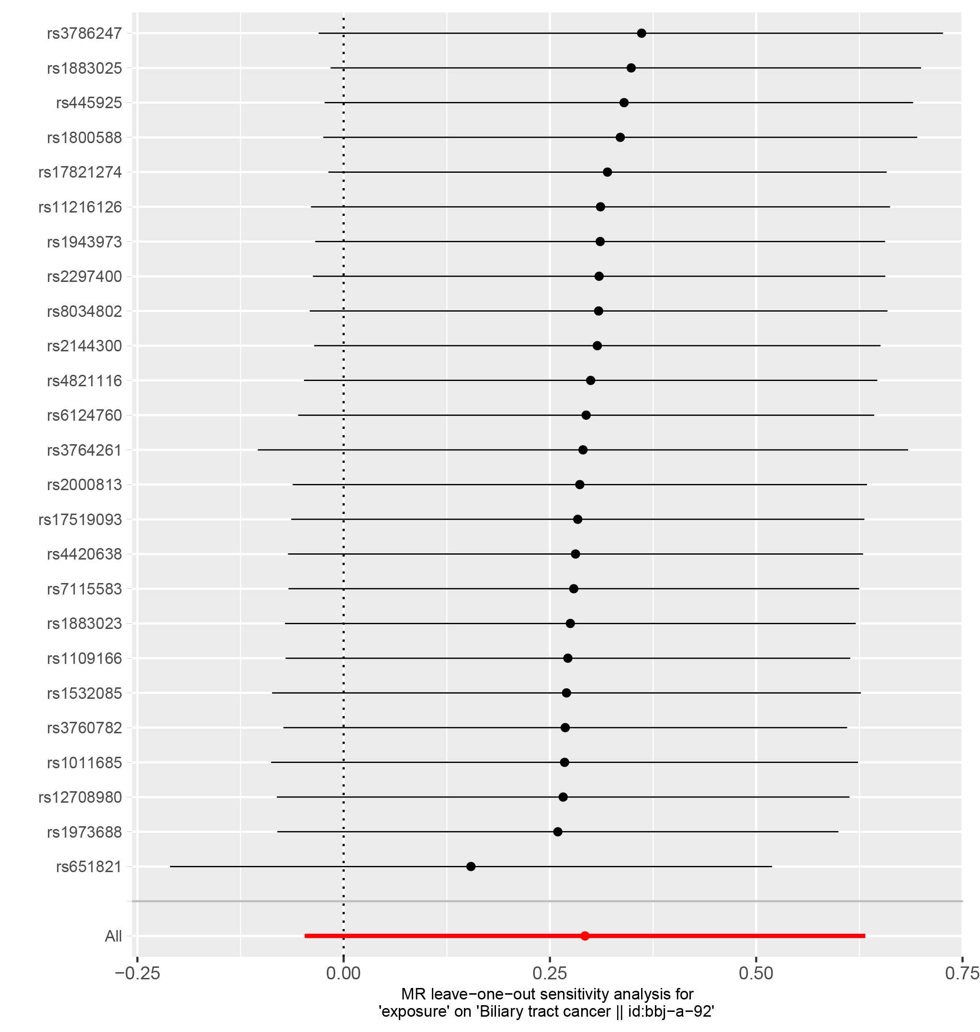

Figure S2. The forest plot of leave-one-out analysis for low-density lipoprotein cholesterol.
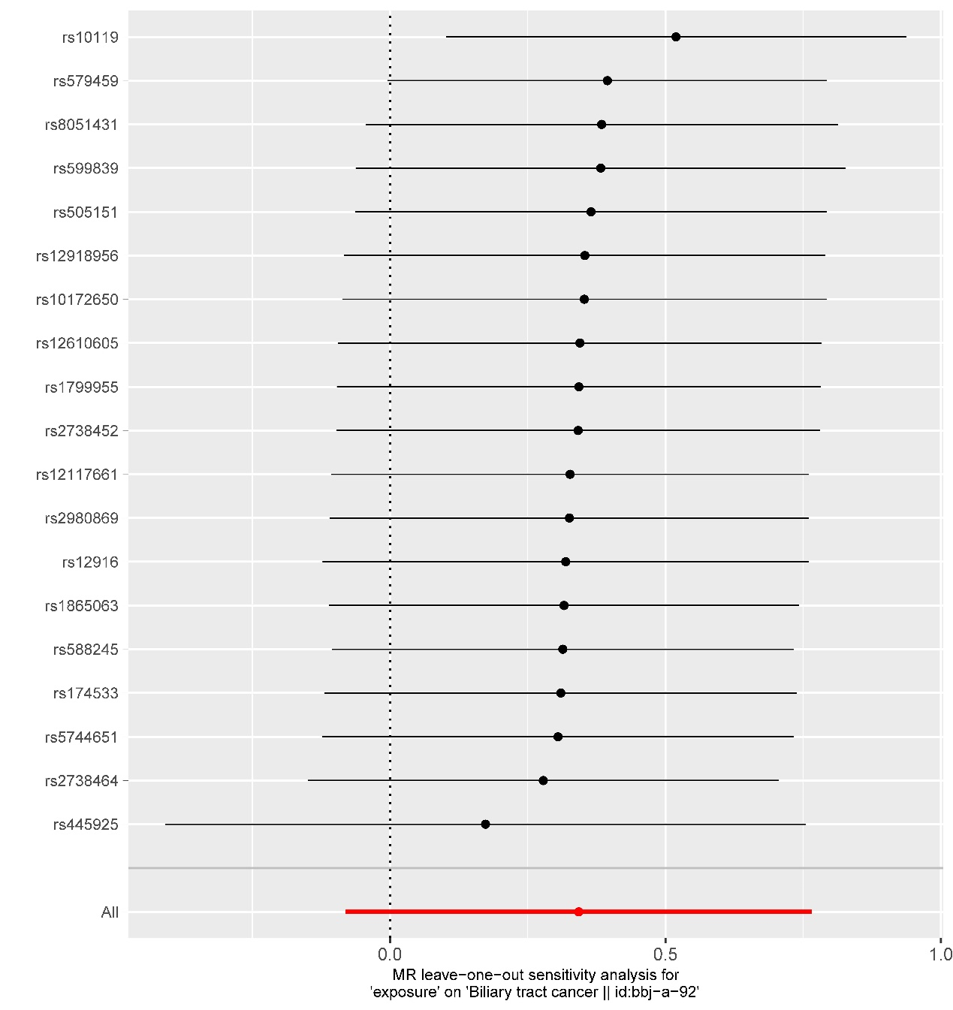

Figure S3. The forest plot of leave-one-out analysis for total cholesterol.
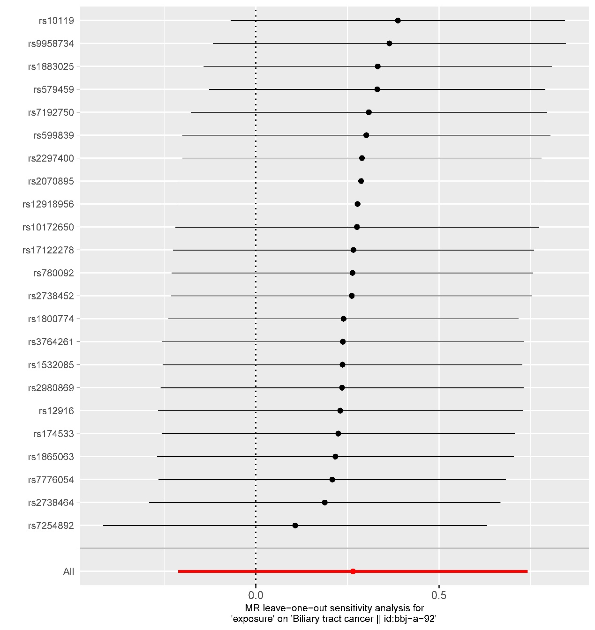

Figure S4. The forest plot of leave-one-out analysis for triglyceride.
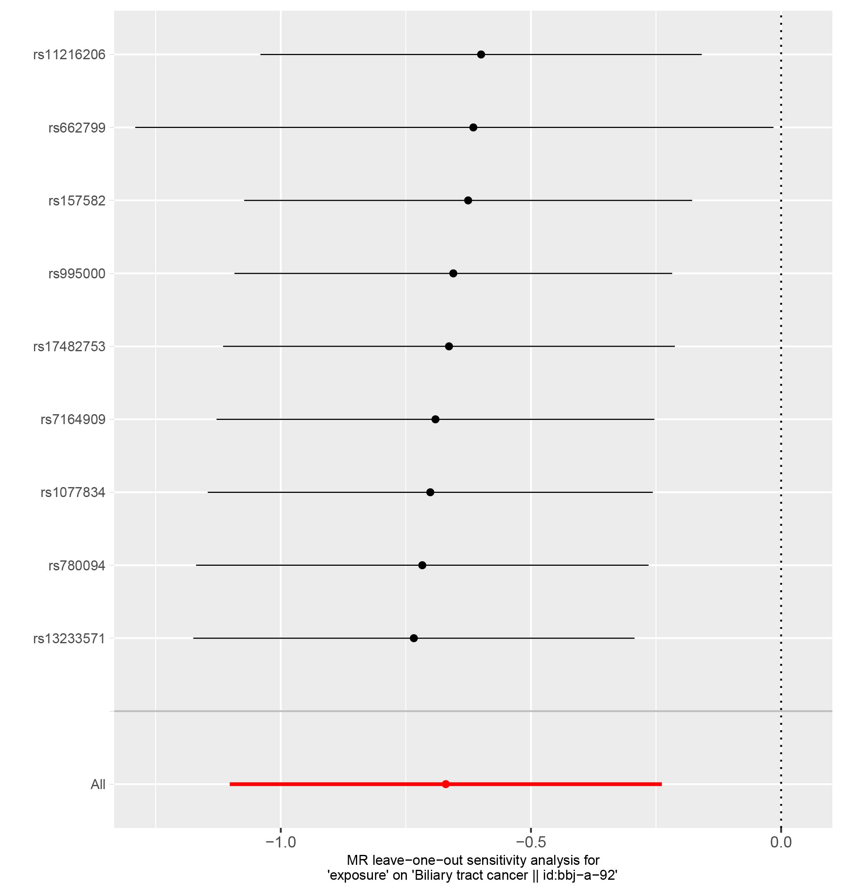

Figure S5. Results of pairwise multivariable Mendelian randomization analysis.
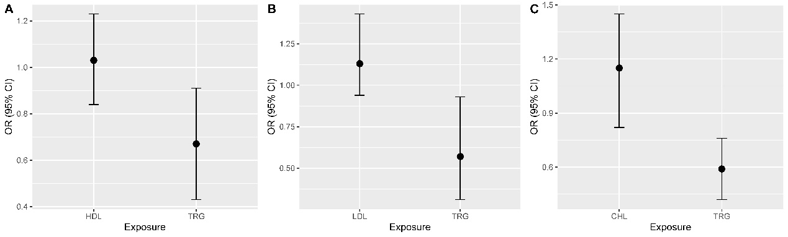

Figure S6. Results of multivariable Mendelian randomization analysis.
